Blindata Release Note 11.5.4 

5 May 2023

Bug Fixes and Enhancements

The following bugs and cosmetic changes were recorded in www.support.blindata.co.uk and have been resolved.

19236. Invoice Email Field
19249. Optimisation Query - Qubit 310145
19275. Tape Stock Issue - Despatched orders Tape usage not being issued off stock
19277. Fabric Stock Issue - Random Fabric orders usage not being issued off stock
19285. Label Print - Bespoke 92
19290. Production Documentation > Label Print - Bespoke 92

New Work and Customer Requests

18902. Reports > Sales Analysis > Sales Analysis by Account Type

There is a new report called ‘Sales Analysis By Account Type.

19137. Quotation - Bespoke 21

Some adjustments have been made to the detail lines in this report.

19301. Micro Pneumatics Roller Table Barcode

It is now possible to record OS1 and OS2 quantities and save them in the barcode for this roller table. This can be done by setting up cutting sizes for OS1 and OS2 in Blind Types > Cutting Options. The Type field now contains choices for OS1 and OS2 and these should be applied to the relevant records, as they will then be used in the barcode.

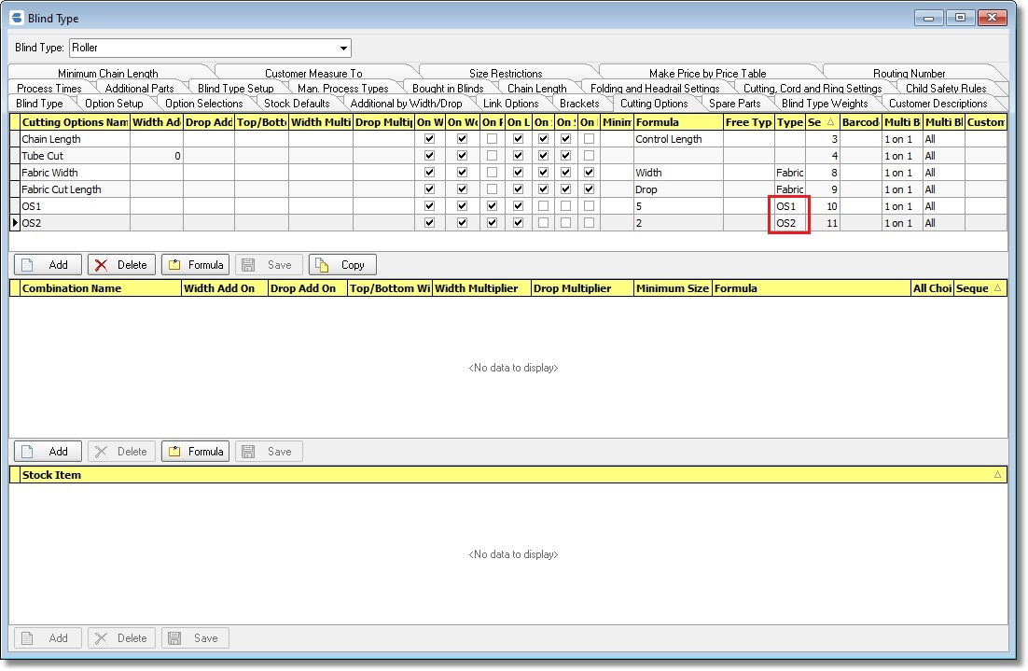

19302. Blind Types > Cutting Sizes > Formula

There is new functionality in the Formula form to determine formulae by calculator held against the fabric record.

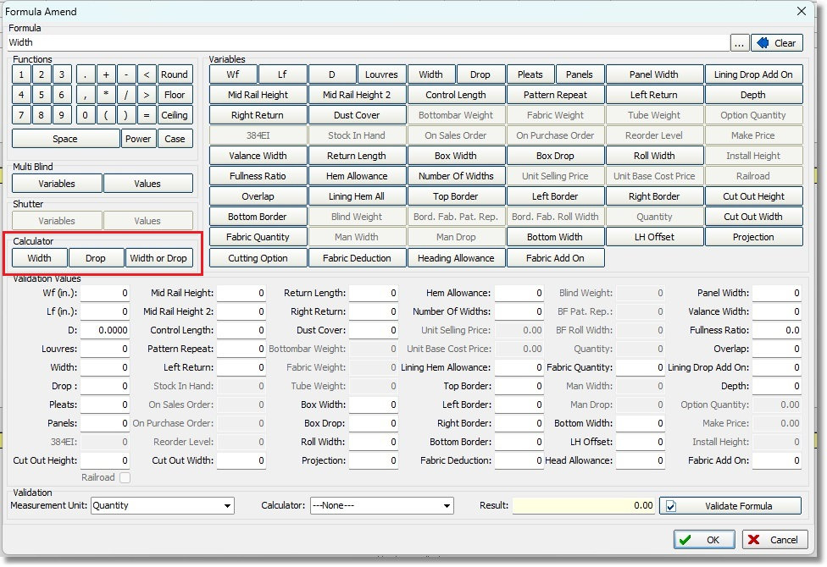

If Width is selected then it will insert the following code in the formula:

<<Width>>Width

It is then possible to create formula like this:

Case WHEN <<Width>> then Drop ELSE Width END.

There is also a Calculator choice at the bottom of the form to assist with validation.

19303. Label Print – Bespoke 92

This label will now allow 3 cutting sizes to be printed on it.

19304. Order Processing > Global

‘Date Cancelled’ has been added as a column choice on the Global form. There is also now a choice (in the context menu) to ‘Copy To Clipboard’.

