Blindata Release Note 11.5.3 

5 May 2023

Bug Fixes and Enhancements

The following bugs and cosmetic changes were recorded in www.support.blindata.co.uk and have been resolved.

19173. Order Detail Line Entry
19198. Batch picking list print Issue 2.0
19204. Order 312891
19215. Good in showing incorrectly on pick lists
19230. Picking Operation Failed
19231. No of vanes on order 132745
19237. Can’t Untick Same Day Flag in an Order
19240. Blindata Blind Types

New Work and Customer Requests

19175. Label Print - Bespoke 92

There is a new label print called ‘Label Print – Bespoke 92’ which is 4” wide by 1” deep.

The options and cutting sizes that appear on the label can be controlled in Blind Type > Blind Type Setup > Label Control.

The data on the top left of the label is taken from the ‘Free Type’ field in the ‘Label Control’ section. A label is printed for each record that is added in the ‘Label Control’ section.

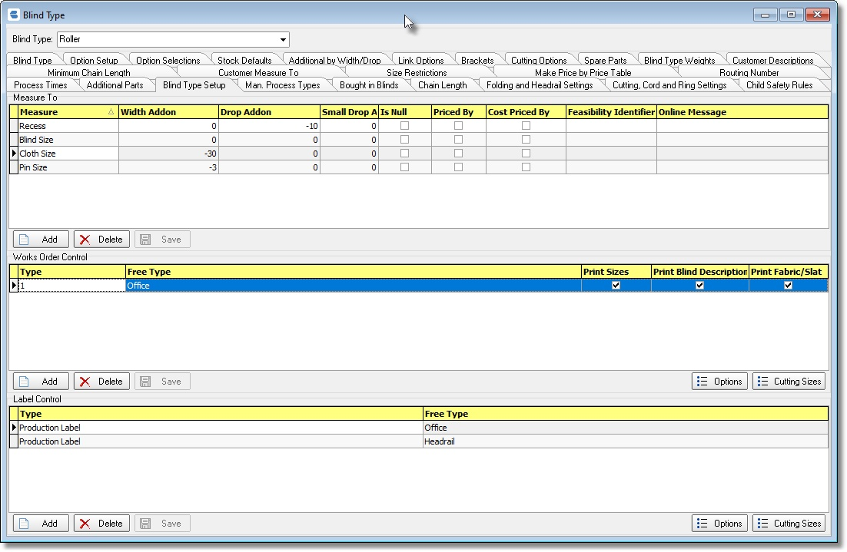

The options selected can be determined by clicking on the ‘Options’ button (bottom right above) and then adding in the required options for this label.

