Blindata Release Note 11.4.5 

3 March 2023

Bug Fixes and Enhancements

The following bugs and cosmetic changes were recorded in www.support.blindata.co.uk and have been resolved.

18781. Roller fabric BOM Cost
18788. Multi Blind Pricing
18793. Invoice - Bespoke 34A
18794. Fabric Override Issue
18800. Adjustment Scan Fix 2.0
18843. Mertex accounting CSV files filename change
18845. unable to print

New Work and Customer Requests

18369. Automated Task > Daily Status Report

The daily status report is now sent out even if sub accounts have been set up against main accounts.

18472. Customers > FTP Setting 2 > FTP Invoice File

There is now an option to send out a weekly invoice to customers in Customers > FTP Settings 2.

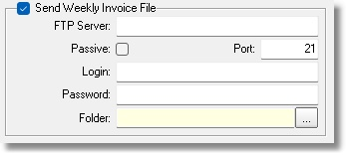

18509. Blind Types > Multiply Details By Quantity

There is a new field in the blind type record called ‘Multiply Details By Quantity’. This is required to ensure that all detail lines have a quantity of 1. If this flag is set to true and a quantity > 1 is entered in an order detail line, it will be copied Quantity – 1 times and the quantity set to 1.

18547. Sales Files > Customers

There is a new flag in the customer record called ‘don’t Send Early’. If this is set to true, when an order is entered, the same flag in the order will be set to true.
18782. Parameters > Accounting Parameters

The ‘Lakeview’ choice has been removed in Parameters > Accounting Parameters and replaced by ‘Xero CSV’. The Xero csv flags have been moved to the Xero accounting tab.

