Blindata Release Note 11.3.0 

18 November 2022

Bug Fixes and Enhancements

The following bugs were recorded in www.support.blindata.co.uk and have been resolved.

17936. Order Acknowledgement - Document printing out over two pages
17948. Customers > Use Original Detail Line Defaults Online. Options not staying and are defaulting
17957. Retail Quote on tablet lists 22 blinds - only 2 blinds have imported
17961. EDI Discounts
18000. Date Account Opened in Sales Files
18008. Blindata Online - Warning Messages
18014. Incorrect Product Codes
18020. Purchase Credit Enquiry > Post

New Work and Customer Requests

7021. Purchase Credits

There is now functionality to create purchase credits in the context menu in ‘Purchase Order Enquiry’. This can be enabled by switching on the ‘Create Purchase Credit’ flag in Administration > Users > Advanced Permission.

There are also new menu options for ‘Purchase Credit Enquiry’ and ‘Purchase Archive Credit Enquiry’.

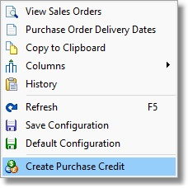
This will then display the following form. It will only display detail lines that have been turned into purchase invoices.

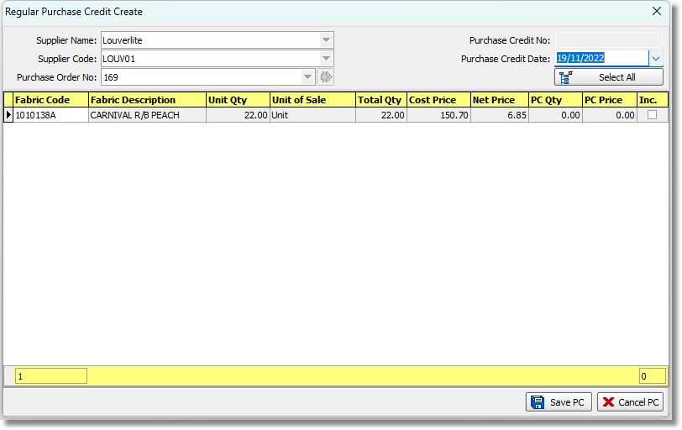

Once a purchase credit has been created, it will then appear in the ‘Purchase Credit Enquiry’ form.

In the ‘Purchase Order Enquiry’ form it is then possible to post the purchase credit.

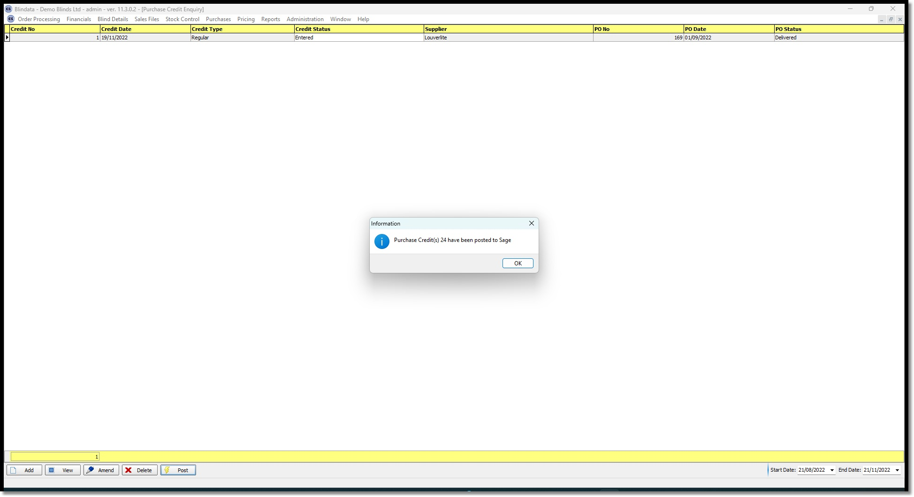

15834. Invoice - Bespoke 73

The existing 'Invoice - Bespoke 73' has been removed and replaced by an amended 'Invoice - Bespoke 57'.

16147. Batch Picking List

The ‘Notes’ field has been removed for the batch pick list and replaced with ‘Notes 2.

16916. Carriage by Area

The 'Area' field has been added to the 'Sub Account' record in Sales Files > Customers.

17161. Parameters > Automated Tasks > Feedback Emailing

It is now possible to send the feedback emails in HTML format.

17233. Report > Sales Lead Estimate Landscape

Boxes have been added for the ‘Quote Number’ and ‘Order Number’.

17782. Parameters > Other Reports > Survey Sheet – Bespoke 47

There is a new survey report called 'Survey Sheet - Bespoke 47'.

17871. Works Order - Bespoke 73

This works order now prints detail lines in the order they were entered.

18016. Administration > Parameters > Online tab

There is a new parameter in Parameters > Online tab called 'Select Blind Identifier First' which defaults to false. If false, the online order detail line entry performs as it did before the blind identifier change was made. If true, then the current functionality should work.

