Blindata Release Note 11.2.1 

16 September 2022

Bug Fixes and Enhancements

The following bugs were recorded in www.support.blindata.co.uk and have been resolved.

17422. bill of materials
17433. cannot receive online orders

New Work and Customer Requests

14727. Sales Files > Customer Update

There are new columns for ‘Outstanding Balance’, Amount Spent In Year’ and ‘Date Account Opened’. Records can now be filtered by these criteria to determine if they are going to be updated to ‘Inactive Customer’ or not.

15465. Sales Files > Customers > Activity

There is a new ‘Unallocate’ button on the Activity form. This means that receipts or credit notes that have been allocated by mistake can be reversed.

16567. Production Scheduling

There is a new field in 'Stock Items' called 'Schedule Days' which defaults to 0. If it is greater than 0, it is used in calculating a scheduled date for the order detail line. The scheduled is calculated as the schedule date + schedule days and scheduled as the first available schedule date after this.

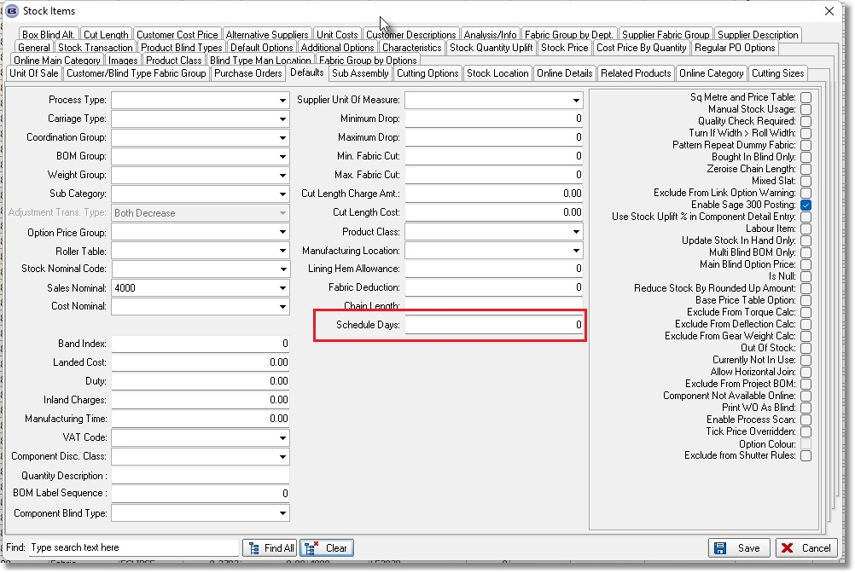

17145. Works Order – Bespoke 91

There is a new works order report called ‘Works Order – Bespoke 91’.

17147. Label Print – Bespoke 91

There is a new label report called ‘Label Print – Bespoke 91’.

17339. Fabric Group By Option Choice and Fabric

There is a new table called 'Fabric Group By Fabric and Option'. This contain fields for id, fabric id, option choice id and fabric group. This is visible in Stock Items > Fabric Group By Options and there is an import function in Import From Excel called ‘Fabric Group By Fabric and Option’.

When an order is entered, the fabric group is normally selected from the stock record for the fabric. We now look at this table to see if there is a record matching the fabric record and any option choice in the detail line. This means it has to be rechecked every time a fabric or option is changed.
17348. Works order - Bespoke 90

Some amendments have been made to the layout of this report.

