Blindata Release Note 11.1.8 

26 August 2022

Bug Fixes and Enhancements

The following bugs were recorded in www.support.blindata.co.uk and have been resolved.

16763. 4 x 1 Label Layout & 2.5mm Font Size
17221. Stock transaction entry -2
17230. Picking scan - 3
17277. Order 128060
17280. Repair Function
17281. Order Processing > Orders > Add New Order - View Blinds
17285. Price Table import error
17290. Invoice Print
17310. Order Processing > Orders

New Work and Customer Requests

16536. Import From Excel > Fabrics

The following fields in the Characteristics tab can now be imported in Import From Excel > Fabrics.

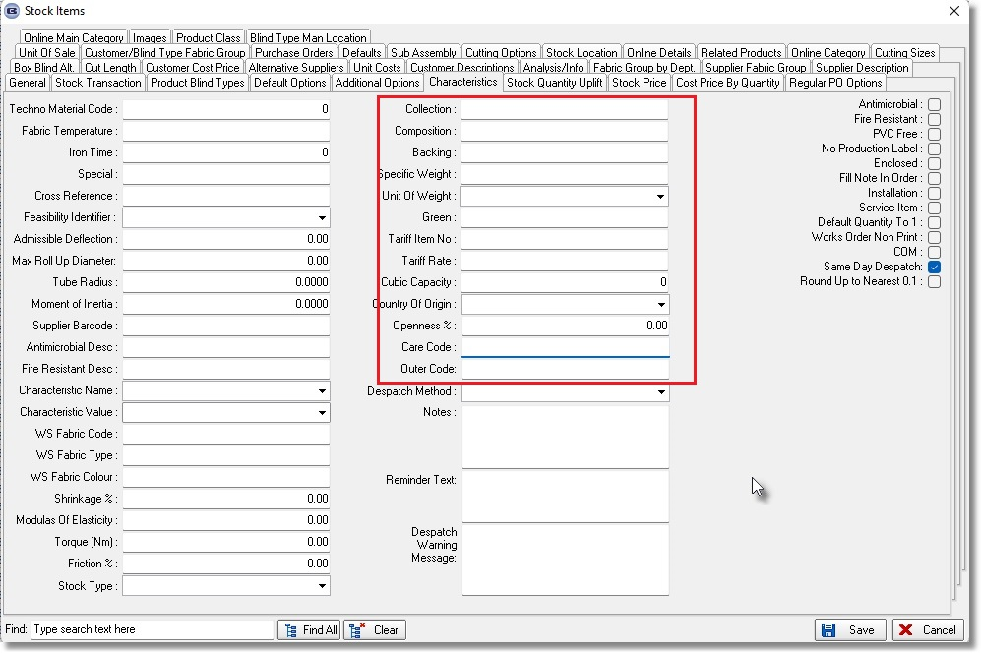

16888. Sales Invoice via API

A new 'API' tab has been added to the Administrator>Parameters screen.
A new button 'Submit Invoice' has been added on the Financials > Invoice Print and Post screen.

When the invoice is submitted, a JSON request will be sent. A folio value from the response will be saved to the Order > Sage Transaction Number field and enlacepdf, enlacexml will be saved to the Order > Notes 2 field.

'Null Invoice' function has also been implemented.

17091. Order Processing > Orders > BOM

There is a new user permission to allow a user to amend the Quantity in a fabric BOM record. If the quantity is amended, all of the other detail lines with the same fabric have their quantity set to 0 and the 'Manually Changed' flag in the BOM record set to true for all of these detail lines.

The new permission is called 'Edit Fabric BOM Qty' and defaults to false. It is not possible to edit the fabric quantity after the blind has been manufactured (or if 'Update Stock At WIP' then after 'Work In Progress').

17306. Purchase Order Bought In - Bespoke 52

If the blind identifier = Wood, the ‘Chain Length’ and ‘Valance Size’ are both now printed in the detail section of this report.

