Blindata Release Note 10.4.2 

26 February 2021

Bug Fixes and Enhancements

The following bugs were recorded in www.support.blindata.co.uk and have been resolved.

12800. Email Texts on Quotes "Administration" "Company Details" "Email Texts" "Email Quotation Text"
12801. Label - Bespoke 37A
12814. Curtain Size Edit Issue
12819. Online | Stock quantity displaying online
12821. acknowledgement
12837. Quote 83 Parameterized Text Issue

New Work and Customer Requests

12218. Orders > Orders > Bought In Column

There is a new column choice for ‘Bought In’. This means users will be able to see those orders that have bought in blinds.

12264. Label Print - Bespoke 75

This label now prints out by serial id and includes the barcode for the serial id.

12436. Sales Files > Customers

There is a new field called ‘Mandatory Customer Order Number’ which defaults to false. If true, this field is required in the order entry form.

12445. Reports > Sales Analysis

If 'Exclude' is selected and 'Use Analysis Codes' is also selected, then the report will now exclude the analysis codes selected. In this example it would exclude all lines with Carriage in them (the word ‘Carriage’ should be saved in the relevant stock record).

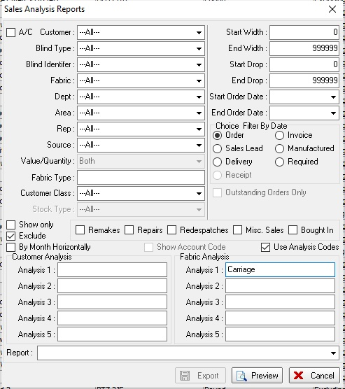

12492. Sales Files > Customers

There is a new field in the customer record called ‘Fill Note In Order’, which defaults to false. If true, the note from the customer record will be saved in an order.

12525. Order Processing > Orders > Maxoptra Export CSV

A number of new fields can now be exported to the Maxoptra csv file. See specification.

12607. Blind Types > Size Restrictions

There is now a column for Customer here so blind type sizes can also be restricted by customer.

12649. Order Processing > Global Search

There is a new button on the Global Search form called 'Filtered Contact Management'. When this button is selected, it displays all of the contact records for the filtered records instead of just the record that is being pointed at.

There is also a button visibility flag for this button.

12650. Invoice - Bespoke 39

Previously if a component detail line was entered, the description was being cut off on the invoice. This field now to prints on two lines instead of the current one.

12847. Sales Files > Customer Update > Create Receipt Invoice

There is a now an option to update the ‘Create Receipt Invoice’ field.

12848. PO XML Transfer File 2

If the chain/control length attribute BLI_CONTROLS_LENGTH is in the XML file, the size is now rounded down to the nearest 10cm. For example, if the control length is 875mm, then the value for BLI_CONTROLS_LENGTH is 80.

