Blindata Release Note 10.0.8 

3 July 2020

Bug Fixes and Enhancements

The following items were recorded in www.support.blindata.co.uk and have been resolved.

10734. Bug. Upgrade
10742. Bug. cm-mm
10764. Acknowledgement - Schedule Date

New Work and Customer Requests
7259. Financials > Invoice Batch Print

There is a new parameter in Administration > Parameters called ‘Use Post Invoice Batch Number’ which defaults to false. If true, then a batch number will be written to the invoice and reprints can be done by selecting the invoice batch number.

The layout of the ‘Invoice Batch Print’ has also been amended.

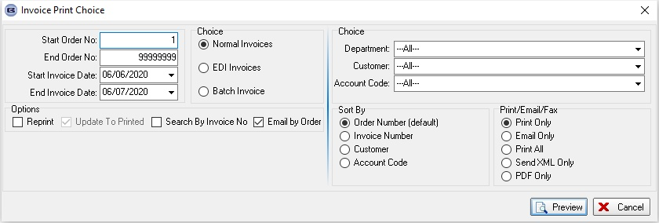

10555. Order Processing > Orders > Despatch Method

There is a new parameter called 'Use Despatch Method From Stock code' which defaults to false. If true, then in the component detail line entry, the despatch method will be taken from the stock record if it exists.

10637. Acknowledgement – Bespoke 37 Email

The functionality for emailing this report has changed. If an order has made to measure blinds and components on it, the email is sent out with 2 separate pdf files.

10658. Works Order - Bespoke 73

If the fabric is railroaded, the amount of fabric required prints in metres.

10685. Acknowledgment - Bespoke 76

The totals have been formatted to match those in ‘Quotation – Bespoke 76’.

10686. Invoice - Bespoke 76

The totals have been formatted to match those in ‘Quotation – Bespoke 76’.

10688. Purchase Orders

The record locking functionality has been improved in purchase ordering.

10699. Work Order- Bespoke 37A (Multi Blind)

In the case of a ‘Multi-Blind’, the work order prints the line but without options.
The report layout has been changed from landscape to portrait, so that it fits onto one page.

10710. Stock Items > Additional Options > BOM Calculation

There is a new flag called 'By Quantity' in Stock Items > Additional Items'. If this is set to true, then the result of the calculator is multiplied by the 'Quantity' in the 'Additional Option' when calculating the BOM record for an additional option.

10751. Carrier/Freight Feedback

The pop ups no longer appear when emails are generated after carrier feedback is received.

10755. Purchases > Purchase Order Enquiry

There is a new column choice for 'Received' (is_received field in the PurchaseOrder table).

