Blindata Release Note 10.0.3 

29 May 2020

Bug Fixes and Enhancements

The following bugs were recorded in www.support.blindata.co.uk and have been resolved.

10385. work order picks up the wrong slat count chart
10441. Work Order print/preview
10444. Blind Details > Blind Type > Option setup
10445. Order Processing > Orders

New Work and Customer Requests
10211. Option Restrictions

There is a new 'Supplier' column in the 'Option Restrictions' system table where you should be able to restrict the blinds from a particular supplier. Thus, if you need to restrict the supplier's blinds (Web Service) for a customer then the 'Option Restrictions' functionality will now work.

10269. Blind Type > Multi Blind

In the case of Multi-Blind blind type, the system now checks the width of individual blind width rather the overall width of the blind, regardless of the setting of the 'Turn If Width > Roll Width' flag.

10272. System Tables > Dimension Codes > Formula

There is now a button called ‘Option Quantity’ in the Formula form, which now means the BOM can be calculated on the quantity held against an option choice.

10302. Order Processing > Orders > Batch Status Field

There is a new button on the ‘Order Amend Enquiry’ form called ‘Batch Status Field’. This will allow ALL filtered records that have the status changed at once.

This is obviously a dangerous field (if misused) and there is a new button visibility flag for it in Users > Button Visibility.

10357. Auto Generate PO's for Bought In Blinds

We have added new 'Sales Files > Customers > Add/Amend > Options > Disable Auto Generate Bought In PO' flag.
It is only visible if 'Administration > Parameters > PO Parameters > Auto Generate Bought In PO' flag is switched on.
10360. Administration > Parameters

There should be a new field for 'Location' in Parameters > Order / Quotation Processing 2 > Location which should default to false. If true, then the 'Location' in the order detail line entry should be filled.

10368. Purchase Order Regular – Bespoke 28

When ordering a product from an alternate supplier, this report now shows the code set up in Stock Items > Alternate Suppliers. If this is empty, it shows the main suppliers code on the PO.

10369. Quotation Enquiry / Archive Enquiry

If the ‘Notes’ field is filled in, the ‘Notes’ button will be highlighted as red for the relevant records.

10377. Maintenance > Clean Up Locations

The ‘Clean Up Locations’ functionality has been improved with the following choices.

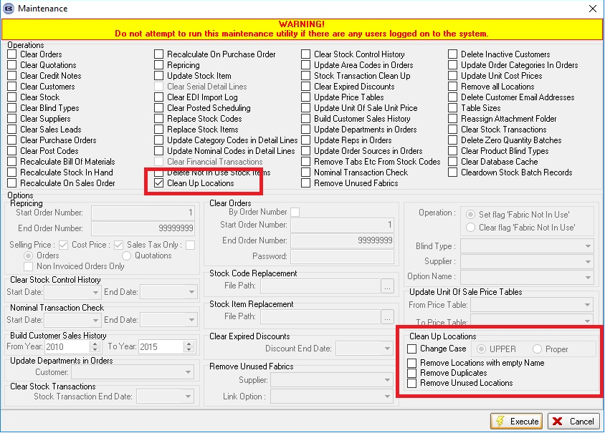

10379. Order Processing > Fitters Sheet / Sales Leads

There is a new parameter in Administration > Parameters > Fitters Sheet / Sales Lead called ‘Include components in Appt Total’ which defaults to false. If tis is set to true, the component quantities are included in the ‘No Of Blinds’ total.

10450. Blind Types > Option Setup

There are three new fields in the Option setup form.

Alternative Option – if another option name is entered here, then the option will share option choices with the ‘Alternative Option’. As an example, a border option for a curtain may want to use the same list of fabrics as the fabric description, and so the ‘Alternative Option’ would be set to ‘Fabric’.

Alternative Calculator – this can be used to calculate the BOM for the alternative option choice

Alternative Price Formula – this can be used to price the option and will override the price in ‘Option Price Enquiry’.

10452. Stock Control > Stock Items

This form has been resized. It is now wider and shallower, so can be seen on screens with large screen resolutions.

10454. Blind Types > Make Price

There is a new field in the blind type record called 'Make Price'.

There is then a new button in the 'Formula' for Pricing > Option Price Enquiry' and Square Metre / Linear Width Pricing for'Make Price' which accesses this new field.

10455. Order Processing > Orders

If blind identifier = Bedding and 'Enter Depth Size' = true in the blind type record, the 'Depth' goes immediately below 'Drop'.

