Blindata Release Note 10.0.2 

22 May 2020

Bug Fixes and Enhancements

The following bugs were recorded in www.support.blindata.co.uk and have been resolved.

9303. Special instruction capacity / function
10355. retail quotations
10362. Link option Using Area does not calculate correctly when size is changed from Window Blind Amend Screen
10376. Purchase Order Enquiry
10383. Carrier File Import
10403. Reports > Financial Reports > Bought In Purchase Orders Accrued

New Work and Customer Requests
5992. Blind Types > Cutting Options

A button ‘Depth’ has been added to the formula for cutting options. This can also be used for ‘Projection’ in external blind identifiers.

7241. Pricing > Option Price Discount

There is a new flag in this record called ‘Apply To Main Discount’ which defaults to false. If true, this discount % is applied to the whole blind (ie to the base price as well). It will not be an accumulative discount.

7247. Quotation – Bespoke 76

The installation costs can now be printed in the total section and not displayed in the detail section. Please see Redmine 9722.

To implement this, there is a new ‘Installation’ flag in the stock record. For this report, any items with this flag set to true will be totalled in the footer section of this report and will not appear in the detail section,.

7249. Order Processing > Orders > Number Of Widths (Ignored)

The 'Number Of Width' value remains the same if was entered manually even if the options were changed. There is a new 'Number Of Width Overridden' flag for the 'Curtain' blind type in the blind entry.

If the flag is true, the value of 'Number Of Width' value will not be recalculated.

10241. Sales Files > Customers

There is a new ‘Blind Type Lead Time' tab in Sales Files > Customers. If there is a record here, it will be used to calculate the ‘Required Date’ in the order entry.

10268. Work Order – Bespoke 37A

Blind Detail > Blind Type > Blind Type Setup > Works Order Control > Option can now be used to arrange the order in which the options are printed.

10285. Reports > Sales Analysis

There is a new flag called ‘Outstanding Orders Only’ (will be displayed for the 'Sales Analysis by Option Choice'). If this is true, then the report shows orders that have not yet been invoiced i.e. they do not have an invoice date.

10294. Purchase Order Bought In - Bespoke 64

‘Non Print Items’ no longer appear as options on this report.

10305. Order Processing > Orders

It is now possible to have options that can share specific option choices eg for curtains, there may be choices for borders. This means we need to look up fabrics for the fabric description and also for different borders.

To achieve this, there is a new button in Stock Items > Product Blind Type tab called ‘Alternative Link Options’.

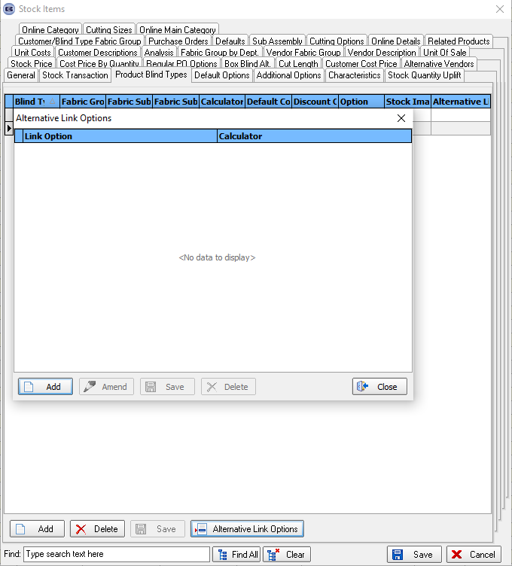

The ‘Alternative Link Options’ could be set up against fabric records as follows for borders on curtains.

In this case it means that four different border options will lookup fabrics and each one can have a calculator specific to the option.

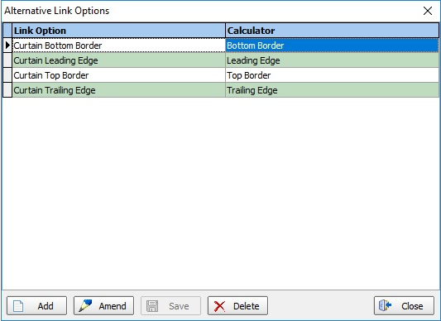

10321. Bedding Blind Identifier

There is a new blind identifier called 'Bedding'. It has the same setup as 'Curtain' in the blind type, but there is a new flag called 'Display Depth Size', which defaults to false. If true, a new size appears in the order detail line entry called 'Depth' (beneath 'Drop').

This field now appears in the detail section for 'Works Order - Bespoke 73', 'Quotation - Bespoke 73' etc.

There should also be a button for 'Depth' in the 'Formula' form for 'Dimension Codes' and also 'Pricing'.

10371. Quotation - Bespoke 73

'Despatch Method' now prints in the header of this report.

10373. Blind Types > Austrian/Romans

If the ‘display allowances’ flag is set to true for blind identifiers where the blind identifier = Austrian/Roman, the Hem Allowance, Lining Hem Allowance, Overlap and Border (flag) fields will be displayed in the order detail line entry.

10375. Order Processing > Order Enquiry

There is now a column choice for 'Location' (from the order detail line) on this form.

10388. Work Order – Bespoke 42

Even if the customer is configured as the 'Including Tax' the 'Company Name' will now be printed on this report.

