Blindata Release Note 10.0.1 

15 May 2020

Bug Fixes and Enhancements

The following bugs were recorded in www.support.blindata.co.uk and have been resolved.

10334. Stock created date
10341. error when updating address of new transferred account from sage

New Work and Customer Requests
7242. Online Ordering > Order Confirmation

When a customer enters an order but does not submit it, they can print out the order. Previously the order print was the same before and after it is submitted.

It still says ‘Order Confirmation’ after it is submitted. If it is not submitted, it now says ‘Unsubmitted Order’.

7248. Invoice - Laser Print (Letterhead Logo) 8.5 x 11

There is a new invoice report called ‘Invoice – Bespoke 87’ based on ‘Invoice – Laser Print (Letterhead Logo) 8.5 x 11. All other text fields except ‘Invoice Text’ have been removed in the footer and it has been made far larger. Also this new report is A4 size.

10079. EDI XML Dispatch Export

There is a new parameter called 'Send Dispatch File at Invoice Post' which defaults to false.

If the new parameter is false, then the file is created as normal. If true, it is not created at the 'Dispatch' stage, but when the invoice is posted.

10257. Administration > Maintenance > Clear Stock Transactions

There is now a ‘Stock Transaction End Date’ in the ‘Clear Stock Transactions’ option. This means all stock transactions up to the date entered will be deleted.

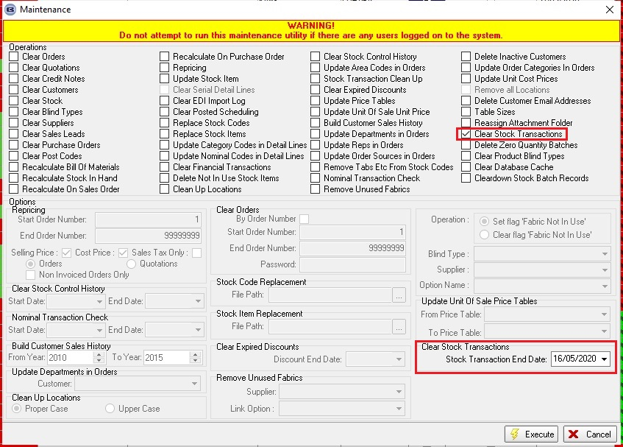

10298. Order Amend Enquiry > Fabric Summary

The header section of this report has been replaced with the header section of 'Quotation - Bespoke 73' except it says 'Fabric Summary' instead of 'Quotation'.

10299. Order Amend Enquiry > Email Fabric Summary

There is a new button (with a Button Visibility permission) called ‘Email Fabric Summary’ on the ‘Order Amend Enquiry’ form.

10306. Bought In Purchase Orders Accrued

There is a new report in Reports > Financial Reports that shows bought in purchase orders that have been ordered and delivered but not yet invoiced, up to a specified date.

The report shows bought in PO detail lines, grouped by sales nominal code and then ordered by order number, and then totalled by sales nominal code. There is then a grand total at the bottom of the report.

Fields shown are order date, PO number, delivered date, supplier, value.

The specified date relates to the delivered date of the PO. All orders delivered but not invoiced up to the date entered are printed on the report.

