Blindata Release Note 10.0.0 

8 May 2020

Bug Fixes and Enhancements

The following bugs were recorded in www.support.blindata.co.uk and have been resolved.

10287. Carrier File Import
10284. PP-Viewing-Old-Orders
10292. Order Processing > Archive Enquiry > Print Invoice
10300. Order Processing > Orders > Window Blind Amend
10303. Order Processing > Orders > Window Blind Amend
10304. Order Processing > Orders > Window Blind Amend

New Work and Customer Requests
7237. Lead Time By Order Category

There is a new field in the ‘Order Category’ system table called ‘Lead Time’ which default to 0. If this is greater than 0, then it is used as the number to calculate the required date when an order is entered (required date = order date + lead time).

This is applied after all other lead times are applied.

7238. Blind Types > Cutting Option By Customer

There is a new field for ‘Customer’ in Blind Types > Cutting Option so specific cutting options can be held by customer.

When cutting sizes are calculated the customer is now taken into account.

7239. Orders / Quotations / Archive Enquiry

The new(ish) search in Sales Files > Customers > Company Name, is very useful.

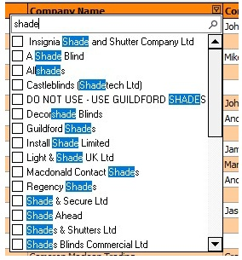

This has also been applied to the Quotations, Orders and Archive Enquiry forms.

7240. Import From Excel > Stock Update

There is now an import for the ‘Component Blind Type’ field in the stock record. This is also a field choice in ‘Fabric Group Setup’.

7243. Users > Button Visibility (2) > Option Price Enquiry

There are now choices for the ‘Add’, ‘Amend’, ‘Delete’ and ‘View’ buttons in the ‘Option Price Enquiry’ form.

10143. Order Processing > Orders > Notes

There is a new flag in the stock record (in the Characteristics tab) called 'Fill Note In Order' which defaults to false. If this is set to true, then update the 'Notes' field in the order.

10255. Order Amend Enquiry > Fabric Summary

The 'Works Order 2' flag in Blind Types > Option Setup is now used to determine whether an option is displayed in this report or not.

10256. Blind Details > Blind Types

There is a new flag in the blind type record called 'Enable Scanning By Sequence' which replaces the same parameter in the 'Parameters' form. It defaults to what is currently set in the Parameters form, and the flag in the Parameters form has been removed.

The 'Blind Process Scan' function has been changed to look at the blind type record for this parameter.

10297. Purchases > Suppliers

We added a new column in the csv file that is emailed to Eclipse (see 10152).

At the moment this is happening automatically, so we have added parameter for it. This is called 'Include Address Number in CSV File' and defaults to false.

This parameter is in the supplier record and only appears if 'Also Email CSV File' = true.

If the new parameter = false, the address number will not be added as a column in the file, if true it will be.

