Blindata Release Note 3.9.9 

14 April 2008

Bug Fixes and Enhancements

2261. Works Order Portrait Barcode

- The blind serial id is now printed.
- Vane length only prints for blind identifier = vertical or vanes only.
- No of vanes only prints for blind identifier = vertical or vanes only.
- No of brackets now prints.
- Chain length now prints.
- If the option is flagged as ‘Extra’, the entered text now prints after the option, in brackets.
- We have fitted 3 cutting sizes in vertically, beneath the options.

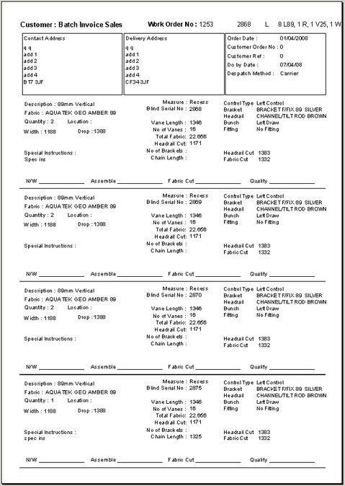

2262. Square Metre Pricing

If we have minimum width of 1800mm and minimum drop of 1800 and minimum square metreage of 2.4, if a blind is entered as 1200mm width and 1400mm drop, it is now calculated as 3.24 sq metres, because we need to use the minimum width and drops.

2263. Film Cutting Sheet / Hardware Sheet

The item number on these reports now relates to the blind number in the blind detail line. Both reports have been fixed.

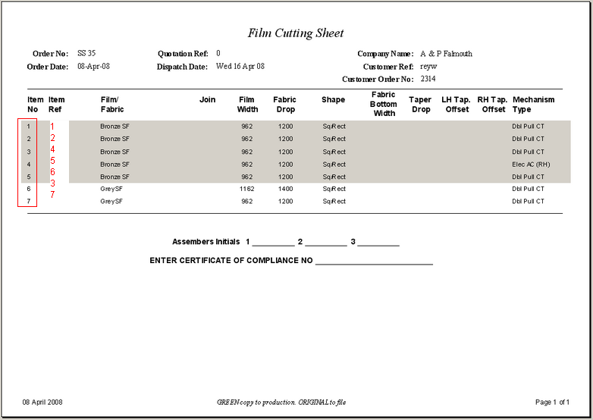

2264. Label Print – Bespoke 18

The line up has been adjusted.

2265. Box Assembly

Carriage lines no longer appear on this report.

2266. Packing List

Carriage lines no longer appear on this report.

2267. Order Processing > Orders

If a detail line had been entered for a blind type where ‘Cost Price Related’ = true and there was an uplift percentage entered, when the second line was entered, the uplift percentage was not copied from the first line. Fixed.

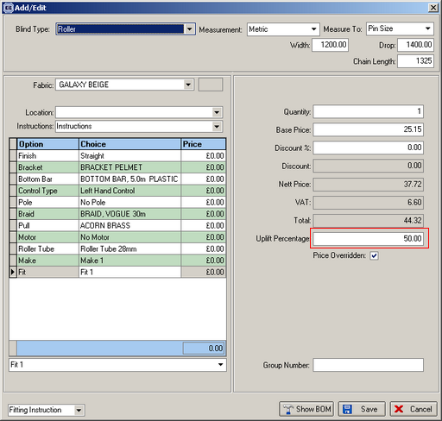

2268. Delivery Docket – Agent

- The delivery address is now the delivery address from the order.
- The address (invoice) does not print at all.
- The text at the bottom left now comes from the quotation text from Administration > Company Details, not the Invoice Text.
- The totals no longer print here. If you switch on ‘Hide Totals’ in report parameters, it removed the totals but also the text to the left – it no longer removes it.

2270. Purchase Order Enquiry > Display Order

If you cancel a detail line in a purchase order, it no longer prints on a purchase order report.

2271. Order Enquiry > Deliver

- The lookup now only shows despatch method records where ‘Fitting/Delivery Before Invoice’ = true.
- ‘Custumer’ is spelt ‘Customer’.
- ‘Dispatch’ is spelt ‘Despatch’.

2272. Order Processing > Orders

If ‘Enter Valance Size’ = true in the blind type, now it is not be possible to save a detail line without entering a Return. A message appears saying ‘Please choose a Return’.

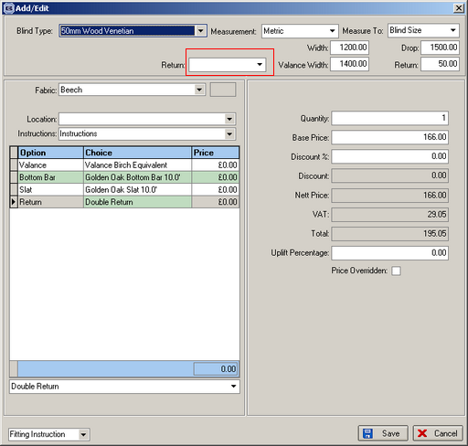

2273. Delivery Docket – Van Despatch Manifest

The delivery address now comes from the delivery address in the customer record. Also the company name is the customer company name.

New Work and Customer Requests

975. Despatch / Deliver Status Codes

We are now able to distinguish between a despatched order and a delivered order. A despatched order will be one that has left the factory, but a delivered one will be an order that the customer has received. We have customers that has their own vans to deliver blinds so this is why the this change was required, as they need to record what has been delivered. Some of the orders will be sent out by carrier and some by van. The orders that are sent out by carrier have the following status sequence: despatched, create invoice, print invoice. The ones that go by van will have the following status sequence: despatched, delivered, create invoice, print invoice.

All previous references in status codes in orders and order detail lines to ‘Delivered’ have been changed to ‘Despatched’. So for all other existing customers, the program logic will remain the same, the only difference being that the word ‘Deliver’ is replaced by ‘Despatch’.

We have created an extra order status but this only applies to certain orders, depending on the despatch method for the order. This can be enabled with a revised parameter in Administration > System Tables > Despatch Method called ‘Enable Deliver Status’.

The logic of this is very similar to the ‘Fitting Before Invoice’ functionality, which is what the parameter was called previously. It means that if this parameter is true, then an invoice cannot be created before the order has been ‘Delivered’.

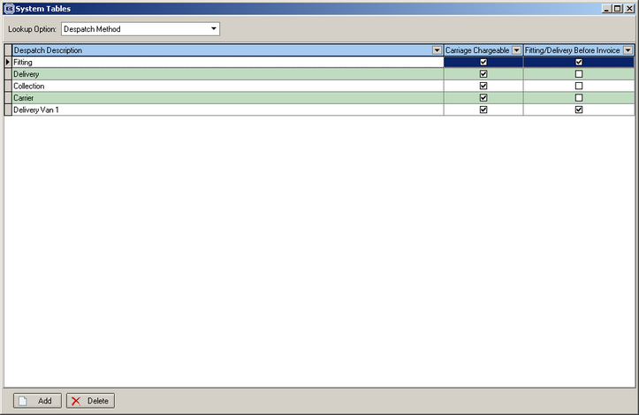

When the van driver returns with the manifest, the user then needs to tell the system which orders have been delivered. There is an existing button on the ‘Order Amend Enquiry’ form called ‘Fitting’. The description of this button has been changed to ‘Fitting/Delivered’ and is only enabled if ‘Fitting/Delivery Before Invoice’ = true.

We have changed the ‘Create Invoice’ functionality for individual orders and also in Financials > Create Invoices, so that invoices cannot be created for orders that have status = Despatched and ‘Fitting/Delivery Before Invoice’ = true, and have not been ‘Delivered’.

976. Despatch Manifest for Vans

A new despatch manifest by van (despatch method), has been created , grouped by customer, then by order. It is called ‘Delivery Docket – Van Despatch Manifest’. The despatch manifest will only print if the orders have a status of ‘Despatched’ and if ‘Fitting/Delivery Before Invoice’ is true for the despatch method held against the order. It shows customer, order number, bar code, then blind type, fabric description, width, drop.

977. Despatch / Deliver Form

In Order Enquiry, there is a new button called ‘Deliver’. When clicked, a new form will display, by despatch method and despatch date, showing a list of the orders that have been despatched and where ‘Fitting/Delivery Before Invoice’ = true. There is an option to scan a bar code on the despatch manifest (for goods that have not been delivered) and set the order status back to ‘Order Manufactured’. There is also be a button that allows the user to set all the other orders to ‘Delivered’.

983. Order Processing > Orders

We have introduced a new lookup field in the order detail entry if ‘Enter Valance Size’ = true in the blind type record. This looks up a new table called ‘Return Valance Size Add On’ which is held in System Tables. It holds blind type, ‘Return Description’ and ‘Return Add On Size’. ‘Return Description’ is a text field and ‘Return Add On Size’ is numeric.

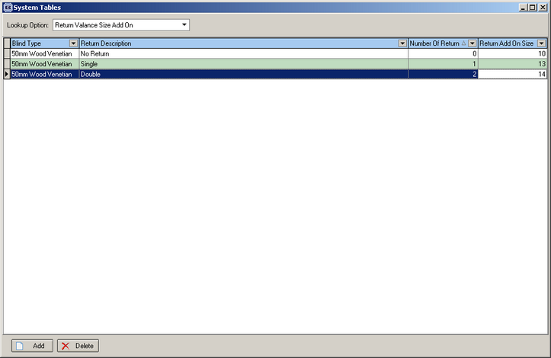

When the ‘Return’ description is chosen in the order detail entry, it adds the ‘Return Size Add On’ amount to the ‘Valance Width’. If the ‘Valance Width’ is manually entered, then it will override the calculated default value plus the return size add on.

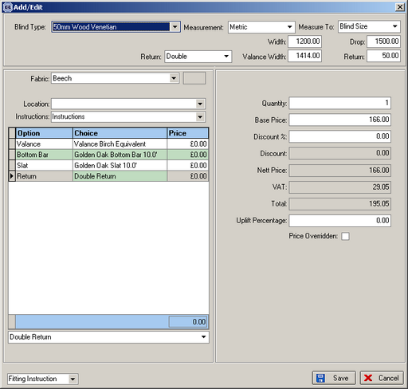

We also print this new field on ‘Works Order Label 1’. If no return, it prints 0, one return prints 1, 2 returns print 2. There is a ‘/’ between the return size and the number of returns.

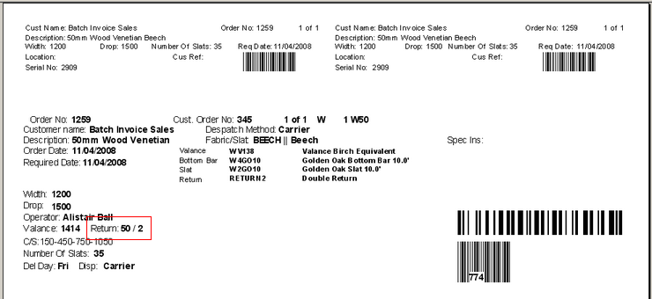

988. Order Processing > Orders

If ‘Print Batch Documentation’ = true in Report Parameters, the following form appears.

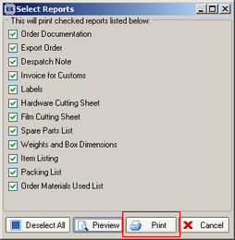

There is a new button here called ‘Print All’. This sends all the reports to the printer without previewing them. They go to the default printer.

1001. Diary Optimisation

We have speeded up the access to the diary, especially when there are a lot of records in the table.

