Blindata Release Note 3.9.6 

21 March 2008

Bug Fixes and Enhancements

2224. Pricing > Square Metre Pricing

The ‘Minimum Square Metre’ field now displays to 2 decimal places.

2225. Quotation Bespoke 16

The tel number was printing instead of the fax number. Fixed.

2226. Order Processing > Fitters Sheet / Sales Lead

When entering the diary, an error message appeared (only if Department Filter was switched on). Fixed.

New Work and Customer Requests

774. Order Processing > Orders

When works orders are printed, it is now also possible to do the label print run. This is useful if you are selecting different orders, and if both reports are run at the same time, you do not have to select the multiple orders again. We have created a new parameter in Administration > Parameters called ‘Print WO and Labels together’. This defaults to false. If true, the works order will print preview and then the labels will print preview.

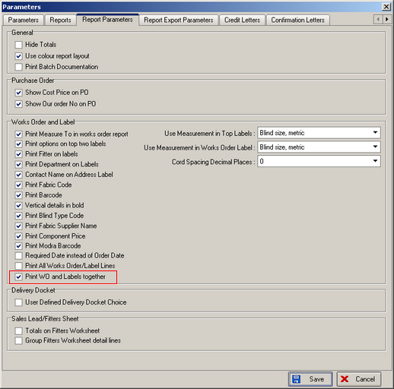

965. Order Processing > Orders > Receipts

We now show the total amount and the balance of an order on the receipt form. The balance is updated after a receipt is entered.

968. Administration > Import From Excel

We are now able to import records to the Box Blinds table. This can be done in Administration > Import from Excel. The option is called ‘Box Blinds’ and imports a spreadsheet with the following fields: blind type code, fabric code, width, drop, stock code, weight. It is possible import the file with or without the weight field included. Here is an example:

S25, NATURAL, 1000, 1200, W1-NAT100120, 1.5.

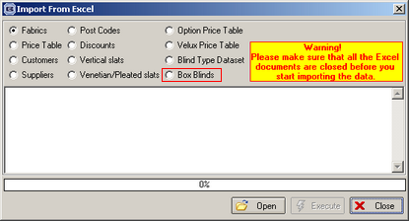

970. Order Processing > Orders > Receipts

There is a new advanced permission for posting receipts to Sage. This is called ‘Post Receipt’ and is in the Order section in Advanced Permissions.

