Blindata Release Note 3.9.5 

17 March 2008

Bug Fixes and Enhancements

2214. Works Order – Bespoke 15

The ‘Branch/Dept’ field now shows the department description.

2215. Create EDI Transaction

When an EDI file is being created, and if ‘Use Department Delivery Address’ is switched on, the delivery address is now taken from the department record and not from the sales order. (Previously, if ‘Direct Delivery by Supplier’ was switched on the delivery goes directly to the end user).

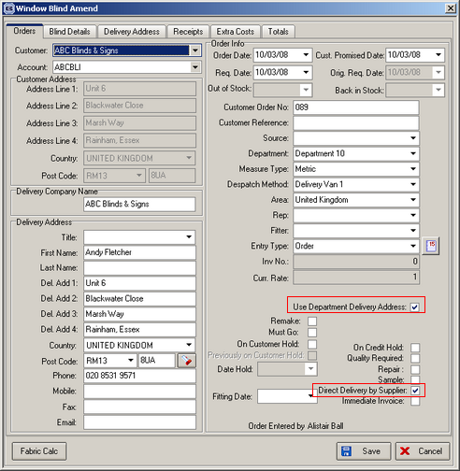

2216. Stock Setup > Purchase Order Enquiry

It is now possible to enter a nominal code in ‘Cost Nominal’. This looks up the nominal codes in System Tables and looks for all nominal codes that have all other fields set to false.

2217. Order Processing > Credit Notes

If ‘Use Department Credit Note No’ is ticked in Administration > Parameters, the Next Credit Note No is now taken from the department table.

2218. Order Processing > Fitters Sheet / Sales Lead > Add Sales Lead

The employee lookup field was being displayed on top of the buttons at the bottom of the form. Fixed.

2219. Invoice – Sage Laser Print

The invoice text was being cut off after 4 lines. It is now possible to print 6 lines of text.

2220. System Reports > Quotation Contact Management

Quotations no longer appear on this report if they have been deleted.

2222. System Reports > Last Quotation Contact Report

Quotations no longer appear on this report if they have been deleted.

2223. Works Order - Label 1

If blind identifier = Wood, ‘Return’ is now printed on the label.

New Work and Customer Requests

829. Employee by Department

We now have the facility to filter employee by department when viewing the Fitters Sheet / Sales Lead diary.

When the diary is viewed (ie Administration > Parameters > Use Department Filter = true), the user is only able to see the employees by relevant department.

To achieve this, we now hold the department against the sales lead record. The department is a mandatory field in sales lead entry when ‘Use Department Filter’ is true. When adding a record, the department defaults to the first one set up against the operator.

Also the user only see sales leads that relate to the departments set up for that user.

It is possible for an employee to belong to more than one department. The departments can be set up against employees in Administration > Parameters.

895. Order Processing > Quotations > Convert to Order

The ‘Convert to Order’ routine now checks that the detail lines have been converted, and displays how many detail lines are now in the order. It also checks that the bill of materials has been created for each order detail line.

931. Fitters Sheet / Sales Lead

We now have the company name appearing on the sales leads mouse over popup as well the persons last name and address. When a fitting appointment is made, it is also possible to see the job reference field in the pop up.

953. Pricing > Square Metre Pricing

We now hold a minimum square metre amount against the square metre pricing records (as well as minimum width and minimum drop). If a blind is less than the minimum square metre amount, it is priced at the minimum square metre amount multiplied by the price.

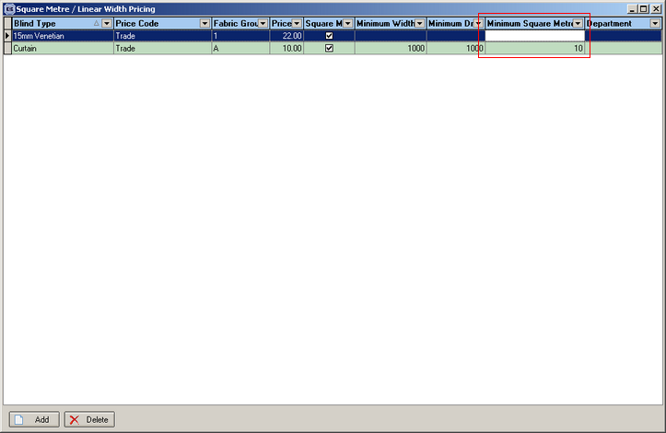

There is also an option to switch off minimum size pricing by customer. There is a new flag in the customer record called ‘Disable Minimum Size Pricing’. It defaults to false. If set to true, the minimum width, minimum drop and minimum square metre sizes in the square metre pricing record will be ignored and the blind will be priced at it’s actual square metre size.

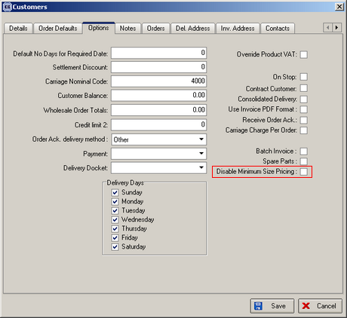

957. Fitters Sheet / Diary > Fitter Sheet / Sales Lead Enquiry

We have added ‘Telephone Number’, ‘Order Source’, ‘Company Type’ and ‘Department’ to the column choices.

958. ZPERWEEK

We used to have "ZPERWEEK" table on the old system. We have now created a similar table in the new system. The following fields are in the table:

Order Date (Date/Time)
Period No (Text 3 char)
Week No (Text 5 char)

960. Order Processing > Orders > All Contact Reports

The problem analysis reports are now also choices on this form.

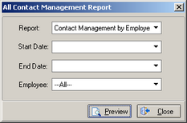

971. Stock Setup > Purchase Order Enquiry

The ‘Include Fabric’ flag is now applied to each detail line in the purchase order, and not to the overall order.

