Blindata Release Note 3.9.4 

7 March 2008

Bug Fixes and Enhancements

2203. Reports > System Reports > Stock Usage Report

The wrong report was being brought up. It was bringing up the ‘Promised v Required Date’ report instead. Fixed.

2207. Order Acknowledgement - Laser Print

If the number of details lines went onto a second page, the page number overwrote the balance field. Fixed.

2208. Order Processing > Quotations

If a quotation is entered that has detail lines with blind types = cost price related, when the user copies the quotation and then changes the customer, the prices are now be kept in the detail lines. The following message appears:

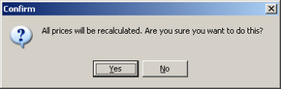

The prices are no longer recalculated for detail lines where blind type cost price related = true. The reason for this is that the user wants to enter one quotation (which may have 50 detail lines on it, price the blinds by the cost price related method, enter an uplift percentage, then save it. They will then copy the quotation and change the customer. They want to keep the same prices for the copied quotation.

2209. Reports > Quotation Contact Management

If a quotation status = ‘Ordered’ or ‘Don’t Follow Up’ = true, a record for the quotation no longer appears in this report.

The company name also appears on this report after quote no and before contact date.

2210. Reports > Next Quotation Contact

If a quotation status = ‘Ordered’ or ‘Don’t Follow Up’ = true, a record for the quotation no longer appears in this report.

Also, the contact name is now the contact name from the quotation, not from the customer record.

2211. Reports > Outstanding Quotation Contact

If ‘Don’t Follow Up’ = true, a record for the quotation no longer appears in this report.

2212. Reports > Last Quotation Contact Report

If a quotation status = ‘Ordered’ or ‘Don’t Follow Up’ = true, a record for the quotation no longer appears in this report.

2213. Order Processing > Quotations

It is now possible to enter a group number when entering a ‘Component’ detail line.

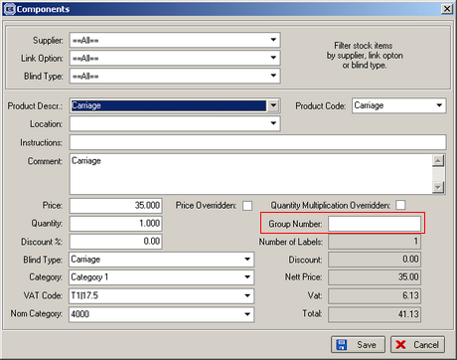

New Work and Customer Requests

