Blindata Release Note 3.9.1 

25 February 2008

Bug Fixes and Enhancements

2189. Label Print – 200 x 24mm(Partly)

- This part of the label was not being printed because of the margins on the printer. Fixed.
- Cust ref is now on top right of label. The Work No (order no) has been moved down to the right of the blind type description.
- Free type from Blind Type > Blind Type Setup prints here for a vertical blind. Cord spacing appears if it is a Venetian or pleated blind.

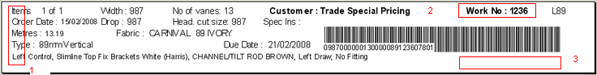

The bar code also needs to be tested for this label. It is not being read by the Techno TS2000 machine.

2190. Order Processing > Orders > Fabric Calc

The quantity is now calculated as the ((drop + drop add on)/1000) * (roll width/1000) * quantity * multiplier = 1.8 * 2.5 * 2 * 0.5 = 4.5 square metres.

2191. Quotation – Bespoke 21

- If a customer receives a discount of any type a line now prints saying ‘Relevant discounts have been applied’. It does not be print if there are no discounts set up for a customer.
- If the quotation is a Proforma, then the text ‘Payment must be made before goods can be dispatched’ is printed.
- If the quotation is a proforma, the title now prints ‘PROFORMA INVOICE’ instead of quotation.

2192. Label Print – Bespoke 18

The CHECKED BY and DATE have been moved to the left by 5mm as it wasgoing over the edge of the label by 2mm. There is now a space between the option names and the options.

2193. Order Processing > Orders > Fabric Calc

The price in the detail line is now updated regardless of whether ‘Price Overridden’ = true or false. This only applies to changes that are made when ‘Cost price related’ = true in the blind type.

New Work and Customer Requests

780. Square Metre Pricing

We have adjusted the way ‘Square Metre Pricing’ is working. Previously, the ‘Square Metre Pricing’ flag is held against the blind type. But, in some cases, square metre pricing may only relate to certain customers. There is additional functionality required because we can also have linear width pricing for some customers.

Therefore we have made the following changes.

- The ‘Square Metre Pricing’ flag has bee removed from the Blind Types form.
- We have changed the ‘Square Metre Pricing’ menu option in Pricing to ‘Square Metre / Linear Width Pricing’.
- We created a new field in the square metre pricing table to indicate whether pricing is square metre or linear width metre price.
- We now show the minimum width and drop fields for sq metre pricing in the square metre pricing table.
- We have added the department to the square metre pricing form.
- We have altered the order detail entry so it can look up prices for square metre and linear metre by price table and blind type, fabric group and department. If there is a record in the ‘Square Metre Pricing’ table, then the square metre / linear price should be used, otherwise the standard price table is looked at. The pricing functionality looks at the minimum sizes and works out the price the same way as it does at the moment.

858. Roller Fabric Calculation

We have introduced new fabric calculators called ‘User Defined Width’, ‘User Defined Drop’ and ‘User Defined Turnable’. This is required for a client because of the way they wish to calculate roller fabric usage. They want to be able to specify themselves how the fabric is to be cut from the roll. If the calculator for the fabric is ‘User defined’, then the roll width will be displayed, the user will be prompted to choose either ‘Width’ or ‘Drop’ and to enter a multiplier. The multiplier is required because we need to decide how many blinds can be cut from the roll width and also we need to take into account the quantity of blinds being entered in the detail line.

Once the detail lines have been entered for roller blinds where ‘Cost Price related’ = true, and fabric calculators are set to ‘User Defined’, the user can click a new button on the bottom left of the orders form.
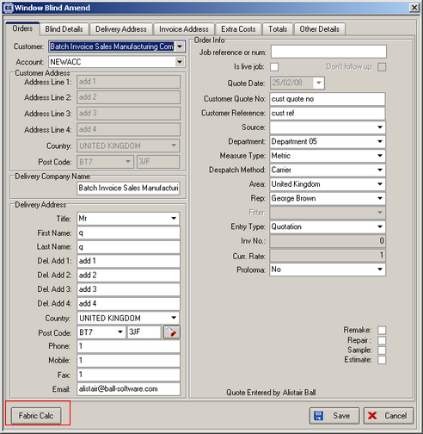

When ‘Fabric Calc’ is clicked, the following form is displayed:

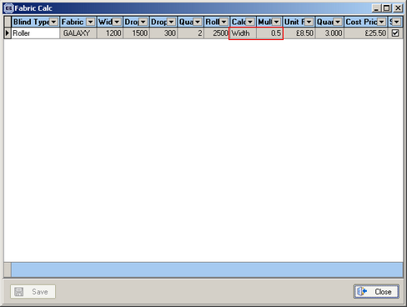

In here it is possible to amend the calculator and the multiplier. The calculator can either be ‘Width’ or ‘Drop’. The multiplier relates to the number of cuts you can get from the roll width. If you can only get one, then the multiplier is 1. If you can get 2, then the multiplier is 0.5. If you could get 4 blinds from the roll width, the multiplier would be 0.25.

The system can take into account whether a fabric is priced by square metre or by linear metre. This needs to be set up in the fabric record, along with the correct calculators.

Example 1: a fabric is 2600mm wide.

Blind 1: width = 1200, drop = 1400 ( + 300 for tube wrapround). This needs 1200 x 1700, so the user should enter ‘Width’ and a multiplier of 1 (the default) . This means the amount of fabric usage will be 1.2m. But if a second blind was the same size (and the quantity was entered as 2), it would not be the most efficient. We could actually cut this fabric from the same part of the roll, like this. This means only 1.7m of fabric is required instead of the 2.4m that the system calculates. In this case the user should enter ‘Drop’ and a multiplier of 1. The fabric usage will then be 1.7m.

Example 2: width = 1200, drop = 2800 ( + 300 for tube). This needs 1200 x 3100, so the system calculates 3.1m. This is not the most efficient way to calculate this, as more than half the fabric is being treated as waste. The user would therefore enter ‘Drop’ and a multiplier of 0.5. The quantity used would be 1.65m and the cost would be halved.

Example 3: 4 blinds are required, width 1200, drop 1400. The user would choose ‘Drop’ and a multiplier of 2, as this is the best way to use the fabric. The usage would therefore be 2.8m.

887. Maxton Accounts

We have a client who links to an accounting system called ‘Maxton’. Therefore we have created a new parameter in ‘Sage Parameters / Invoicing’ called ‘Use Maxton Accounts’. If this is ticked, then Sage will not be used and when an invoice is posted to Sage (individually), the Maxton functionality will be called.

Also, if ‘Use Maxton Accounts’ = true, the ‘Add to Maxton’ and ‘Update to Maxton’ will be enabled in the customer enquiry form.

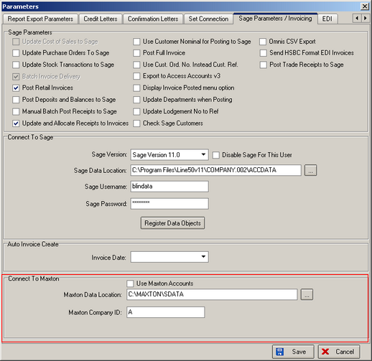

937. Reports > Sales Analysis

It is now possible to choose whether to display the customer name or the account code on the ‘Sales Analysis by Customer by Month’ report.

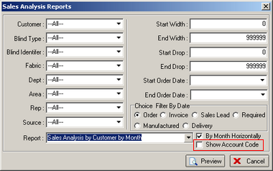

949. Label Print – Bespoke 18

For inverted blinds underneath the text on the bottom 2 labels (of the 4) it prints in bold lettering INSTALL INVERTED. You must switch on the ‘Inverted’ flag in stock items for the relevant options.

We can print stock items on the labels that are specific to a customer who asks for those items regularly. These are set in spare parts.

950. Hardware Cutting Sheet

For a Litetite blind the bottom rail is different to all the others so we now print the letters BO displayed next to the bottom rail cutting size.

