Blindata Release Note 3.9.0 

15 February 2008

Bug Fixes and Enhancements

2181. Blind Details > Blind Types

When you duplicate a record, the blind weights now get duplicated as well.

2182. Order Processing > Order Enquiry

The following message appeared when you used the ‘Blind Out of Stock’ scan button. This message no longer appears.

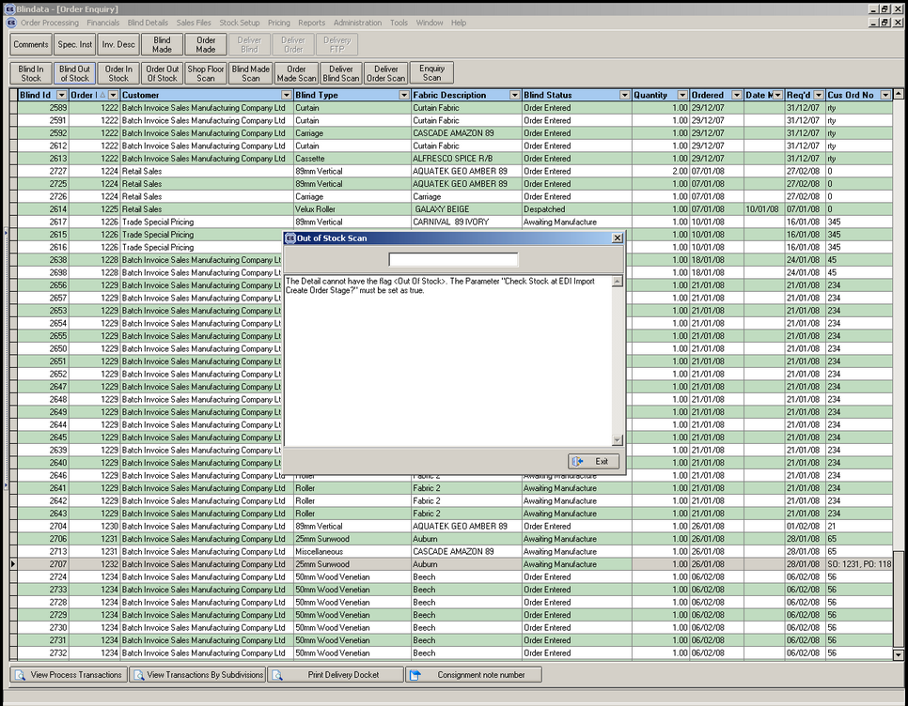

2183. Order Processing > Orders

When you selected a ‘vanes only’ blind type and entered the number of vanes, it stores them, but once you selected or changed the fabric, the number of vanes reset to 0. Also, if you opened and re-saved the blind, the no of vanes also reset to 0. Fixed.

2184. Works Order Label 1

The Fabric Cut amount on the works order label for a ‘vanes only’ blind now calculates the same way as it does for a vertical blind.

2185. Works Order Label 1

The Return amount no longer prints if box blinds = false.

2186. Hardware Cutting Sheet

The ‘Sill’ cutting size calculation is now appearing on the report.

2187. Label Print – Bespoke 18

‘SUPP’ has been replaced by ‘SUPPORT NAME’. The figures on the top RH label now print to 1 decimal point

2188. Weights and Box Dimensions

‘Support Type’ now says ‘Support Name’ so the support name option can print here.

New Work and Customer Requests

911. Order Processing > Orders

When entering detail lines, the second line options default to those in the first detail line (if the blind types are the same). There is now an option to keep the original defaults for the second and subsequent detail lines appear initially in the first detail line, before any changes are made.

To facilitate this we have created a new parameter in Administration > Parameters called ‘Use Original Detail Line Defaults’ which defaults to false.

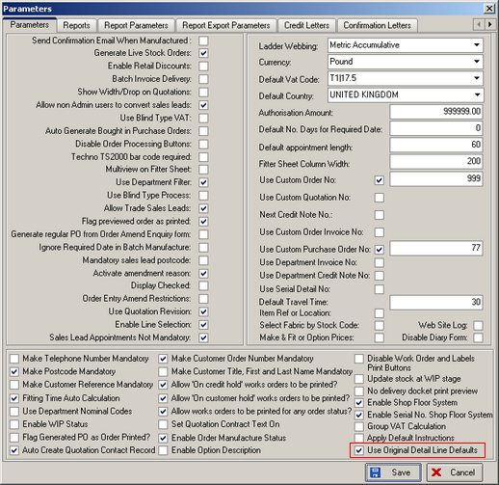

940. Order Processing > Orders > Special Pricing

Previously the special pricing worked if the special price found was lower than the normal price. It now works if the special price found is higher as well.

However we have also created a new parameter in Customers called ‘Select Only Lower Special Pricing’. This defaults to false, and is looked at when special pricing is being applied.

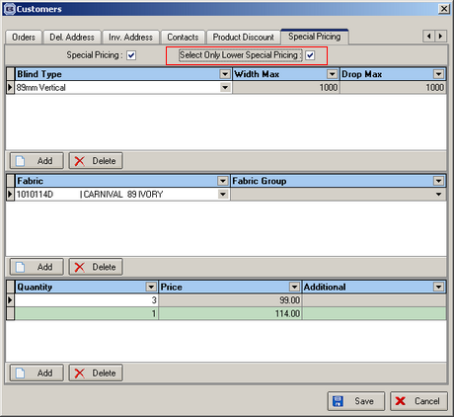

942. Invoice For Payment / Customs

We can now define what appears in the footer according to what the report is called. Therefore there is an extra text field in ‘Invoice By Area’ to hold the following:

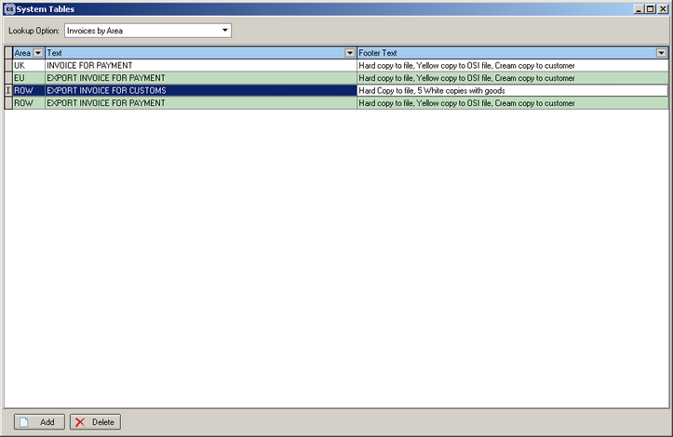

This text replaces the hard coded footer text in the report. Also on the report we have:

Reduced footer size slightly
Reduce header slightly
Made a consistent left and right hand margin.

943. Packing List

We have removed the additional items quantity column completely.

944. Acknowledgement – Lead Time Text

If there is an Auto Code detail line, the auto stock code now appears on the detail line, in the same place as Velux Code would appear.

945. Delivery Docket (A4 Pre-Printed)

The stock auto code now appears on this delivery docket.

