Blindata Release Note 3.8.5 

11 January 2007

Bug Fixes and Enhancements

2112. Quotation – Laser Print

- Registered company name and address now appear at the bottom of the page as follows: Registered Office, Registered Office address, Company Reg No: Reg No’. If these fields are empty, then ‘Company Reg No’ does not appear.
- If ‘Use Department Filter’ = true, then the address details come from the department record.
- If ‘Use Department Filter’ = true and ‘Also Delivery Address’ = true in the department record, then the address details come from the department record.
- The first detail line on the second page showed 0 for discount. Fixed.

2113. Quotation – Laser Print (Email version)

- Registered company name and address now appear at the bottom of the page as follows: Registered Office, Registered Office address, Company Reg No: Reg No’. If these fields are empty, then ‘Company Reg No’ does not appear.
- If ‘Use Department Filter’ = true, then the address details come from the department record.
- If ‘Use Department Filter’ = true and ‘Also Delivery Address’ = true in the department record, then the address details come from the department record.
- The first detail line on the second page showed 0 for discount. Fixed.

2114. Acknowledgement – Laser Print (Email Version)

- ‘Disc %’ does not appear if there is no discount.
- Registered company name and address now appear as follows: Registered Office, Registered Office address, Company Reg No: Reg No’. If these fields are empty, then ‘Company Reg No’ does not appear
- The order acknowledgement number now appears properly on the email subject.

2115. Works Order – Bespoke 15

The slat metreage totals were still not adding up properly in the bottom left hand corner. It is now a total for that fabric per page.

2116. Bought In Purchase Order (Email)

The number on the form header did not match the purchase order number – fixed.

2117. Purchase Order Enquiry > Display PO > Email

If you tried to email a purchase order for a regular PO, it did not work. Fixed. It is sent as a pdf.

2118. Reports > Financial Reports > Deposits by Nominal

This report was taking the nominal code from the blind type record when it should have been looking at the nominal code in the detail line. Fixed.

2119. PDF Invoice

When you create and send a pdf invoice, the number on the attachment name for the pdf file was incorrect. Fixed.

2120. Order Processing > Quotations > Text Entry

- The ‘Lookup Option’ drop down is now in alphabetical order.
- The ‘Lookup Option’ dropdown box is much wider.
- Moved group number up to the ‘Lookup Type’ line.

2121. Hardware Cutting Sheet

- All items are now sorted by ‘Roll Tube’ size. There is a change in the shading behind the different cassette sizes but it only changes once the cassette size changes.
- Removed the company name from the title so it just leaves ‘Hardware Cutting Sheet’.

2122. Film Cutting Sheet

- There is a change in the shading behind the different film colours but it only changes once the film colour changes.
- Removed company name in heading.

2123. Export Order

- We now display the carriage text from the order (it was already in the invoice).

2124. Spare Parts Report

The Spare Parts report was listing all of the additional items as well. The additional items are now only displayed on the Packing List

2125. Delivery Docket – Laser Print

- The Velux Code now prints if blind identifier = Velux.
- The fabric description was not printing properly. Fixed.

2126. Reports > Outstanding Balances

If customer ‘Trade Type’ = Retail, the invoice date appeared on reports as 30/12/1899. Fixed.

2127. Works Order – Bespoke 5

If blind identifier = Headrail only, the quantity of vanes and rail cut size now appears on top 2 smaller labels of the label, similar to a blind identifier = Vertical.

2128. Quotation – Laser Print (Email)

The text at the bottom was overlapping onto the totals. Fixed.

2129. Stock Setup > Stock Items > Default Option Tab

If this form was open, it was still causing record locks and timeouts in the order entry program. Fixed.

2130. Order Processing > Orders

If you entered a wood box blind that has the valance field activated, the valance size did not calculate properly if Recess size was entered. For example, the difference between recess and blind size is 12mm, but the valance width calculation was done using the recess size. It is now based on the blind size. (Valance Width = Exact Blind Width + Val Size Add On).

2131. Works Order – Label 1

If blind type box blind = true and ‘Enter Valance size’ = true, the valance size now prints on the works order label. Previously it only worked if blind identifier = wood and box blind = false.

2132. Order Processing > Orders

If the second detail line in an order was for a blind type with ‘Enter Valance Size’ = true, the valance size was only calculated if the width was entered. It now defaults to the exact width + Val Add on size.

2133. Blind Details > Blind Types

If you tried to delete a blind type record that had no related records, it did not delete. Fixed.

New Work and Customer Requests

860. Works Order - Portrait

We now have the customer phone number printed on the works order.

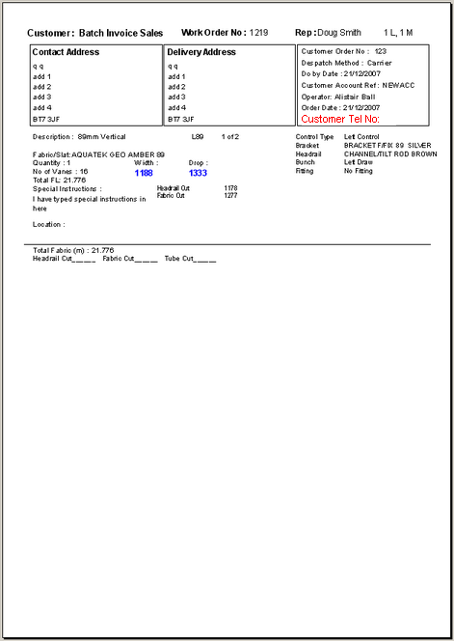

875. PDF Quotation Print Parameter

We have a new report parameter for pdf quotation layouts, based on ‘Quotation – Laser Print (Letterhead)’. This is the same as the existing quotation but has the logo in the top left.

878. PDF Order Ack Print Parameter

We have a new report parameter for pdf order acknowledgement layouts, based on ‘Acknowledgement – Laser Print (Letterhead Logo)’.

884. Reports > Sales Analysis

There is a new report called ‘Sales Analysis by Current Rep by All Customers’. This looks exactly like ‘Sales Analysis by Rep by Customer’ except that the records are grouped by the rep that is currently held against the customer and not by the rep that is held in the order record. It also show a customer even if there are no sales for that customer between the dates entered.

885. Works Order – Bespoke 22

This is a new works order report and is called ‘Works order – Bespoke 22’. It prints onto preprinted paper.

886. Label – Bespoke 22

This is a new label layout and uses the same label paper as ‘Works Order Label Blind Size’, but it is a label print (because the customer also prints out works orders (see dev 885)). The label print is called ‘Label – Bespoke 22’.

896. Works Order – Label 1

The return size now print on this report if ‘Enter Valance Size’ = true in the blind type record.

