Blindata Release Note 3.8.3 

31 December 2007

Bug Fixes and Enhancements

2093. Reports > Sales Analysis > All Sales Analysis Reports

The fields have been lined up properly when the report is exported to Excel

2094. Delivery Docket – Bespoke 17b

We have moved all text up by 15mm and all text left by 10mm, with the exception of the delivery address. This has been moved up 15mm but only moved 5mm to the left.

2095. Export Order / Invoice For Customs (Payment)

The carriage text now comes from the carriage text that is entered in the order (see bottom of Order Totals tab), not from the area record.

2096. Packing List

If you had 14 detail lines on an order, the entire footer moved to the next page. Fixed.

2097. Spare Parts List

This is now showing the correct company name at the top of the report.

2098. Label Print – Bespoke 18

We have moved this text slightly to the left so it is lined up with the t in Item.

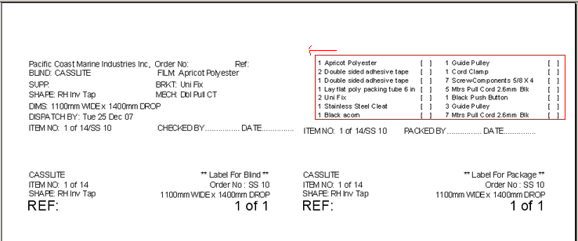

2099. Order Processing > Order Enquiry

If you clicked ‘Order In Stock’ and scanned a blind, Blindata changed the order header status from WIP to Order Printed, but the detail lines remained at WIP and didn’t change. The detail line status also now changes back to ‘Order Printed’.

2100. Film Cutting Sheet

We have tested this with each of the following blind shape options. All cutting rules are now being properly applied.

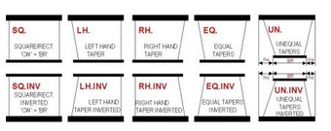

2101. Order Processing > Orders (Customer Specific)

There is an issue with entering a blind and then changing the size. Here is an example.

If you enter a cassette blind with width 1300 and drop 1500, it selects tube diam 25 and cassette size 45. If you change the width to 3000, it should then select a cassette size of 64 and a tube size of 38. If you then change the width back to 1300, it reselects the correct cassette size of 45, but leaves the tube diam as 38. It should change it to 25.

The following setup is required to get this to work.

After the user changes width, drop, fabric or option when entering detail order detail – a function is called and this changes the options according to rules specified on Blind Type > Link Options using the following algorithm:

A cycle moves through all ‘Link Option Name’ elements but sorting is performed by 'Sequence' field. In other words, Inverted (sequence = 1) will be processed first and then Support Name (sequence = 2), Tube Diam (sequence = 3) and Join – the last. (Inverted, Support Name and Join are options that have been selected).

The application searches for the first allowable condition that corresponds to data in order detail, in particular three options (Choice 1, Choice 2, Choice 3), range of allowable sizes (Width >=, Width <=, Drop >=, Drop <=) and Fabric Weight Group. Again, priority depends on Sequence field. For example if order detail meets all three conditions with Sequence field value 2, 7 and 9 then the condition that has field value Sequence = 2 will be taken into consideration.

In fact we need to specify list of allowed options here that will be displayed on Order Detail Edit form.

2102. Quotation – Bespoke 21

This report has been tidied up and detail lines now print.

2103. Order Processing > Quotations > Convert to Order

When you convert a quotation to an order, the option prices were being rounded to the nearest integer. They are now converted as they were in the quotation.

2104. Works Order A4 Individual

- There is more room to the right for the customer company name and the ‘Cust Ord No’ has been moved down a line and left slightly.
- The location has been moved up and right so it is level with the blind description.
- The cutting options have replaced the hardcoded calculations and have been moved up to where ‘Location’ was.

New Work and Customer Requests

724. Quotation Text Entry

We have altered the way in which quotation text is entered into quotations and also the way the text is stored.

The form now looks like this. It is possible to make text bold, italics, underlined and justified with the quotation text field itself.

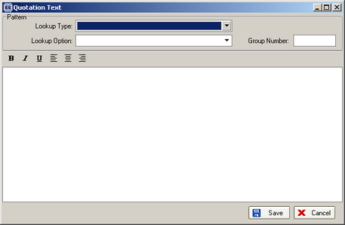

830. Complaints

We no longer need the complaints form, because the same information can be stored in ‘Contact Management’. The following has been done.

- ‘Blind Type’ is now a field in the contact management record but is not mandatory.
- The ‘Complaints’ option has been taken off the ‘Order Processing’ menu.
- The reports in the Complaints form have been moved to Reports > System Reports.

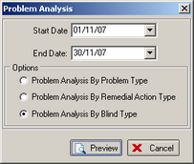

853. Blind Details > Blind Types

Quite often a customer will sell a blind that is not set up on the system. This is almost always a blind that they are buying from another manufacturer (ie bought in). We are now able to enter a blind type that is not set up and also a fabric. We already have an option for adding free type to an option, and it is now possible to do this for both blind types and fabrics.

It is then possible to print a purchase order for this blind type and fabric using the existing bought in purchase orders.

There is a new parameter in the blind type record called ‘Free Type Entry’. If this is set to true, then the user is able to manually enter the blind type description and also the fabric description. The default is false. We can also store these blind type and fabric free type descriptions so they can be used again.

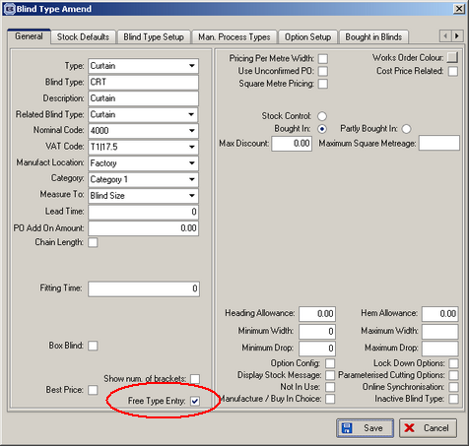

We have made adjustments to the window blind detail entry form to allow for a ‘Free Entry Type’. The simplest thing would be to adjust the form so the fields were entered as follows.

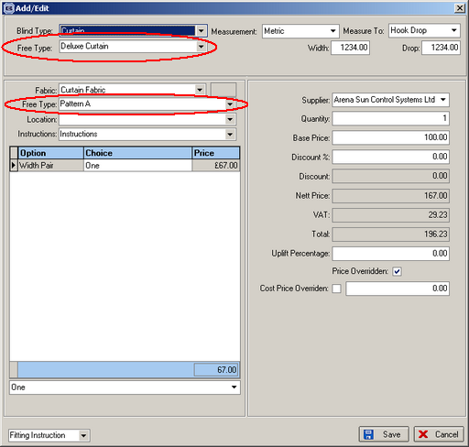

859. Order Processing > Quotations > Detail Line Enquiry

The column heading ‘Options’ can be changed to ‘Make & Fit’. This is done by setting a new parameter in Administration > Parameters called ‘Make & fit or Option Prices’ to true.

