Blindata Release Note 3.8.2 

14 December 2007

Bug Fixes and Enhancements

2071. Order Processing > Orders

We have made a major change to the link options in Blind Detail > Blind Types to take into account a refreshing issue with sizes and options in the order entry form. The link option form now looks like this.

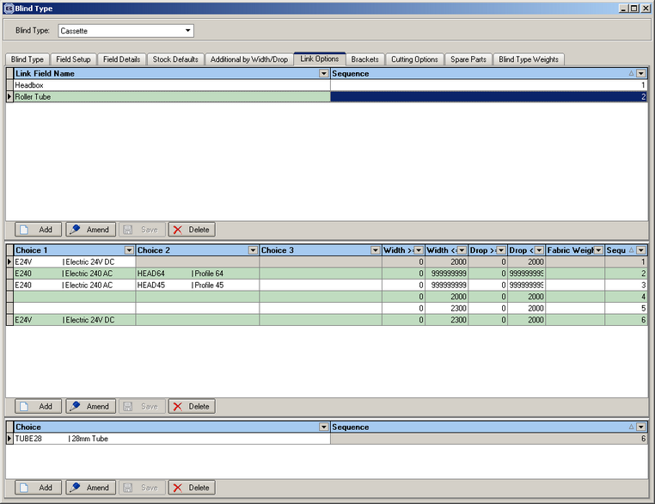

2085. Delivery Docket – Bespoke 17a

The layout of the delivery docket has been adjusted.

- The headers have been removed as they are already pre-printed on the paper.
- Line up has been adjusted for all fields.

2086. Order Processing > Orders

When you added new order and added a detail line, when entering a second detail line an error occurred if the Blind Type had the option “Cost Price Related” flag ticked. Fixed.

2088. Delivery Docket – Bespoke 17b

Some details have been removed as they are already pre-printed on the delivery docket.

2089. Quotation – Bespoke 16

1. The contact name now appears above the address. It concatenates Title, First Name and Last Name.
2. We now have a hardcoded line to say

‘Dear [Title] [Last Name],

Many thanks for your recent enquiry. As requested we have pleasure in submitting our quotation as follows.’

3. The postcode now appears on the company details at the bottom of the page.
4. The logo has been made larger.

2090. Order Processing > Quotation > Square Metre Calculation

The fabric cost with scrap is now being stored in the BOM when the fabric is being chosen from a dummy fabric and square metre pricing is being used.

2091. Order Processing > Quotations

If you change an option price manually which affects the cost price (and the blind is set as cost price related), the base price is now refreshed immediately. Previously it was only refreshed once you leave the option sub form.

2092. Order Processing > EDI Enquiry > Import Data

When importing an EDI file, the following characters do not get imported. They are now stripped out of the EDI import file and then recreated in the order.

&
‘
“
<
>

New Work and Customer Requests

488. Order Processing > Order Amend Enquiry

We have parameterized the fields that can be displayed on this form. The individual user is able to choose which fields they want to see. This can be done by selecting the relevant fields from ‘Columns’ in the context menu (accessed by right clicking on the form), and then selecting the ‘Save Configuration’ option on this menu.

To return to the default configuration, you can select that on the same menu.

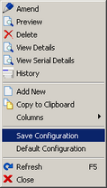

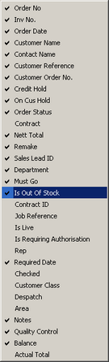

489. Order Processing > Order Enquiry

It is now possible for the user to select which fields appear on this form. The functionality is exactly the same as in the ‘Order Amend Enquiry’ form.

490. Deleting Records

We have stopped users from deleting records that have relationships with other records.

843. Order Processing > Orders

Balance and actual total can now appear on Order Amend Enquiry form.

852. All Reports > Export to Spreadsheet

We now have an option to export all reports to Excel spreadsheets. When print previewing a report, there is an option to save the report.

Once this is chosen, the user then has the choice of saving the report in an Excel format.

