Blindata Release Note 3.7.9 

27 November 2007

Bug Fixes and Enhancements

2022. Works Order - Label Blind Size

The fabric descriptions on the two top labels were getting cut off because the Order Date was too far to the left.

We have changed ‘Description’ to say ‘Desc’, ‘Order Date’ to say ‘Ord. Date’ and made the order date format dd/mm/yy instead of dd/mm/yyyy. This will then make more space for the fabric description.

2034. Works Order – Bespoke 15

- ‘process’ now says ‘Process’.
- The totals in the bottom left box are now the relevant total for that fabric.

2036. Order Processing > Orders

If you entered a vertical blind in a detail line, then entered another vertical blind, but only changed the fabric and then saved it, the number of vanes was not picked up and so the fabric calculation in the bill of materials was not correct. Fixed.

2037. Order Processing > Orders

A message was appearing, even though the required date was not prior to the current date, to say that it was. Fixed.

2038. Order Processing > Orders

If a blind type = vanes only and ‘Calc width from vanes’ = false, when entering an order the first detail line found the price (from the Vanes price Table), but the next detail line entered (also for a vanes only blind) did not find a price. Fixed.

2039. Order Processing > Orders

If you entered a wood blind in imperial, the valance and return entries did not work (because the program thought they were the metric size). Fixed.

2040. Quotation – Bespoke 16

- Logo from Administration > Company Details > General now appears at top centre.
- ‘Quotation Text’ from Administration > Company Details > Parameterised Details prints before details.
- If ‘Hide Detail Line Totals’ is ticked, sub totals no longer appear. The ‘Print Quotation Totals’ should not relate to this sub total.
- This sub total no longer appears if the detail lines in the group are ‘quotation text’.
- The overall total only appears if ‘Print Quotation Totals’ is true. It does not go on the next page if there is room on the current page.
- At the foot of each page the following fields from Administration > Company Details are printed in 8 pitch: company name, address line 1-4, telephone, fax number

2041. Order Processing > Quotations

If the blind type record is set to ‘Cost price Related’ = true, the detail entry options no longer picks up prices for options that are not set to price code = Cost.

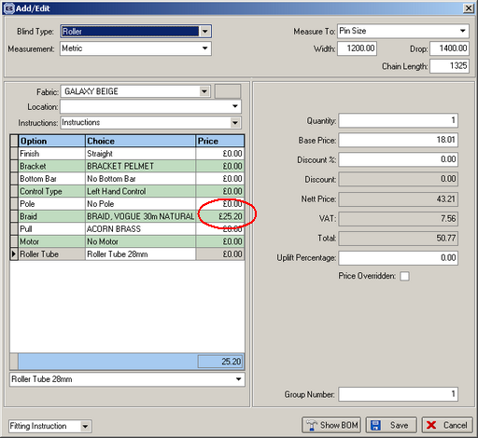

2044. Quotations

An error occurred if you try to amend a revised quotation. Fixed.

2045. Works Order Two Labels

The order of the labels was sometimes incorrect. Fixed.

2046. Blind Details > Blind Types

If you deleted a blind type and you want to ‘delete and reassign the children to’, it did not reassign the fabric records. Fixed.

2047. Order Processing > Orders > Preview

In the Order Amend Enquiry form, if you filtered orders by Department, selected an order, then clicked Preview (displayed Order Acknowledgement), and then clicked close an error appeared. Fixed.

New Work and Customer Requests

727. Blind Types > Blind Details > Link Options

We have improved the link option functionality. If a choice is not selected and a link field is chosen, the user can enter a choice, then width and drop minimums and maximums. It is now possible to choose ‘Fabric Weight Group’ here as well. If the ‘Fabric Weight Group’ is left blank, then the functionality will operate as it does at present.

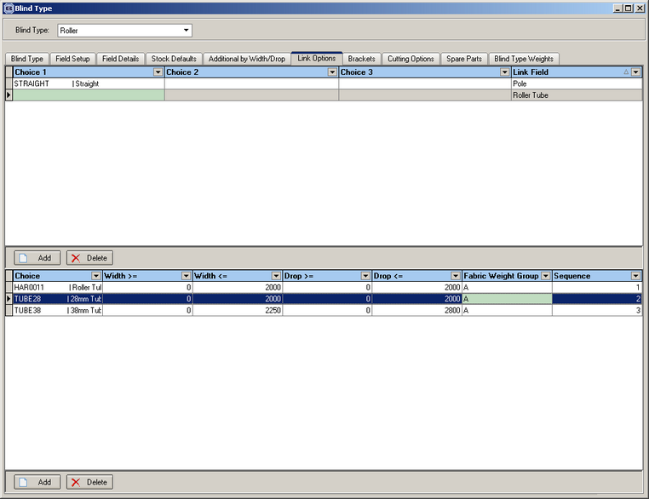

823. Delivery / Fitting Address

It is now possible to hold separate delivery addresses and fitting addresses for orders. If a company has multi location offices, but the blinds are only manufactured at one location, blinds ordered from the other location will have to be delivered to that location first and then fitted elsewhere.

At the moment we only hold one delivery address against an order, which acts as the delivery and fitting address. This is fine for the majority of customers so we do not want to alter the status quo.

We are now able to assign a delivery address dependent on department. There is a new flag against the department called ‘Also Delivery Address’, indicating that we can use the existing address in the department record as the delivery address.

We also have a field in the order entry form called ‘Use Department Delivery Address’, which will default to the setting in ‘Also Delivery Address’ in the department record. This is required because there may be orders that have to be delivered directly to the site address.

When the delivery docket is printed, the system now checks to see if ‘Use Department Delivery Address’ is set to true in the department record. This means that only the delivery docket address is affected. All other reports still have the site (fitting) address.

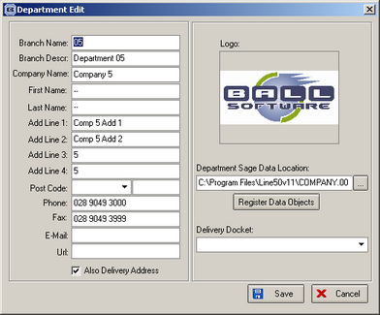

825. Pricing > Discounts

We now display the ‘Discount Start Date’ and ‘Discount End Date’ on this form.

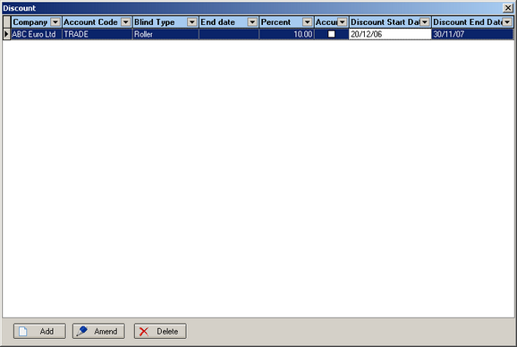

826. Quotation / Order Processing Defaults

We now have defaults for ‘Contract’, ‘Hide Detail Line Totals’, ‘Print Quotation Total’, ‘Exclude From Retail Balances’, ‘Hide Detail Line Discount’ and ‘Display Text Details Only’ in Administration > Parameters. The quotation and order forms will then use these defaults when a quotation or order is created.

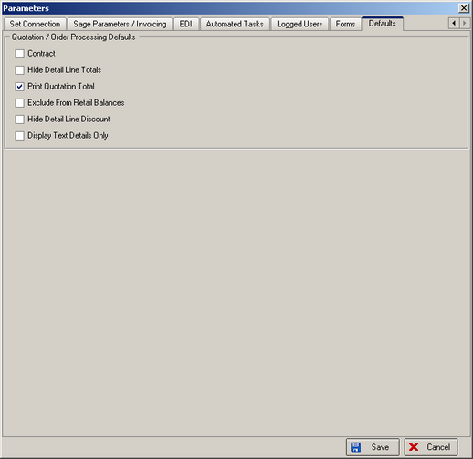

831. Returns

We now have an option to enter the return size in a wood blind that has a valance. The diagram below is an aerial view of a blind. The valance hides the headrail, and the returns are the two small bits of wood that go between the valance and the wall. A blind may have no returns or one or two returns, if it is close to another wall.

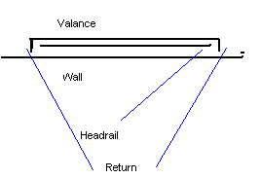

When ‘Enter Valance Size’ is true in the blind type record, we are now able to do the following:

- Hold a ‘Default Return Size’ against the blind type record (available 30/11/07).
- Display the ‘Return’ amount in the order detail entry form (set to the default).
- Calculate the length of wood required for the valance as the (valance + one or two returns).
- Have a method of determining whether an option is for one return or two in the option entry (using the ‘Valance Calc’ function in ‘Option Calculations (available 30/11/07)

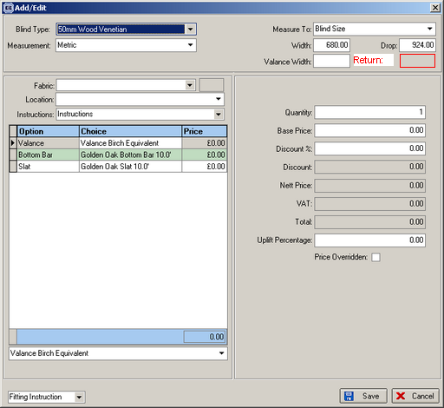

834. Order Processing > Quotations

We have changed ‘Print Unconfirmed PO’ button to say’ Request for Quotation’.

