Blindata Release Note 3.7.6 

5 November 2007

Bug Fixes and Enhancements

1994. Order Processing > Quotations > Create Order

Sometimes when an order is created from a quotation, not all the detail lines go into the order because of a timeout message. We have made some adjustments to the order entry program that should resolve this..

1995. Delivery Docket Print

Sometimes the report printers get mixed up and the delivery docket tries to print to the label size layout. To stop this happening, we have separated out the two reports. The following form appears if both the delivery docket and delivery labels are set to print.

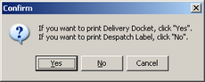

1996. Order Processing > Orders

Timeout errors have been occurring when the order entry program is left open. We have made some adjustments to this.

1997. Order Processing > Order Enquiry

If you had two blinds on an order and changed one of them to ‘Blind Manufactured’, the manufactured date is set to the current date. Let us say this blind was made on 26/10/07. If you then flag the order as ‘Fully Manufactured’ using the ‘Order Made’ button today, both the blinds have their manufacturing date changed to 31/10/07. It now only sets the manufactured date for the blind that has not yet been manufactured.

1998. Label Print – 4 x 1 ½

Brackets now printing on labels for Venetians

We now print number of vanes for vanes only

We have tidied up order no and ‘1 of 20’ text on top right.

1999. Acknowledgement – Laser Print (Letterhead Logo)

- If ‘Hide Detail Line Discount’ = true in Order, then ‘Unit Price’ and ‘Discount %’ does not print.
- For blind identifier = vanes only, ‘Number of Vanes’ now prints where width is.
- The general spacing on detail lines is more uniform
- We are now able to fit 6 detail lines onto page.
- Company details are now at the bottom of the page.

2000. Administration > Company Details

Parameterised text was being cut off in the field – fixed.

2001. Reps/Fitters Schedule (General Report)

We have rearranged the address fields on the report.

2002. Quotation Email

- When sending email, the quote number was wrong on subject. Fixed.
- We have excluded html text in the body of the email.

2003. Stock Setup > Stock Items

Timeout errors were occurring when users were making changes to stock records, in particular whilst in the ‘Default Options Tab’. Fixed.

New Work and Customer Requests

791. Quick Search

There is a new button on the ‘Order Amend Enquiry’ form called ‘Quick Search’. In here you can enter a surname, and then a search will be done through all sales leads, quotations, sales orders (including archive) and records that match the surname will be displayed, showing number, record type (sales lead, quotation, order) and status. The search is NOT case sensitive.

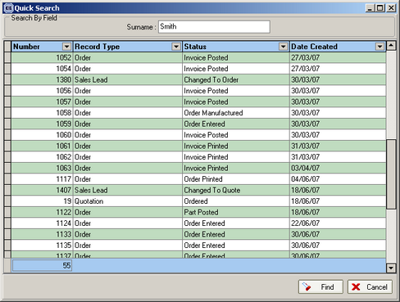

793. Parameterised Fitters Worksheet

There is a new report in the parameter for Fitters Worksheet.

This is based on the existing ‘Fitters Worksheet’ and is called ‘Standard Fitters Worksheet’.

797. Balances Report

There is a new report that has the same criteria as the ‘Balances by Nominal’ report, except that it only prints order lines. It appears in Reports > Financial Reports.

It shows ‘Order No’, ‘Order Contact Name’, ‘Order Date’, ‘Nett’, ‘VAT’, ‘Balance’’.

809. Order Processing > Quotations

If a quotation is flagged as an estimate, it isno longer possible to convert the quotation to an order. A message appears saying ‘This quotation has been flagged as an estimate. It should be changed to a quotation before it can be converted’.

819. Weights Multiplier

We have added two fields at the end of the technical data sheet, called ‘Blind Fitted Weight’ and ‘Boxed Weight for Carriage’. The ‘Blind Fitted Weight’ is the total weight of the blinds in the quotation. The ‘Boxed Weight for Carriage’ is the total weight of the blinds in the quotation multiplied by a multiplier figure from a new table called ‘Weights Multiplier’. This is held in Administration > System Tables and contains two fields, Quantity (of blinds) and Multiplier. As an example, if there are 7 blinds on the quotation (weighing 15.6 kg in total), the multiplier will be 1.58, therefore the ‘Boxed Weight for Carriage’ will be 15.6 * 1.58 = 24.648 kg.

820. Order Processing > Orders

There is now an option for ‘Hide Detail Line Discount’ on order entry totals tab (it had already been done for quotations).

