Blindata Release Note 3.7.5 

26 October 2007

Bug Fixes and Enhancements

1986. Financials > Post Invoices To Sage

In version 3.7.4, if you tried to run the “Print Audit Trail” option you got an error. Fixed.

1987. Works Order – Bespoke 15

If blind identifier = headrail, the number of vanes are now printed.

1988. Order Processing > Orders

The arrows on the right now always display, regardless of screen resolution.

1989. Order Processing > Orders

In the example in the screenshot there is a roller blind with width 1500 and drop 1600. The ‘Dimension Calculations’ are set up so 250mm is added to the drop. Therefore the amount of fabric required is 1500mm x 1850mm.

If this is cut from a fabric with roll width of 1600mm, then it will require 1850mm to be cut. This means the usage, including scrap, will be 1.85m * 1.6m = 2.96 sq metres.

If this is cut from a fabric with roll width of 2000mm, then it will only require 1500mm to be cut, because the fabric has a calculator of ‘Width or Drop’. This means the usage, including scrap, will be 1.5m * 2.0m = 3 sq metres.

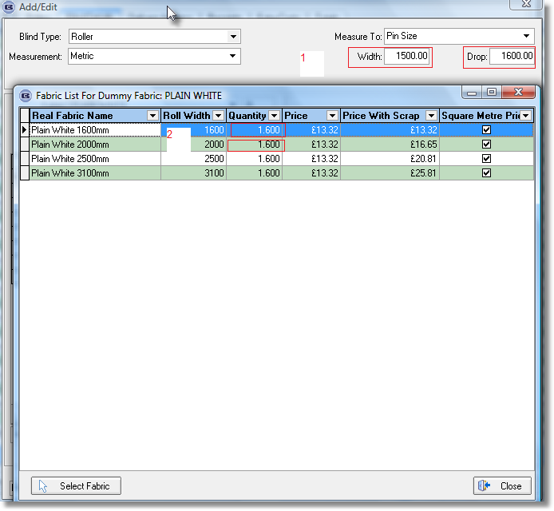

1990. Financials > Post Credits to Sage

The credit note number is now updated to Sage. Previously it was updating ‘Credit No’. The column ‘Credit No’ is no longer displayed on the ‘Credit Note Amend Enquiry’ form because it was confusing.

1991. Quotation – Bespoke 21

We have made a number of minor adjustments to this report.

1992. Works Order – Bespoke 21

We have made a number of minor adjustments to this report.

1993. Credit – Laser Print

If you entered a component line in a credit note, it did not print out properly on the report. It now wraps round and allows for 4 lines of text to be printed.

New Work and Customer Requests

649. Order Processing > Orders

If a remake is entered, there is now a method of tying the remake order back to the original order. We now hold the original order number against this order in the Totals tab. This is only displayed if ‘Remake’ or ‘Repair’ is true, and it is not mandatory. There is a lookup to choose the order number from all previous orders for that customer.

795. Invoice – Laser Print (Letterhead Logo)

This report is now available in Report Parameters > Batched Invoice lookup.

796. Sales Analysis by Category

We have split the category sales column into 3 separate columns, headed ‘Sales Value’, ‘Credit Value’ and ‘Net Value’. The sales value no longer contains credit notes, the credit value only contains credit notes and the net value is the existing sales value (ie orders/invoices minus credit notes). We also have quantity columns for sales and credits. We no longer print the cost and profit column.

804. Order Processing > Orders > Post Trade Receipts

There is now a facility to post trade receipts to Sage.

There is a new parameter in Administration > Parameters > Sage Parameters / Invoicing called ‘Post Trade Receipts to Sage’. If this is set to true, then it should be possible to post receipts to Sage for customers with trade type = Trade.

When a receipt is posted for a trade customer, the balance in the totals tab is also updated.

If the parameter is set to post an invoice for a trade customer the same rules will apply as apply to retail customers. The invoice will not change to posted until the balance is 0. If the invoice is posted and a receipt has been posted but the balance is > 0, then the status should be ‘Part Posted’.

The trade receipts get printed out in the receipts reports.

805. Order Processing > Archive Enquiry

We can now look for invoice and delivery address in archive find.

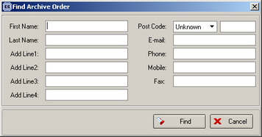

806. Pricing > Option Price Enquiry

There is now a button to print out a report showing option prices, by blind type. The report prints out prices only for the blind type the record pointer is pointed at. The report has a similar layout to the price table report, except more than one price table prints per page.

808. Order Processing > Orders > Receipt Entry

When we are entering a receipt, we need to enter the VAT code as well. When the receipt is updated to Sage, we need to make sure that the correct VAT code is updated to Sage. The VAT code will determine how the VAT amount is calculated in the receipt.

Also, the receipt date should also default to today’s date.

814. Order Processing > Orders > Guarantee Text

In order entry, the standard guarantee text now defaults to the first choice.

815. Fitting Status

There is a new function to stop the creation of invoices from orders until the blinds for the order have been fitted. However this may only apply to some of the orders. Therefore we have made the following changes.

- In the table ‘Despatch Method’, there is a new field called ‘Fitting Before Invoice’. This defaults to false.
- There is a new field in the Orders table called ‘Fitted’ (true/false).
- There is a new button on the ‘Order Amend Enquiry’ form called ‘Fitting’. This will only be enabled for orders where the order status ‘Delivered’ and the order has a despatch method where ‘Fitting Before Invoice’ = true.
- If the ‘Fitting’ button is clicked, a message appears saying ‘Have the blinds for this order been fitted?’. If yes, then the ‘Fitted’ field should be set to true. A record is also written into the Order History file to say it has been fitted.
- In ‘Create Invoices, we now to check the despatch method field to see if ‘Fitting Before Invoice’ = true. If so, the invoice should only be created for these orders if ‘Fitted’ = true in the relevant orders.

816. Label Print – 4 x 1 Datamax

We have fitted in one parameterised cutting size on this label. It should go here:

