Blindata Release Note 3.7.1 

28 September 2007

Bug Fixes and Enhancements

1926. Order Processing > EDI Enquiry > Receiving Data

It is now possible to import a record with a ‘Customer Order No’ that is an alphanumeric value. This was not possible previously.

1935. Order Processing > Orders > Print Batch Documentation

This now says ‘Deselect All’, not ‘Unselect All’.

1937. Export Order

On the invoice paperwork where it advises what type of blinds are included in the order it was listing each individual blind separately. This has been fixed.

1939. Item Listing

- If bottom width = 0, we now do not print 0.
- Reduced size of titles slightly.

1945. Works Order – Bespoke 17

- The category code was being pulled from the blind type – it now comes from the fabric record.

1946. Invoice – Bespoke 17 (Batched Invoice)

- Rep now appears.
- We now print ‘Customer Order No’, not Order No.
- Totalling was being done only on the last page for batch invoice run – it is now done for each invoice.

1947. Invoice – Bespoke 17 (Regular Invoice)

A message came up saying ‘This is in development’. See 1746. Now fixed.

New Work and Customer Requests

711. Stock Setup > Purchase Order Enquiry > Display Order

We are now able to hold a goods received note number against a purchase order when the goods/blinds are delivered into stock.

715. Stock Setup > Stock Items

We can now hold alternative suppliers for stock items. These are held in a new tab in the stock items form called ‘Alternative Suppliers’. We can store supplier, part number and cost price.

743. Reports > System Reports > Customer by Rep

We are now able to select a rep for this report or choose all.

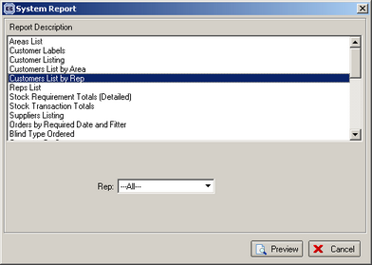

748. Order Processing > Orders

Rep and ‘Required Date’ can now be added in order amend enquiry form. If you right click on the form and then select ‘Columns’, you can add fields.

749. Acknowledgement – Bespoke 19

A new order acknowledgement report is required has been created.

751. Sales Lead / Fitters Sheet Individual

A new layout was required. It is called ‘Sales Lead – Bespoke 19’.

752. Order Processing > Orders > Component Detail Line Entry

It is now possible to enter the ‘Location’ in the component detail line entry, with the same functionality as is in the blind detail line entry.

754. Order Processing > Orders > Location

The Location label is called Item Reference on one customer system. We have a new parameter called ‘Replace Location with Item Reference’. If true, ‘Item Reference’ will display instead of ‘Location’.

755. Invoice – Bespoke 20

A new invoice layout has been created.

756. Acknowledgement – Bespoke 20

A new order acknowledgement report has been created.

757. Quotation – Bespoke 20

A new quotation report has been created.

758. Delivery Docket – Bespoke 20

A new delivery docket print has been created.

772. Administration > System Tables > Departments

We can now hold postcode, website, email address along with department address because these are needed to print on ‘Delivery Docket – Bespoke 17’ and ‘Invoice – Bespoke 17’.

775. Label Print – High Priority

A new label print has been created called ‘Label Print – 3 ½ x 1 – No Desc’.

