Blindata Release Note 3.7.2 

8 October 2007

Bug Fixes and Enhancements

1938. Order Processing > Orders > Print Batch Documentation

If you saved a record, then printed the documents ‘Hardware Cutting Sheet’, Film Cutting Sheet’ and ‘Item Listing’, then amended a detail line and printed the documents again, the documents did not change when you printed them again. You had to log out of Blindata and then back in again to get the changes to print. Fixed.

1940. Hardware Cutting Sheet

- There is now a line to separate detail lines from totals.
- There is now a line at bottom immediately above ‘DAFFODIL …’.
- Recess Fitting is now picked from option – there will be an option name called Recess Fitting (this is a separate thing from ‘Measure To’).
- ‘Fit cable support bracket…’ message now only appears if cable support selected in option Support.
- Inner Chann is a cutting size constant. There is a slight complication here – there are always two channels so we display as eg 2 x 1000.
- Outer Chann is also a cutting size – same principle as Inner Chann
- Bottom rail calculation – this is a deduction from the bottom width.
- Sill is a cutting size.
- Bead Chain is a cutting size.

1941. Film Cutting Sheet

- Fabric is now lined up with column title
- Mech Type is now called ‘Mechanism Type’ in the heading
- Square metreage now calculates to 2 dps
- Taper Drop is now a cutting size calculation.
- LH and RH Tape Offset: RH Offset = Blind width – LH Offset – Bottom Width.
- Bottom width – see hardware cutting sheet.
- On the film Cutting Sheet if there is NO JOIN can this be left blank and only print when there is a requirement for a JOIN. We can to set an item as ‘Non Print Item’ in Stock Items so it won’t print.

1942. Box Assembly Report

- Wrong company name was on header – is now Company Details name
- ‘Cass Size’ is now ‘Cassette Type’ to satisfy option selection
- The date on for the despatch date now displays with day eg 26 Sep 07 be Wed 26 Sep 07.
- ‘Mechanism’ is now called ‘Mechanism Type’ to satisfy option selection

1943. Labels

- Box shape now has brackets like this with a space in middle [ ].
- There is now more room for text for BOM records

1944. Packing List

- The wrong company name was being shown – it is now the company name from Administration > Company Details.

1949. Pricing > Price Table Enquiry > Price Table Print

We can now fit up to 30 widths on one page. Also, the logo appears in the correct proportions.

1950. Order Processing > Orders

If you enter a roller blind that has width and drop both greater than the roll width, it will bring up a warning message, and then let you proceed. The roller fabric calculation is correct, but it didn’t not calculate the roller tube width properly. It works if the blind size does not need a join. This has been fixed.

1951. Works Order – Label 1

The fabric cut is now (Man Drop – Headrail Depth). Previously it was (Man – Drop – Headrail Depth + Fold Over Size). The ‘Fabric Cut’ text has been renamed ‘Vane Length’.

1952. Order Processing > Orders > Status Fields

We have done an audit of what happens when the ‘Status Fields’ button is used. The following happened, described in second column. The third column describes what now happens.

Status Changed to Lines Changed to Should Change To
Works Order Printed Order Entered Awaiting Manufacture
Despatched Invoiced Delivered
Invoice Created Despatched Invoice Created

1954. Acknowledgement – Bespoke 13

- We have fitted in a couple more detail lines on the page.

1955. Quotation – Bespoke 13

- The quotation number has been moved to where ‘Reference’ was. Reference is no longer printed.
- The width and drop do not appear if the parameter ‘Show width/Drop on Quotation’s is false.

1956. Quotation – Laser Print (Letterhead)

- If the flag ‘Hide Detail Line Discount’ is set to true, the nett price and discount no longer appear on the first detail line of the second page.
- If the ‘Print Quotation Total’ flag is set to true, the totals now appear. We have standardised this, so the customer can choose want they want to do according to the settings in the ‘Totals’ tab.

1957. Email Invoice > Invoice – Laser Print (Letterhead)

- The logo is now in proportion.
- The totals have been moved nearer the bottom of the page (20mm from bottom) – this will then allow for more detail lines to be printed on a page.

New Work and Customer Requests

712. Order Processing > Quality Control

When an order is taken off ‘Quality Control’ (quality control is checked), a record is now stored in the order history. It holds operator, date/time and says ‘Quality Control checked’.

747. Order Processing > Fitters Sheet / Sales Leads

We have made some enhancements to the sales lead entry form.

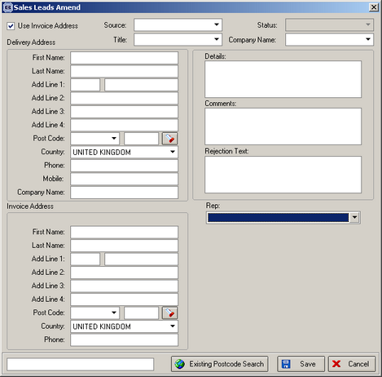

1. We have put another address into sales lead. Previously the address where the blinds are to be fitted is recorded – this is the delivery address. We now also record an invoice address. If you set ‘Use Invoice address’ on, an extra address will appear.

2. It is now possible to change sales lead to order without making an appointment. To do this we have added the rep into sales lead entry form. When the record is saved, it is now visible in the ‘Sales Lead Enquiry’ form. It is now possible to open a sales lead from the sales lead enquiry form. To enable this, we have created a new parameter in Administration > Parameters called ‘Sales Lead Appointments Not Mandatory’. If this is set to true, then the rep field will appear in the sales lead entry form, and the record will appear in the sales lead enquiry form if an appointment has not been made.

750. Invoice – Bespoke 19

A new invoice report has been created.

759. Order Processing > Orders

We have made a change to the way a second width is entered for a blind. For one customer, top width is always the wider width, and they define it as the width and have to enter the bottom width. But for shaped pleated blinds, bottom width (normal width) is always the wider. Therefore, previously, we could enter the top width and the width. The width is the normal width and the top width is the smaller width (left hand drawing). This can only be done if the blind identifier = pleated.

We have made the following change to meet their requirements. In the blind type, if blind identifier = roller, we have created a new field called ‘Enter Bottom Width’. This defaults to false. If it is true, then the detail line entry will ask for a ‘Bottom Width’ as well as a normal width. This is stored in the ‘Top Width’ field.

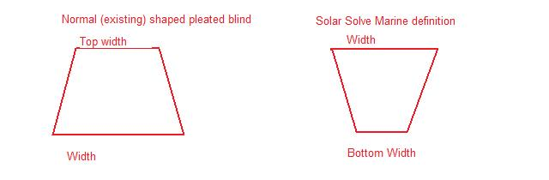

We are now able to do cutting calculations from the bottom width. In the ‘Cutting Options’ tab in the ‘Blind Types’ form, we have added an extra field called ‘Top/Bottom Width Add On Default’. If this has a value in it, the add on calculation will be done from the top/bottom width field.

We have also made sure that the stock calculation works properly for top/bottom width. At the moment there are calculators for ‘Bottom Width’ and ‘Top Width’. If the blind identifier = pleated blind, the calculation will be ‘Top Width’, and if the blind identifier = roller, the calculation will be ‘Bottom Width’.

Having made this change, we are now able to display the cutting sizes for ‘Bottom Width’ correctly in ‘Bottom Rail’ in the Hardware Cutting Sheet, for ‘Bottom Width’ in the ‘Film Cutting Sheet’ and for ‘Bottom Width’ in ‘Item Listing’.

762. Spare Parts / Packing List

Another new field has been created in the spare parts table. The Additional items field in spare parts table is used to define the items that appear in the additional items box for each blind type. These will then appear on the additional items on the packing list.

781. Order Processing > Orders

We are now able to select fabric by code instead of fabric description in the order detail line entry. There is a new parameter in Administration > Parameters called ‘Select Fabric by Stock Code’. The default for this is false. If true, the fabric description label in the order detail line entry will say ‘Fabric Code’ and the lookup will display the stock codes.

