Blindata Release Note 3.6.6 

24 August 2007

Bug Fixes and Enhancements

1895. Delivery Docket (A4 Preprinted)

There has been a misunderstanding between Decora and us about this layout. We thought this was to go on preprinted stationery but it is actually going to print on blank paper, so we need to have everything in the report.

Decora have requested that this be done in v3.6.4 as well, by Thursday night.

- Logo in Administration > Company Details
- Administration > Company Details
- Logo 2 (can we create a new field for another logo in Administration > Company Details)
- Logo 3 and Logo 4 (can we create a new field for another logo in Administration > Company Details)
- Administration > Company Details > Delivery Text

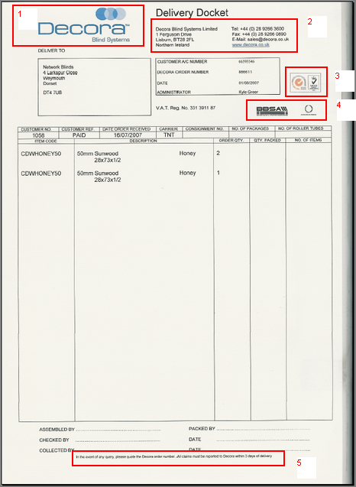

Vladimir

1896. Order Processing > EDI Enquiry > JL EDI Import

The circled field should go into the ‘delivery Company Name’ when the order is imported.

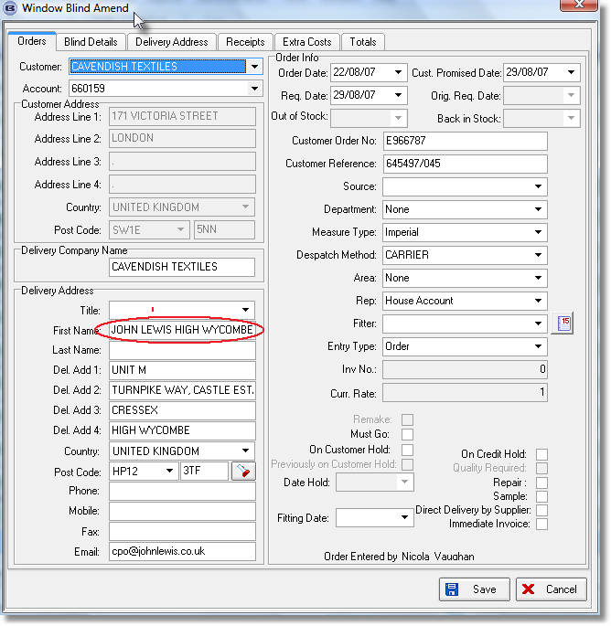

Valerij

1897. Label Print – 5 x 1 ½ CB

‘Delivery Address Line 4’ should be on the label print.

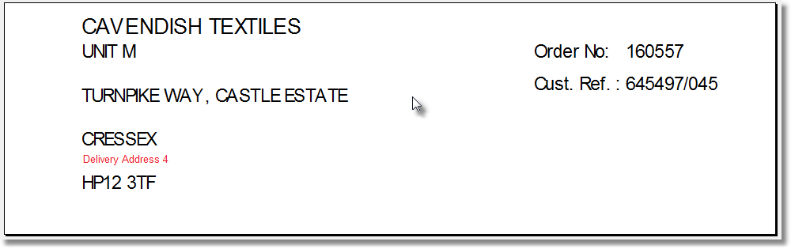

Vladimir

1898. Works Order – CB

This is showing the wrong address, but only for records that have been imported by the ‘JL EDI Import’.

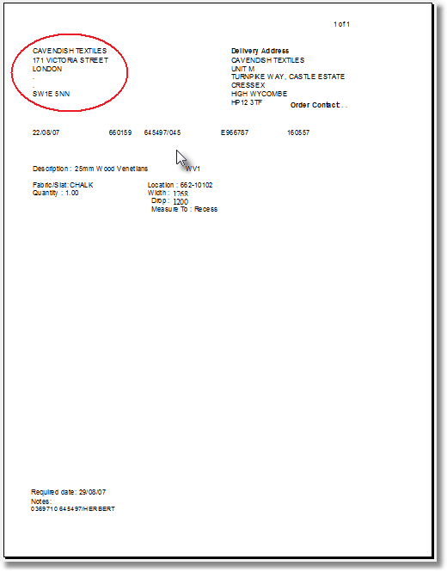
Valerij

1899. Works Order – CB

Works Order – CB

- The fabric description is being cut off.
- The order tel number should print here.
- Number of vanes should show on works order if blind identifier = vertical or blind identifier = Headrail. either.
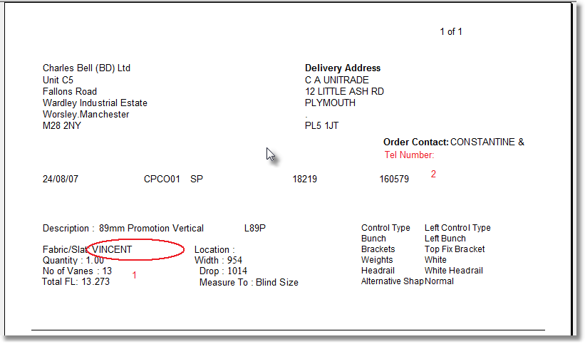

Vladimir

1900. Reports > System Reports > Customers On Stop

Customers on stop report should only show account code and company name and should be in alphabetical order by account code.

Valerij

1901. JL EDI Import

The JL EDI Import is importing the data in these two fields, ‘Customer Order No’ and ‘Customer Reference’ the wrong way round.

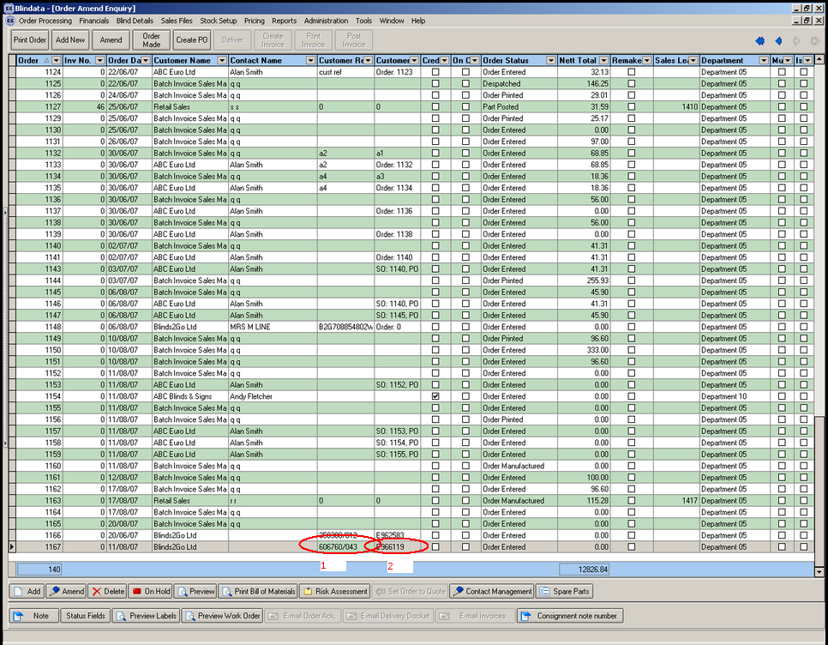
Valerij

New Work and Customer Requests

707. Quotation Print

We need to hold a sub group for quote detail lines. This will then be used in the quotation report to group detail lines and have sub totals for those detail lines. This means we need to have a field in the quote detail line so the user can enter the group number. If no group numbers are entered, then the quotation detail lines will not be sub grouped. This should be a numeric field. We also need choice of whether to print quote grand total or not on the quotation. This should be a field in the Totals tab called ‘Print Quotation Total’ and should default to true.

The new quotation print should be called ‘Quotation – Bespoke 16’ and should print onto A4 paper. I have included below a complicated quotation printed from the old system the customer was using.

- Hardcoded text
- Order Number
- Quotation invoice address
- Quotation Date
- Contact name (Title + Last Name)
- Quotation text
- Quotation text
- Quotation text
- Quotation text
- Quantity from detail line
- Nett price from detail line
- Sub total for first group
- Quotation text
- Quotation text
- Quotation text
- Quotation text
- Quotation text
- Quotation text
- Quotation text
- Nett total for quotation – this should only appear if ‘Print Quotation Total’ = true.
- Quotation text

We should also put the page numbers on the report in the style ‘Page 1 of 3’. This should go in the top middle.

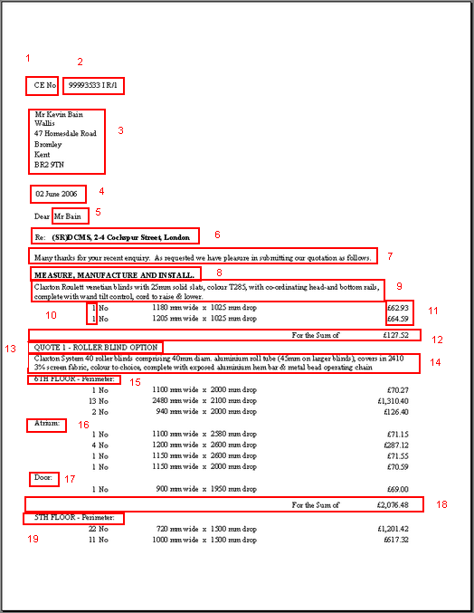

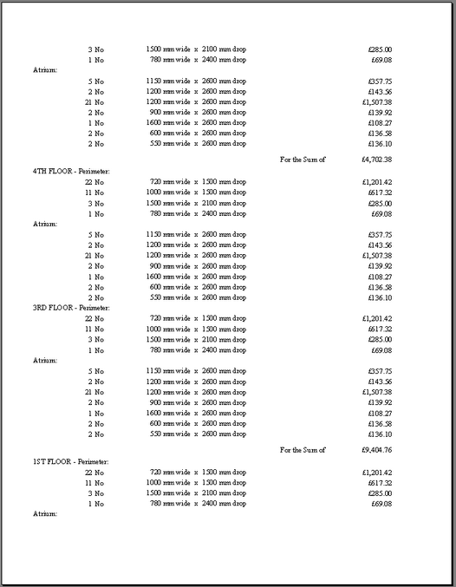

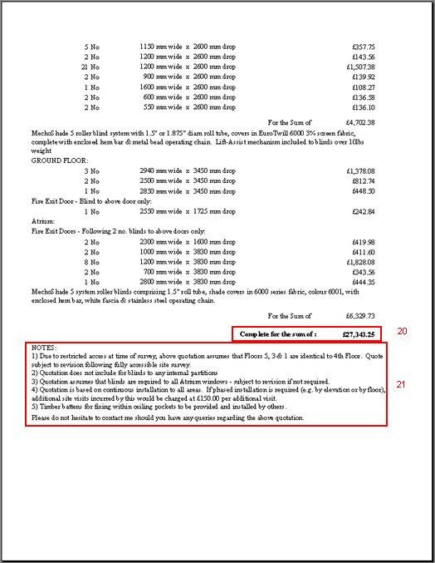

The nearest quotation we have to the one we want is ‘Quotation – Bespoke 10’ so I think this would be a good starting point. I have started to enter the quote, and have created ‘quotation text’ for 6, 7, 8, 9 and 13.

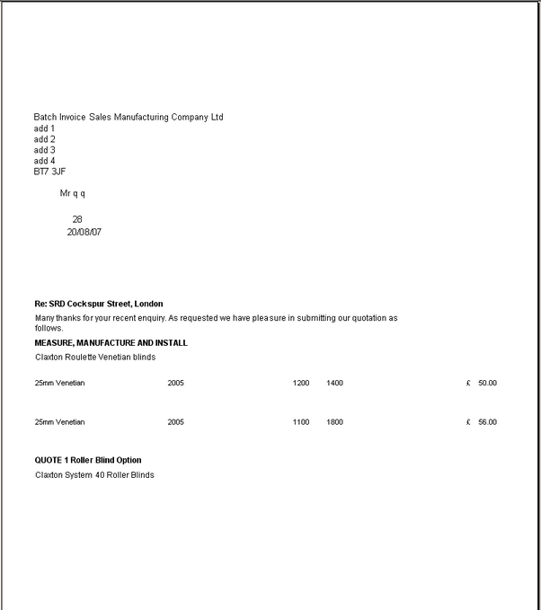

Valerij

709. Order Processing > Quotations

Add ‘Is Live’ to columns on quotation form

Valerij

710. Reports > System Reports

Contact management report – need to choose live and/or non live quotes

Valerij

