Blindata Release Note 3.6.5 

21 August 2007

Bug Fixes and Enhancements

1879. Administration > Backup

The backup now works with SQLExpress and/or Vista.

1884. Invoice – Laser Print 11 Detail Lines

All the option totals are now showing under the unit price.

1885. John Lewis EDI Import

There was a problem with importing the JL EDI file. There is no pattern regarding whether the blind type line comes before the fabric line or the other way round in the import file. Therefore we have hard coded a method of doing this that has no impact on the normal EDI import.

1886. Order Processing > Quotations

It is now possible to enter Job reference when you enter the quotation. Previously it could only be added after a quotation had been revised.

1887. Order Processing > Quotations

After printing a quotation using ‘Print Quote’, the record pointer went back to the first record in the form. It now stays at the same record. Also, after amending and saving a quotation, the record pointer now stays at the same record.

1888. Order Processing > Quotations

If ‘Use Quotation Revision’ is switched on, the following message appears after a quotation has been amended. If you answer ‘No’ to this, the amendment is not saved. The amendment should get saved, but a new revision should not be created.

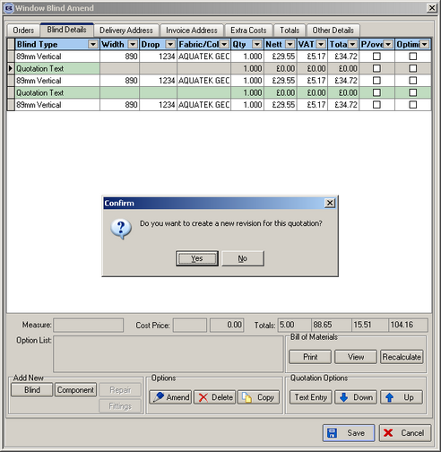

1889. Order Processing > Quotations

If a ‘Quotation Text’ is entered, it can now be viewed properly.

1890. Blind Details > Blind Setup

The buttons are now in line.

1892. Order Processing > Orders > Print Order

‘bellow’ is now spelt ‘below’

1893. Order Documentation Summary

- Date is now in format 17 August 2007, not 17/August/2007
- Same as 1
- ‘Proccessed’ is now spelt ‘Processed’.
- ‘HARDARE’ is now spelt ‘HARDWARE’.
- There should be a bit more space vertically between footer lines.

1894. JL EDI Import

After importing the EDI Files the field Contact Name is now being filled in.

New Work and Customer Requests

428. Sales Files > Customers

The following new fields are now in the customer table:

Bank Customer Ref is in Details tab.

Hardware Badges. This looks up a new table in Administration > System Tables called ‘Hardware Badges’, which contains only an id and Description field. It is displayed in Option Defaults tab.

There is also be a new field called ‘Spare Parts’ (true/false), displayed in Options tab.

429. Spare Parts

We have created a new table for ‘Spare Parts’. This is required because some orders are sent out with spare parts, in case there is a problem. This contains:

Blind Type
Require Option (looks up Fabrics table)
Also Require Option (looks up Fabrics table)
Spare Part
Quantity
Additional Item

There is a new tab for this in Blind Types called ‘Spare Parts’.

When an order is created, the customer checks to see if ‘Spare Parts’ = true or false. If true, then spare parts must be calculated for the order. The spare parts table for the blind type is then interrogated to see what parts are required. It will use a spare part if ‘Require Option’ and ‘Also Require Option’ are both satisfied. If ‘Require Option’ and ‘Also Require Option’ are both null, then the spare part will be required regardless of the options chosen in the order detail line. Quantity may be held as a number < 1 eg 0.1. This is because if a number of blinds are in the order, only one spare part of a specific stock item will be required. The quantity required will then be rounded up to the next whole number.

430. Order Processing > Orders > Print Order

One customer prints a number of reports from the ‘Print Order’ button.

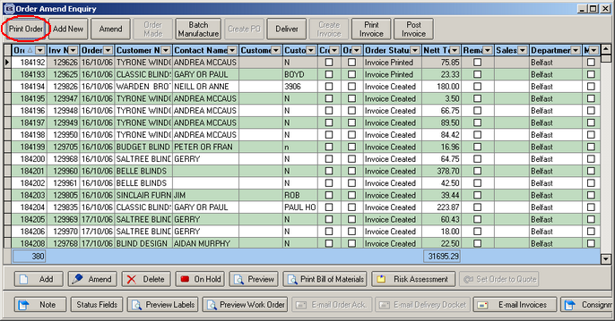

After clicking on the button, the following appears:

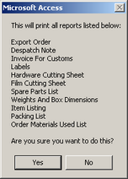

We have a new parameter that allows a customer to do this instead of just printing the order acknowledgement. We have created a new parameters in Administration > Parameters > Reports called ‘Print Batch Documentation’.

The first report prints the ‘Order Documentation Summary’ (see dev 706), then the following reports print. These are not yet complete.

Export Order
Despatch Note
Invoice for Customs
Labels
Hardware Cutting Sheet
Film Cutting Sheet
Spare Parts List
Weights and Box Dimensions
Item Listing
Packing List
Order Materials Used List

702. Calculating Fitting Times

We now have a more sophisticated method of calculating how much time is required to fit blinds for orders. The time taken is split into two: first is the travel time involved in getting to the customer site, second is the amount of time it takes to fit each blind. The time taken to fit a blind varies between blind type.

Therefore we have made the following changes:

1. Hold a ‘Default Travel Time (in minutes) in Administration > Parameters.
2. Allow the user to enter a travel time against the order (in minutes). This is held in the totals tab, and defaults to the ‘Default Travel Time’ held in Parameters.
3. Hold a default ‘Fitting Time’ against the blind type record.

When a fitting appointment is being booked from the orders form, the program calculates the fitting time by adding the travel time in the order to the sum of the fitting times for the blinds in the order, and then defaulting the length of the appointment to the result. This is also connected to dev 703.

703. Order Processing > Orders

We now have a smarter way of selecting a fitter, date and time when in the Order Amend Form. Previously we displayed the diary from the order entry form, but then we had to close that and then enter the fitter, the fitting date and the start and end time. It would be far better if we could click on the diary form (in the relevant time slot for a fitter) and the fitting appointment was created.

704. Fitters Sheet / Sales Leads

It is now possible to see the types of blinds to be fitted in fitter diary. We now display ‘1V, 2R’ field in the diary appointment for a fitting.

706. Order Documentation Summary (see dev 430)

This is the first report that is printed out when ‘Print Order’ is clicked.

