Blindata Release Note 3.6.1 

23 July 2007

Bug Fixes and Enhancements

1861. Pricing > Price Table Enquiry > Print Preview

If a fabric group name is too long (eg Special Effects), an error appeared when trying to print a price table. Fixed.

1863. Works Order Label 1

We made a change (dev 653) to print the bin location from the stock item on ‘Works Order Label 1’. However it was putting the location from the fabric on the label. We actually should have put the location of the box blind stock code that is actually being used to make the blind. This is only applicable to box blinds, so it only prints the location when the blind type = box blind and the option = box blind.

New Work and Customer Requests

674. Bought In Purchase Order

A situation can arise where a customer might enter a sales order for an awning, which is to be bought in from a supplier. But they might fit the fabric themselves to the awning. To resolve this, when you create the purchase order, there is a flag in the purchase order to say ‘Include Fabric’. If this is set to true, then the purchase order is created as normal. If it is set to false, then the purchase order is created without the fabric being mentioned (it should say No Fabric).

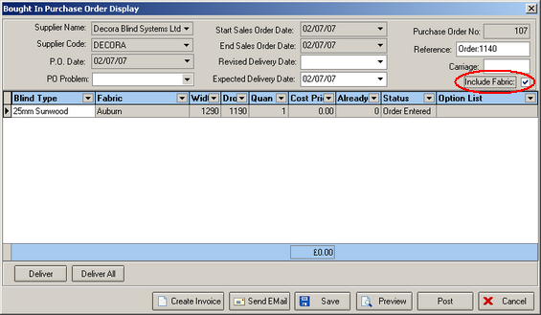

There are also options that are related to the fabric and we need to identify which ones should not print. This is done by having a new flag against the stock item called ‘Fabric Related’.

