Blindata Release Note 3.5.9 

27 June 2007

Bug Fixes and Enhancements

1851. Bill of Materials

The figures shown in the bill of materials report are now correct.

1852. EDI Enquiry

The circled field is now the order number (order_id), not the id.

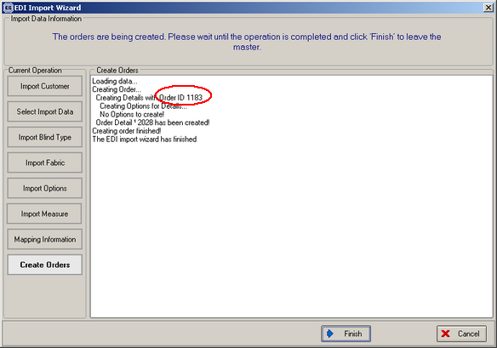

New Work and Customer Requests

671. EDI Import

Previously when the EDI import is done, the customer reference was moved into the customer reference field and ‘Order:9999’ moved into the customer order number field. We also now import the purchase order number into the customer order number field, so it now shows ‘SO:9999, PO:999’ in the customer order number field.

672. EDI Import

previously when an EDI file was imported, it was then deleted from the ftp folder. Instead of the file being deleted, there is now an option to move it to an archive folder. This archive folder name is defined in Administration > Parameters > EDI.

673. EDI Import

When ‘Move to special instructions’ is selected, it now appear at the top of the fabric code lookup box.

