Blindata Release Note 3.5.7 

22 June 2007

Bug Fixes and Enhancements

1842. PDF Invoice

- The company name no longer overlaps the box and does not wrap round. We have made the boxes wide enough around the addresses.
- At the start of the second page, a ‘0’ has appeared in the % discount column. Fixed.
- The attachment name on the invoiced email is now ‘Blindata Invoice 12345.pdf’, not ‘BlindataInvoiceReport12345.pdf’

1843. Invoice – Laser Print

The unit price now prints to 3 decimal places.

1844. Delivery Docket – Sage TF Letterhead

If a detail line is for a velux blind, it now prints the velux code instead of the width and drop.

1845. Order Processing > Quotations

If ‘Cost Price Related’ = true in the blind type record and one detail line has been entered already and a uplift percentage entered, it is now copied into the second line when it is added. Previously the second detail line defaulted everything else to the first line. It now also defaults the uplift percentage.

1847. Administration > Maintenance > Repricing

If a blind type is set to ‘Stock Control’ = true and also ‘Select Cost Price from Table’ = true, if you run Repricing for the cost price, it was calculating the cost price by looking at the bill of materials total. It now calculates the cost price from the relevant cost price table.

New Work and Customer Requests

664. Quotation Bill of Materials

This is a follow up to development item 623.

If the blind type ‘Cost price Related’ = true and you are entering a quotation, selected records from the bill of materials now appear in the red rectangle area (below). This will only show the stock description and the cost price. The user will be able to override the cost price and this will recalculate the base price of the blind.

We can define the bill of materials records that appear in here by a new flag in the stock record called ‘Quote Detail Line’. If set to true, then the bill of material record for the relevant stock item will appear on this form.

If the fabric is blind type = roller, we can also enter the roll width. This will also then recalculate the fabric used and then the price.

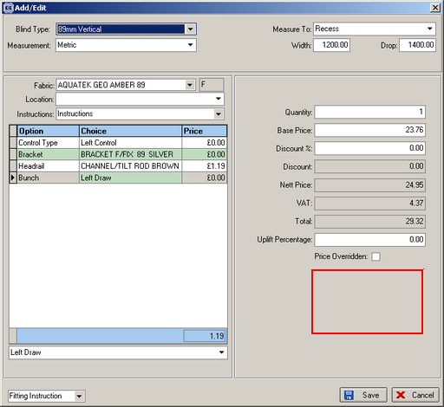

665. Quotation Contact Management

We can now hold contact management records against quotes. This is similar to the contact management for orders but we only hold contact date, next contact date, ownership (employee) and text. We can generate next contact date in quote as quote date + 6 working days. We also hold who entered the contact record.

There is a new report (in Reports > System Reports) that shows:

Records between start and end ‘next contact date’, by employee.

669. Works Order Label Blind Size

It is now possible to print the supplier name (of the fabric) on the large works order label. This is controlled by a new parameter in Report Parameters called ‘Print Fabric Supplier Name’.

670. Invoice – Bespoke 14

The works order number (order id) now prints on this invoice.

