Blindata Release Note 3.5.0 

08 May 2007

Bug Fixes and Enhancements

1778. Reports > Financial Reports

These reports now appear in alphabetical order. Also, the depth of the form has been increased so there is not need for a vertical scroll bar.

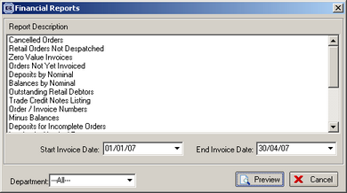

1779. Administration > System Tables > Slat Description

It is now possible to change the type after the record has been saved.

1780. Label Print – 5 x 1

- Width and drop are in larger font and figures in 12 pitch Times New Roman.
- Due date is in format dd/mm/yy, not dd/mm/yyyy
- Special instructions now print on bottom line
- Velux code now prints if blind identifier = Velux.

1781. Administration > System Tables > Dimension Codes

‘Despatch Name’ now says ‘Dimension Name’.

1782. Order Processing > Orders > Receipts > Post Receipt to Sage

If a receipt is entered against an order before the order is turned into an invoice and is posted to Sage, the Sage transaction type is now SA, not SR. The transaction now goes into Sage as an unallocated payment.

Previously when a deposit receipt was posted to Sage (as transaction type SR), when you ran File > Maintenance > Check Data in Sage, the error message below appeared. However this problem went away when the invoice was posted because the receipt was allocated to the invoice.

If the deposit receipt is posted to Sage with transaction type SA (unallocated payment), the error does not occur. If the receipt is posted after the invoice has been posted, then transaction type SR is ok because the receipt is being allocated to the invoice immediately. So the problem only occurred when the receipt was posted before the invoice.

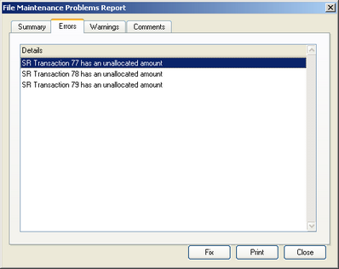

1783. Order Processing > Fitters Sheet / Sales Leads

An error occurred if you clicked on ‘Display Week’ and then clicked back to ‘Display Day’. Fixed.

1784. Order Processing > Quotations.

When trying to copy a quotation an error occurred at one site. Fixed.

1786. Rep Commission/Discount Report

The report was showing figures including VAT. Now the full nett price and actual nett do not have VAT in them.

1787. Works Order Portrait

If blind identifier = Pleated, we now show the number of pleats on the works order.

If blind identifier = Pleated and ‘Show Number of Brackets’ = true in the blind type, we now show the number of brackets on the works order.

If blind identifier = Pleated and ‘Show Cord Spacing’ = true in the blind type, we now show the number of brackets on the works order.

If blind identifier = Vertical and ‘Calculate Spacer’ = true in the blind type, the spacer calculation now appears on the works order, above special instructions.

New Work and Customer Requests

627. Rep Commission Report

This report shows the archived orders by rep. The report is filtered by Start Date and End Date using the date when the balance was paid on an order. If ‘No Commission’ = true in the order, then the order does not appear on the report. It is also possible to choose an individual rep or all.
There is a commission total for each rep, a new page for each rep and the report prints in landscape.

The report is in Reports > Financial Reports.

The fields printed the report are:

Ord No
Contact Name
Reference
Order Date
Balance Paid Date
Nett Total
Actual Nett
Max Discount Allowed: [MaxDiscTotal] = Sum of [MaxDisc] in the detail lines. MaxDisc is calculated by getting the [MaxDiscount] field from the Blind Type entered and performing this calculation on it: MaxDisc = MaxDiscount * [Nett Price] / 100
Discount Given: [Actual List] = ([Full Nett Total]-[Actual Nett])
Discount Diff: [MaxDiscTotal]-[Actual List]
Rep Deduction
Commission: [Commission] = ([Actual Nett]-[RepDeduction])*[RepCommission]/100

Notes:

[RepCommission] is Comm1 held against the Rep.
[Balpaid Date] is the date held against the balance receipt when the balance is reduced to 0.
[RepDeduction] is filled in manually by the user.

We have created a new field, ‘Rep Deduction’, in the orders table and displayed it in the Totals tab in the ‘Order Entry’ form.

We have created a new field against the blind type record, called ‘Max Discount’.

