Blindata Release Note 3.4.9 

23 April 2007

Bug Fixes and Enhancements

1755. Administration > Users > Permissions

We now have a permission for the ‘EDI Enquiry’ and ‘Order On Authorisation’ menu options in Administration > Users > Permissions.

1765. Order Processing > Orders

When a box blind is being entered, the ‘Deduct Each End’ and ‘Slat Add’ calculation is done using the man width and man drop, not the entered width and entered drop.

1767. Order Processing > Orders > Receipts

If you enter a receipt with an alphanumeric lodgement number, the lodgement number did not get moved into the reference field in Sage when the receipt is posted to Sage. Fixed.

1768. Order Processing > Fitters Sheet/Sales Leads

There was an error displaying appointments on the diary in the week format. Fixed.

1769. Order Processing > Orders

Looking up the diary from order entry caused a problem and did not display the diary properly. Fixed.

1771. Works Order Two Labels

- Changed top two labels to this layout:
Customer Name:  Customer Ref:  Width: Drop: | Customer Name:  Customer Ref:  Width: Drop:

- Options font is now the same size as cutting options font
- Moved cutting options to first column (beneath operator). Moved cutting sizes to right to stop cutting description wrapping round.
- Second set of labels on page – moved top two labels down by 3mm – this is only on the bottom half of the A4 sheet – the top two were ok.
- Two right hand labels are in larger font
- Fabric/Slat did not have enough space. Moved to left a bit.

1773. Order Processing > Orders

If an order has a value of 0, it does not go on credit hold ie the credit hold functionality is not applicable.

1774. Order Processing > Order Enquiry > Deliver Blind Scan / Deliver Scan

The employees now appear in alphabetical order.

1775. Order Processing > Order Enquiry > Scan Buttons

To assist users with touch screens for selecting employees before scanning, we have made the employee field far bigger.

Also once the employee has been chosen, the cursor focus now moves to the scan field.

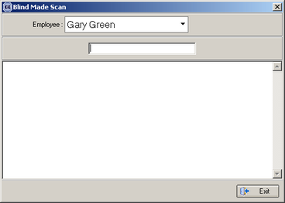

New Work and Customer Requests

588. EDI Invoices

We now have a facility to send EDI invoice files to certain customers. There is a new flag held against the customer, called ‘Send EDI Invoice’. As well as the client printing invoices for this customer, it is possible to send an invoice file electronically.

The file is called EDI-BATCH99.txt, where 99 is the batch number.

600. Order Processing > Orders (Credit Limits)

We have made the following changes to the credit hold functionality.

- We now hold a history record for when an order goes on credit hold. The history record shows the amount by which the credit limit has been exceeded.

- There is a message that appears when the credit limit is exceeded. It has been expanded to show ‘Credit Limit’, ‘Blindata Outstanding Orders total’ (all non posted, non cancelled orders), Sales Ledger Outstanding Amount’. It also displays the amount by which the credit limit has been exceeded.

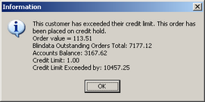

- Previously, if an order was entered and went on credit hold, the credit hold could be switched off in Order Processing > Orders on Hold. If you then went back into the order, it was not put back on credit hold. We have altered this, so if the amount of the order is increased, the credit limit IS checked again.

- If an order is a remake or a repair, or the value is 0, it does not go on credit hold.

We have added the same functionality for ‘Authorisation Hold’ as well (for points 1 and 3).

620. Stock Setup > Stock Items

We have added a new field (true/false) for a ‘Kanban item’. If the fabric for a blind is flagged as being a Kanban item then it is flagged on ‘Works Order Label 1’. It appears on the top line of the main ticket to the right hand side (after the 1 of 3 part).

For you information: http://en.wikipedia.org/wiki/Kanban

