Blindata Release Note 3.4.7 

13 April 2007

Bug Fixes and Enhancements

1730. SQL Express 2005

It is now possible to install a fresh copy of Blindata on a PC that has only SQL Express 2005 installed, and not MSDE.

1738. Sales Files > Customers

In customer delivery address, we now allow blank second part of postcode if the first part of postcode is null.

1741. Order Processing > Production List > Production List by Blind Type

Previously in the production list it made no difference if ‘Show Manufactured Blinds’ was true or false. If a blind has been manufactured and ‘Show Manufactured Blinds’ = false, it no longer appears on ‘Production List by Blind Type’ report.

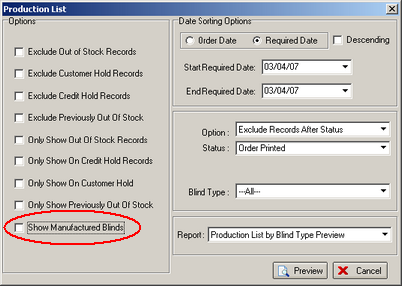

1745. Invoice – Sage Tractor Feed

The discount now prints to 2 decimal places.
The word ‘Disc’ has been inserted between ‘Unit Price’ and ‘Nett’.

1746. Financials > Post Invoices to Sage > Line 50 Export File

If you are exporting a large number of records, timeout errors occurred when running the ‘Line 50 Export File’ routine. This function has been optimized.

1747. Order Processing > Fitters Sheet / Sales Lead

If you only have ‘Show Fitters’ flagged, then only employees who are set up as fitters now appear on the diary. The same applies to all employee types – only those types chosen on the diary form appear.

1748. Pricing > Price Table Enquiry > Selected Price Uplift

When you lookup the fabric groups, they now appear in alphabetical order.

1749. Stock Setup > Stock Items

When you lookup fabric group, it now appears in alphabetical order.

1750. Order Processing > Orders > Post Invoice

The transaction number that appears on the form did not match the transaction number in Sage. It does now.

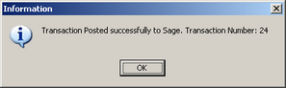

New Work and Customer Requests

514. Order Processing > Orders

There is a new field in the Order table called ‘Checked’. The purpose of this is so that orders can be flagged as ‘Checked’ before they are printed. The following changes have been made.

A new field (true/false) has been created in the orders table called ‘Checked’.
A new parameter has been created in Administration > Parameters called ‘Display Checked’.
A new advanced permission has been created for ‘Checked’ in Administration > Users > Advanced Permissions > Orders.
The ‘Checked’ field now appears in the order entry form, but only if ‘Display Checked’ = true and there is an advanced permission for it.
An order history record is created if the order is set to ‘Checked’ = true.
‘Works Order – Label 1’ does not print if ‘Checked’ = false.

589. Diary Optimisation

We have optimised the way the diary works. The following functionality has been incorporated:

Display day diary (as is done presently)
Display weekly diary (this currently displays the monthly form)
Display monthly diary

We are also be able to determine the employee type we display. Previously we could switch on or off surveyors. We are now also able to switch on or off reps, fitters and service employees. The left hand side of the form, now shows:

Show Reps (true)
Show Fitters (true)
Show Service (false)
Show Surveyors (false)
Display Day (true)
Display Week (false)
Display Month (false)
Fixed Column Width (false)

602. Works Order Label Blind Size

We are now able to print the product code at the start of the fabric description in Works order Label 1). There is a new parameter for this in Administration > Parameters > Report Parameters, called ‘Print Fabric Code’.

603. Order Processing > Orders > View Serial Details

We have added the blind type description, despatch employee and despatch date/time to the View Serial Lines form.

604. Order Processing > Archive Enquiry

We have added an option to view the serial detail lines in the Archive Enquiry form.

605. Administration > Users > Advanced Permissions

There are now Advanced Permissions for all the button options on the Order Enquiry Screen.

606. Administration > Parameters

We can now set the Starting Number for the Serial ID’s. There is also a method of removing serial detail lines first, in Administration > Maintenance.

607. Administration > Employees

There is now a separate menu option outside of System Tables for Employees. The Employees table has been removed from the System Tables lookup.

608. Order Processing > Orders / Order Enquiry > Order Made

If ‘Enabled Serial No. Shop Floor System” is set to Yes, then the ‘Order Made’ date is populated automatically, otherwise it remains as it is.

