Blindata Release Note 3.3.5 

19 January 2007

Bug Fixes and Enhancements

1524. Order Processing > Orders > Status Fields

In the order history, we now identify that the order status was changed using the ‘Status Field’ button. In the description, it says ‘(Status Field Button)’.

1530. Order Processing > Orders > Deliver

The correct employees are now being brought up in the lookup.

1531. Blind Details > Blind Types > Link Option

We now display stock code and description in the Choice field in the lower half of the form.

1532. Works Order Label Blind Size

If an order had 3 detail lines on it, for two blinds and a fitting charge, and we did not want to print a label for the fitting charge, it was still showing ‘1 of 3’ and ‘1L, 1M, 1R’ on the label. It now only shows ‘1 of 2’ and ‘1L, 1R’ on the works order label.

1538. Order Processing > Orders > Works Order / Label Print

A specific problem has occurred at a couple of sites in the last few weeks. When someone tries to print a works order or label it does not print. When we looked at the relevant record, the order status = order entered, but the detail line status = awaiting manufacture. This was why the order won’t print a works order or label. We have altered the order status to ‘Order Printed’ and then it is possible to print the reports. Probably fixed.

1542. Order Processing > Orders

If blind identifier = External, ‘Drop’ now says ‘Projection’.

1543. Fitters Sheet / Sales Lead

After you saved a ‘general diary entry’, it refreshed to the current date. It now stays at the date the user is in.

1544. Reports > Receipts by Lodgement

This report is now working – previously it did not find any records.

1545. Administration > System Tables > Purchase Order Problems

The following error message comes up when you try to save a record in this table. Fixed.

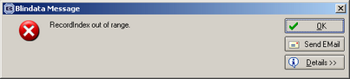

1546. Invoice – Bespoke 4

We have made a couple more changes to this report.

- The data here should be from ‘customer order no’, not order no.
- We now to print ‘Works Order: 9999’, where 9999 is the order no. This is where we removed the delivery address on Monday.

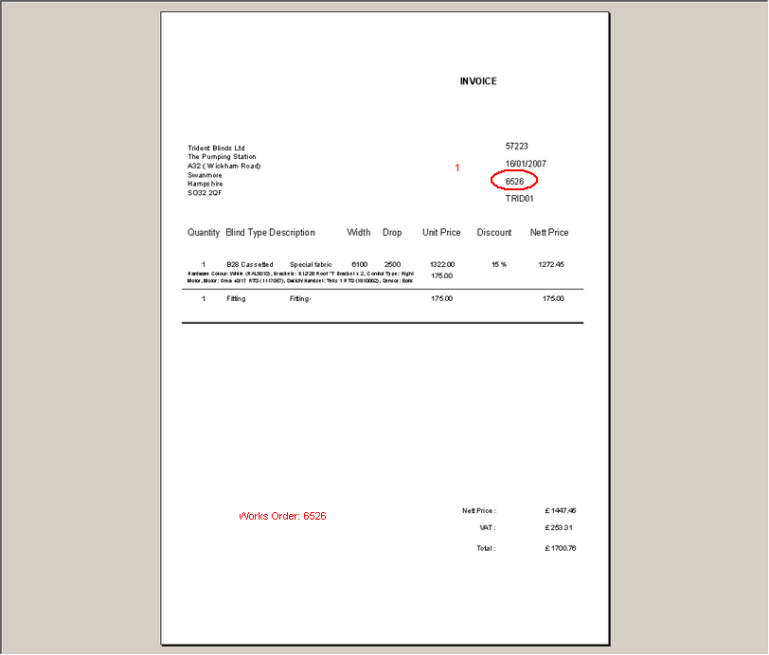

Kolodiy

1547. Label Print – 4 x 1 Datamax

We have made some alterations to the label layout.

1548. Pricing / Price Table Enquiry / Preview

If you tried to preview a price table and the Description of the related table is greater than 10 chars then an error occurred. Fixed.

1549. Archive Enquiry Subquery Problem

http://www.ball-software.com/backups/MikeGoldrickWindowBlindsLimited/MGD-SQLDATA-19Jan07.zip

When you go into the Archive Enquiry using the data from one site, an error occurred. Fixed.

1550. Invoice – Sage Laser Print

This now prints the company name from Administration > Company Details properly.

1551. Order Processing > Orders

If you entered an order and then changed a customer, the invoice address was not getting changed. Fixed.

1552. Works Order Label 1

If Quality Checked = true in an order, “QUALITY CHECK” now appears on the label.

1553. Order Processing > Orders

When trying to email an order acknowledgement, an error occurred. Fixed.

1555. Order Processing > Quotations > Create Order

When converting a proforma invoice to an order, a message appears about credit. This is not required because the order has already been paid for, because it was entered as a proforma invoice. Fixed.

1558. Order Processing > Orders

The email address was not being pulled from the customer record when an order is entered. This was also happening with quotations. Fixed.

1559. Sales Files > Customers

When entering a delivery address in Customers ‘Del Address’ tab, a message now appears warning you to save the record before leaving that tab.

1560. Sales Files > Customers

There is now a ‘Save’ button on this form so users remember to save the invoice address.

New Work and Customer Requests

517. Order Processing > EDI Enquiry

There is now a method of deleting a received EDI order. We have had a couple of cases where the files have been transmitted twice.

518. Order Processing > EDI Enquiry

When you view received records, the records are now displayed in reverse order ie newest first.

