Blindata Release Note 3.3.4 

15 January 2007

Bug Fixes and Enhancements

1504. Order Processing > Delivery Docket Batch Print

The reprint now works properly.

1514. Order Processing > Quotations

When you add a quotation, the field for the email address now appears.

1515. Pricing > Export to Excel

When you export records to a spreadsheet, it exported a lot of cells with value 0, which is unnecessary. Now it only exports cells if there is a width and drop for that cell.

1516. Order Processing > Orders

If you entered a velux blind as the second detail line on an order, and the first blind had an imperial measurement, it brought across an imperial width and drop from the first line. The width and drop are now always be taken from the width and drop in Administration > System Tables > Velux Codes.

1517. Invoice – Laser Print 11 Detail Lines

The quantity was missing if the blind identifier = miscellaneous. Fixed.

1518. Reports > Financial Reports > Deposits by Nominal

Under certain conditions, you get a ‘division by zero’ error. Fixed.

1519. Order Processing > Orders

Temporary error. After you converted a quotation to an order, you got an error when trying to amend the order. Fixed.

1521. Works Order Label Blind Size

We now show the ‘No. of Slats’ if blind identifier = Venetian or blind identifier = Wood. It prints below ‘Cord spacing’.

1522. Invoice – Laser Print 11 Detail Lines

If there are >=9 detail lines on an invoice, the total could print on the following page on its own. Fixed.

1523. Works Order – CB

We now print the ‘Location’ on this works order.

1525. Order Amend Enquiry / Contact management

An error occurred when saving a record in contact management. Fixed.

1526. Pricing > Global Price Uplift

The uplift % is now working to 2 decimal places.

1527. Stock Setup > Stock Items

When duplicating a stock item, the new stock code now gets written to the supplier part number. Previously it was copying the supplier part number from the duplicated record.

1528. Stock Setup > Stock Items

When duplicating a stock code, it now refreshed the stock description (if it was previously changed).

1529. Administration > Users

When copying a user, the contact management permissions now get copied.

1534. Label Print – 4 x 1 Datamax

The following changes have been made.

- The concatenated blind identifiers now appear.
- All dates are now in the format dd/mm/yy.
- If the blind identifier = velux, the width and drop (from the velux table) now appears.
- If one detail line is miscellaneous, it should not print, but it was being included in the ‘1 of n’ amount. This is no longer the case.

1535. Works Order Label Blind Size

If the blind identifier = Velux, the Velux code now appears on the works order label.

1536. Fitters Sheet / Sales Lead

The telephone number has been reset to be a mandatory field.

1537. EDI Receiving

The 'Check for new transactions automatically' only worked with the email method - it now works with FTP.

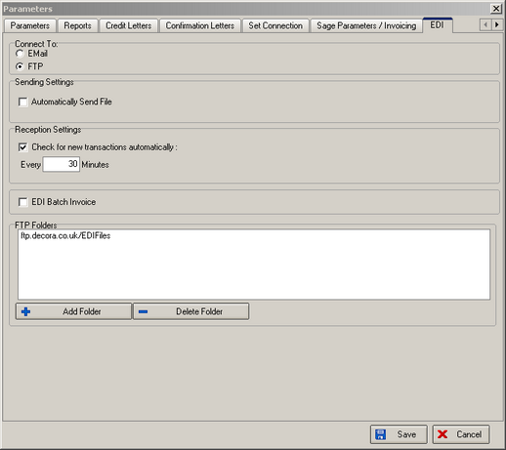

1539. Invoice – Bespoke 4

- Fabric description now prints.
- Discount shows % discount eg 10% (not just 10). If discount is 0 for all detail lines, discount does not show and word ‘Discount’ does not show either.
- The lower delivery address has been removed.
- Moved ‘Nett Price:’ 5mm to right. Moved £99.99 20mm to right.
- Moved ‘VAT:” 5mm to right. Moved £99.99 20mm to right. Moved whole line down by 2mm.
- Moved ‘Invoice:’ 5mm to right and changed to ‘Total:’. Moved £99.99 20mm to right and moved whole line down 5mm.

1540. Works Order Portrait

If you enter a component detail line with a quantity > 1 and ‘Only 1 WO Label’ is true, it now only prints one detail line on the report. If quantity = 10, it now only prints 1 line with quantity = 10.

1541. Works Order Portrait

The header was missing after page 1 of each blind type. Fixed.

New Work and Customer Requests

502. Reports > System Reports > Stock Transaction Totals

It is now possible to choose this report by supplier and blind type.

511. Sales Files > Customers > Product Discounts

It is now possible to discount products by percentage as well as by price. In the following form, there is a new field for discount percentage. The user can fill in either ‘Price’ or ‘Percentage’, but not both. The component detail line entry will then look at the product discount and select the price accordingly. If the percentage is chosen, it will go into the discount percentage in the detail line.

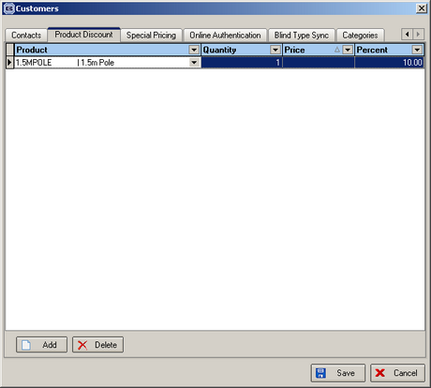

Valerij

513. Label Print – 4 x 1 Datamax

A new label print is available.

