Blindata Release Note 3.3.2 

28 December 2006

Bug Fixes and Enhancements

1476. Invoice – Sage Laser Print

- Rules for address are same as 1472.
- Option price now appears separately.

1480. Fitters Sheet / Sales Lead

It was possible to assign a sales lead to an employee who is a fitter only. You are no longer able to do this. You can only assign a sales lead to an employee that has ‘Is Rep’ = true.

1497. Fitters Sheet / Sales Leads > Sales Lead Entry

The country now defaults to the one in Administration > Parameters. Since the ‘company name’ lookup was added, it was not finding a country until you select a company.

1498. Fitters Sheet / Sales Leads > Sales Lead Entry

When the ‘Existing Postcode Search’ is clicked and an address is found, it asks if you want to use the address. The message now says ‘The following address has been found. Do you want to use this?’. If no address has been found, the message says ‘There is no saved matching postcode’, instead of ‘Not Found’.

1499. Fitters Sheet / Sales Leads > Sales Lead Entry

After a company name has been selected, the address from the customer record is updated to the sales lead address. This does not happen if the customer trade type = retail, because all the addresses will be different, and the address the user has just entered will get overwritten. If customer trade type = trade, the user is now prompted after the company name is entered with ‘Do you want to use the following address for this customer?’ and the address is displayed. There is a yes/no response.

1500. Label Print – 4 x 1

The tube cut size calculation was wrong. It is now the width (blind size) – tube cut difference (in blind type record).

1501. Order Processing > Orders

If you enter a detail line for a blind identifier = vanes only, it now only calculate the width if ‘Calc width from vanes’ = true in the blind type record.

1503. Reports > System Reports > Stock Transaction Totals

Records no longer appear here if they are for sales orders that are on credit hold or if ‘Purchase Order Generation’ is false in stock items.

1508. Order Processing > Orders > Receipts

The following error occured if the lodgement field is null. This should not matter unless ‘Update Lodgement No to Ref’ is set to true. Fixed.

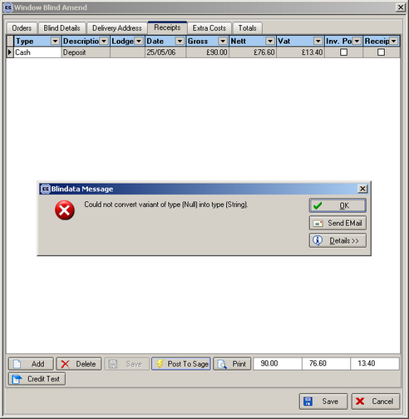

New Work and Customer Requests

467. Stock Setup > Purchase Order Enquiry

There is now a button on this screen to print out the purchase order of the record that has been selected. It knows whether to print out a ‘bought in purchase order’ or a ‘regular purchase order’.

499. Bought In Purchase Order Print (all)

Purchase order print – the total now appears on the bottom of the PO. Want to print the username and email address on PO as well.

Reports also print ‘Expected Delivery Date’, not ‘Required Date’.

The records also display and print (on the purchase order) in the same order as they do on the sales order.

503. Order Processing > Batch Manufacture

We have changed the ‘Batch Manufacture’ function in two ways.

1. It is now a separate menu option on the order processing menu.
2. You can enter a start and end date, either for order date or required date.

504. Order Processing > Orders/Quotations/Credits

We have included arrows to control which order to go to (Go To First, Next, Previous, Got to Last) on the enquiry forms.

