Blindata Release Note 3.3.1 

22 December 2006

Bug Fixes and Enhancements

1464. Fitters Sheet / Sales Leads

If you entered a ‘general diary entry’ and select a fitter, it initially displayed in the employee diary column you are in, but was ok after refresh. Fixed.

1472. Acknowledgement – Laser Print (Letterhead)

- The country is no longer printed and the postcode is now moved up so there are no empty lines (if address line 3 or address line 4 are null).

This also applies to ‘Delivery Docket – Laser Print (Letterhead), ‘Invoice – Laser Print (Letterhead)’, ‘Invoice – Bespoke 1’, ‘Invoice – Bespoke 7’, ‘Invoice – Bespoke 9’, ‘Invoice – Laser Print (Letterhead Logo)’, ‘Invoice – Laser Print’, ‘Invoice – Laser Printer Non Itemised’, ‘Invoice – Sage Tractor Feed’, ‘Acknowledgement – Production Docket’, ‘Order Acknowledgement 6’, all credit notes, ‘Delivery Docket – Laser Print (Special), ‘Quotation – Laser Print

1474. Invoice – Bespoke 2

- Addresses now follow rules in 1472.
- Width and drop sizes no longer print if blind identifier = Miscellaneous
- Actual nett has replaced actual.
- There is now consistency with the date format, dd/mm/yyyy.

1475. Invoice – Bespoke 4

- Same address rule as 1473.
- Width and drop sizes are not printed if blind identifier = Miscellaneous. Also, there is no option price if blind identifier = miscellaneous.
- The option price was printing in the discount column. We have made the option print field narrower so the option price prints underneath the base price.

1477. Acknowledgement – Laser Print (Letterhead Logo)

- Address rules are the same as 1472.
- We now print base price, not (base price + option price).

1479. Quotation – Bespoke 12

- The header now says ‘Quotation – Bespoke 12’.
- Address follows rules in 1472.

1481. Administration > Export to Excel > Stock Record

The following error occurred when you try to export stock records. Fixed.

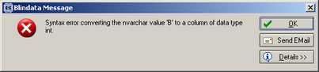

1482. Sales Lead Individual Normal

The contact date printed incorrectly – it was showing the appointment date, when it should be the initial contact date. Fixed.

1493. Label Print 5 x 1 ½ CB

We have included the ‘Customer Order No’ on this label.

1494. EDI Enquiry (Purchase Order Enquiry)

When an EDI file was sent, it was including quotations. Fixed.

1495. Delivery Docket – Laser Print Non Itemised

If a detail line has blind identifier = miscellaneous, comment now print and not blind type.

New Work and Customer Requests

451. Administration > System Tables > Invoice Types

Previously this table defineed how many of each report gets printed. We have expanded this so we can determine different print amounts for each of quotation, order acknowledgement, delivery docket and invoice.

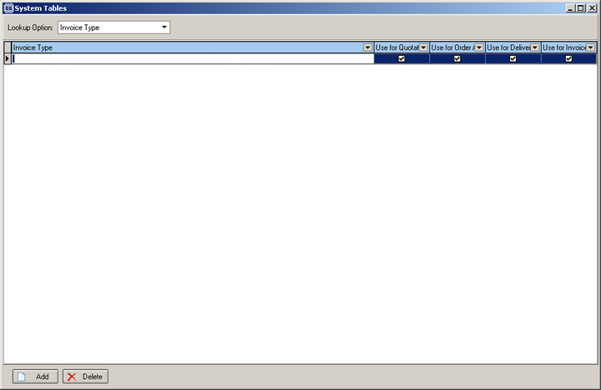

495. Financials > Invoice Batch Print

There is now an option to print the invoices out in invoice number order or alphabetical by customer order.

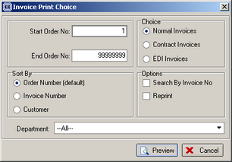

496. Fitters Sheet / Sales Lead

When entering a new sales lead, we can now check previous sales leads by post code and house number to see if there were any matching records. If so, the address should be copied from the old sales lead and filled into the address fields on the sales lead form. This should be done by clicking a new button on the ‘Sales Lead Amend’ form, called ‘Existing Postcode Search’.

The mobile number is now on first part of sales lead entry form instead of on the form that is displayed when the appointment is made.
It is also possible to enter the company name from a lookup on the ‘Sales Lead Amend’ form. Once this is chosen, the address will be filled. This is not a mandatory field. When a sales lead is converted to an order, the sales lead will be converted to a sales order for the company (customer) chosen in the lookup. The existing company field (free text) remains.

On adjacent addresses form, we now show employee (rep or fitter).

We have disabled the fitter postcode find for trade sales when converting a sales lead to an order. At the moment it stops you from converting a sales lead to an order if the postcode is not related to a fitter in Administration > System Tables > Postcodes.

We have added ‘Suggested/Requested Time’ on rep diary report.

