Blindata Release Note 3.2.8 

1 December 2006

Bug Fixes and Enhancements

1444. Order Acknowledgement – Laser print

The order acknowledgement was printing the wrong fax number if the department filter was switched on. Fixed.

1448. Order Processing > Order Amend Enquiry / Order Enquiry

If a sales order has a detail line for a bought in blind, and a purchase order has been created for that bought in blind, it is no longer possible to ‘manufacture’ the order until the purchase order has been ‘delivered’. If you try to click ‘Blind Manufacture’ or ‘Order Manufacture’ (or scan as well), a message appears saying ‘The purchase order (PO no. 9999) for this blind has not yet been delivered’.

This is done in the ‘Order Amend Enquiry’ form and the ‘Order Enquiry’ form.

1450. Order Processing > Orders

If ‘Fabric Not In Use’ is true, it is no longer possible to choose the item as a choice in the detail line entry.

1451. Financials > Retail Balances

There is now a horizontal scroll on this form.

1452. Works Order – CB

All the characters that were entered in the ‘Comment’ line print on the works order can now be printed on the works order.

1453. EDI Import

When an EDI import is done, the customer reference field gets filled with the order id from the sending customer order (eg Order:123456) and the customer order number is filled with the PO number.

This has been changed so that the sender customer reference is imported into the receiving customer reference field and the order id from the sending customer order (eg Order:123456) goes into the customer order number field.

1454. Order Processing > Orders

The delivery address is now being filled in when a customer is selected when adding an order.

1455. Despatch Label 4 x 3 (required 01/12/06)

If you entered only one detail line in a order with quantity = 2, only 1 label gets printed. But if there are two detail lines, with one quantity = 2 and another quantity = 1, it is ok. Fixed.

1456. Works Order Landscape Metric

The number of brackets now prints on this report.

1457. Blind Details > Blind Types > Stock Defaults

‘Code Leter’ now says ‘Code Letter’.

1458. Blind Details > Blind Types > Link Options

The choice of field in the circled area is now restricted to those records with link option = chosen on (in arrowed field).

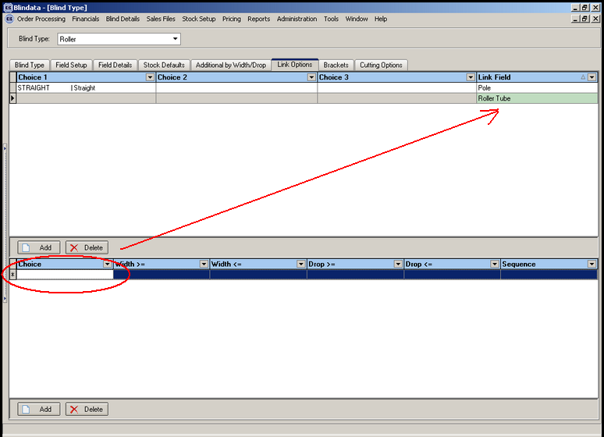

1460. Invoice – Laser Print 11 Detail Lines

- If the detail line blind identifier = miscellaneous, the text was printing too far to the right.
- The option price no longer appears where blind identifier = miscellaneous.
- The two prices shown should be base price and option price. Previously it was showing (base price + option price) and option price.

1461. Invoice by Email

The VAT is now shown properly on an emailed invoice. Also we no longer to show Carriage or deposit in the total part.

New Work and Customer Requests

462. Administration > Users > Advanced Permissions

There is a new advanced permission to allow a user to amend the ‘quote date’ when entering a quotation.

463. Pricing > Global Price Uplift

There is a new facility so all the prices from one blind type can be uplifted to prices in another blind type. There is now a ‘From Blind Type’ and a ‘To Blind Type’ field. If the ‘To Blind Type’ records already exist, a message appears saying ‘These tables already exist. Do you want to overwrite them?’

466. Reports > Daily Order Control Report

It is now possible to choose the daily order control report by department as well as by start date and end date.

468. Blind Details > Blind Types

Previously options could only be locked down for the whole blind type. It is now possible to lock down individual options on the blind type as well. There is now a flag in Blind Details > Blind Type > Option Setup so we can switch on/off the locking of individual options. This will only work if the blind type option lock down = false.

470. Reports > System Reports

There is a new report to show customer promised date < required date. This is in Reports > System Reports. The layout contains:

Order id, order date, customer, contact name, required date, customer promised date.

471. Fitters Sheet / Sales Lead > Convert to Order

If the fitting date is not entered when converting a sales lead to an order, the required date is now generated automatically for trade type = retail. It obeys the same rules as trade type = trade.

476. Blind Details > Blind Types

There is a new flag against vertical blinds called ‘Calculate spacer’. If this is true, then the spacer is calculated and displayed on the ‘Works order label blind size’. If it is false, it does not print on this report.

477. Works Order Label Blind Size

Previously we had a parameter that allowed the user whether to choose blind size or entered size, and also metric or imperial (in Administration > Parameters > Reports). One client has asked if this parameter could be set up twice, once for the two top labels (20mm deep) and one for the large label. This customer wants to print ‘Entered size’ on the top two labels and ‘Blind size’ on the larger label.

Therefore we have split this into two parameters called ‘Use Measurement in Top Labels’ and ‘Use Measurement in Works Order Label’.

478. Posting Receipts to Sage

There is a new parameter in Administration > Parameters > Sage Parameters / Invoicing called ‘Update Lodgement No to Ref’. If this is set to true, then the lodgement number is posted to the Ref field in Sage.

479. Carriage Charge Per Order

There is a new field in the customer table called ‘Carriage Charge Per Order’. If this is set to true, then when ‘Create Invoices’ is run, a carriage charge is added to each order (according to what is in Area > Carriage Amount) rather than checking to see if the total of the orders for that customer exceeds the carriage free over amount.

480. Sales Analysis by All Blind Types (Quantities Only)

There is a new report exactly the same as ‘Sales Analysis by All Blind Types, except it does not show the values, only the quantities of blinds.

484. Label Print 4 x 1

We have created a new label print, similar to ‘Label Print 5 x 1’.

