Blindata Release Note 3.2.5 

10 November 2006

Bug Fixes and Enhancements

1407. Works Order – CB

If a component line was entered with quantity < 1, a works order did not print. Fixed.
Also, it now prints the quantity to 2 decimal places.

1408. Order Processing > Orders > Repairs

It is now possible to enter repair value to 2 decimal places.

1409. Invoice – Bespoke 8

Unit price prints to 3 decimal places for miscellaneous items.

Registered office now appears in far smaller print and uses the company details address, which prints like this.

Registered Office: Address Line 1, Address Line 2,
Address Line 3, Address Line 4

1410. Invoice – Bespoke 8

- The first nett price for the detail line is now multiplied by the quantity.
- The totals now only appear on the last page of an invoice.

1411. Purchase Order Enquiry > Generate Bought In PO

This now changes the sales order status to ‘Order printed’ if the purchase order is generated and the printed (providing the parameter ‘‘Flag Generated PO as Order Printed’ has been switched on).

1412. Fitters Sheet / Sales Leads

When you opened this form it defaulted to starting at 9am, which is fine. But if you converted a sales lead to an order, the diary screen redisplayed and started at 8am. It now starts at 9am as well.

1413. Order Processing > Orders > Deliver

If a retail order has been entered and the deposit = the total value of the order (ie the balance = 0) and the following parameters are set, an error appeared when you tried to deliver the order. Fixed. This is only applicable to those who have the Parameters set as below.

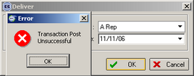

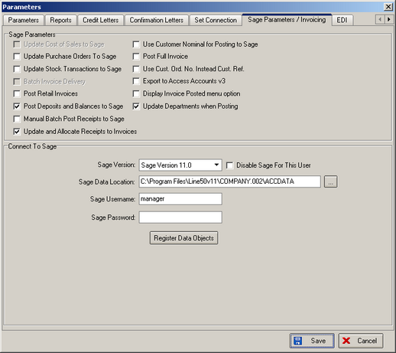

1414. Order Processing > Orders > Receipts

It is no longer possible to amend a receipt line if it has already been posted to Sage ie if either of the two flags are true.

1415. Order Processing > Orders > Deliver

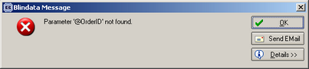

When you tried to print the report ‘Despatch Label 4 x 3’, the above message appeared. Fixed.

1416. Blind Details > Blind Types > Duplicate

When you duplicated a blind type, it duplicated all the ‘product blind type’ records for fabrics. It no longer does this, because this is what the related blind type field is for. However it still duplicates options ie records in ‘product blind type’ where the option is not a fabric.

New Work and Customer Requests

368. Order Processing > Orders > Receipt Entry

Once a receipt has been paid against an order which makes the balance = 0 and the order has a status of despatched, it is automatically changed to posted if case 3 or case 4 or case 5 is true in Administration > Parameters (see table below). This means that the user had then to go to ‘Archive Enquiry’ if they wanted to print an invoice.

 | Post Retail Invoices | Post Deposits and Balances to Sage | Manual Batch Post Receipts to Sage | Update and allocate Receipts to Invoices
1 | √
2 | √ |  |  | √
3 |  | √
4 |  | √ |  | √
5 |  |  | √

There are therefore two points at which the order can be changed automatically.

- When a receipt is posted that makes the balance = 0 and the order already has a status of despatched.
- When the order is delivered and the balance of the order is already = 0.

Immediately after these two points, and before the order is changed to posted, a form now appears saying ‘This order has been despatched and has a balance of 0, therefore it is about to be archived. Do you want to print an invoice?

393. Works Order Portrait Barcode (New Report)

There is a new works order report based on ‘Works Order Portrait’, the only different being that a barcode prints out if blind identifier = L. This is designed for a TS2000 vertical slat machine and will only print the barcode if the parameter ‘Techno TS2000 barcode required’ is switched on in Administration > Parameters.

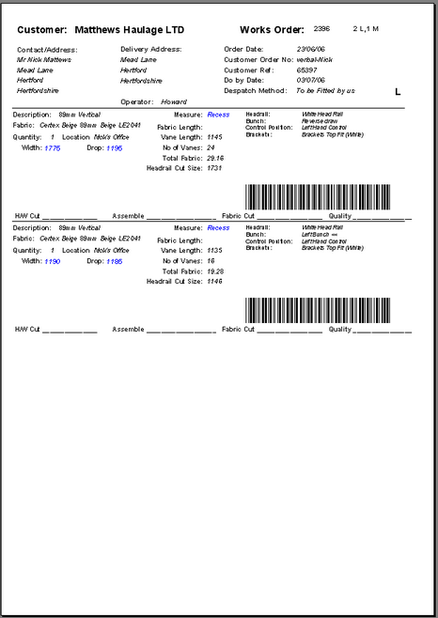

TS2000 Barcode:

This barcode is split into 8 sections making up a total of 30 characters.
 | Barcode Field | Characters | Example Value | Access Field
1 | [Maximum Length] | 4 | 1200 | [Order Detail Line].[VaneLength]
2 | [Minimum Length] | 4 | 0 | Always 0
3 | [Number Of Louvres] | 4 | 22 | [order detail line]. [Number of Vanes]
4 | [Material Id] | 4 | 6351 | [fabrics].[fab_material_id]
5 | [Louvres Width] | 3 | 89 | [blind type].[slat size] 89 or 127
6 | [Order Id] | 6 | 128574 | [Orders].[Order Id]
7 | [Position] | 3 | 78 | Always 78
8 | [Type Of Work] | 2 | 1 | Always 1

The values are padded out with zeros in front of the value to make up the full number of characters.

The barcode is built like this: 1200+000+0022+6351+089+128574+078+01
So the Barcode is stored like this: 120000000022635108912857407801

449. Order Status Change

There is a new parameter in Administration > Parameters, called ‘Flag Generated PO as Order Printed?’ If this is set to true, then sales orders will have their status switched to ‘Order Printed’ once the associated bought in purchase order has been generated and printed.

450. Despatch Labels

There is a new report parameter so that labels can be printed at despatch as well as a delivery docket. This means we can now print two separate reports at the point the order is delivered.

The despatch labels are required to be stuck on each blind that is sent out. The label is 4” wide (101.6mm) by 3” deep (76.2mm) and shows Order id, despatch address, ‘1 of n’, Cust Ord No, Cust Ref, Location, blind type, fabric, width and drop.

452. Order Processing > Orders > Delivery Address Lookup

There is now a postcode lookup for the delivery address in the order entry form.

454. Invoice – Bespoke 4

Detail line now shows:

Qty, blind type description, width, drop, unit price, disc, nett price
Options, option price (one line for each priced option)

455. Administration > Maintenance > Repricing

A new feature has been written that will allow the user to reprice a lot of orders at once. This is required because some prices may have been set up incorrectly, or discounts not set up, and it will make it a lot easier to reprice between two order numbers rather than have to change each one individually.

The program asks for a start and end order number, and then looks up and store each base price, option price, discount percentage and then recalculates the value of the detail line and then the order.

It ignores all detail lines where the price overridden = true.

456. Order Processing > Orders > Component Detail Entry

In component entry, there is a new option to stop quantity being multiplied by unit price to give the nett price.

There is a new true/false field called ‘Quantity Multiplication Overridden’. If this is set to true, then the price does not get multiplied by the quantity to give the nett price. It will be as if the quantity is always 1, even if a larger figure has been entered.

