Blindata Release Note 3.2.3 

30 October 2006

Bug Fixes and Enhancements

1361. Order Processing > Orders > Component Detail Line Entry

The comment field was restricted to 100 characters, but has been changed to 200 characters. There was still a restriction of 100 characters on the comment line in the form. Fixed.

1368. Label Print 5 x 1 ½ CB

The width and drop no longer print for blind identifier = Velux.

1369. Financials > Create Invoices

When creating invoices with ‘EDI Batch Invoice’ switched on, the program now only allocates one invoice number to the orders that share the same PO number (and have been imported in a batch together). Previously it was giving a new invoice number to each individual order. It now only does this if ‘EDI Batch Invoice’ is switched off in Administration > Parameters > EDI.

1372. Invoice – Bespoke 8

- The first and second parts of the postcode were the wrong way round. Fixed.
- The invoice number was incorrect. Fixed.

1376. Works Order – CB

Special instructions were being overwritten slightly by the ‘Measure To’ field. Fixed.

1377. Invoice – Bespoke 10

The blind type was printing out for miscellaneous items. It no longer prints and Comments has been moved to the left.

1378. Invoice – Bespoke 8

1. We have moved everything in the right hand header 15mm to the right.

1379. Sales Files > Customers

An following error occurs when you tried to delete a customer. Fixed.

1380. Reports > Sales Analysis > Sales Analysis Audit Trail Report

- ‘Vatt’ now say ‘VAT’.
- Nett amount is zero when there should have been an amount in the record.
- The nett detail figure was negative – it shouldn’t be. Fixed.
- There is now a thin line between each order/invoice. It will make it easier to read.
- The grand total was also negative. It should not be. Fixed.

1381. Delivery Docket – Laser Print

- Postcode now prints below address line 4. Please move tel and fax down a line. Ok.
- Price fields do not print, regardless of whether ‘Hide detail Lines Total’ is true/false in Orders > Totals.

1382. EDI Enquiry

The ‘Imported’ field is now called ‘Mapped’.

1385. EDI Enquiry > Receiving Data > Print Report

- The batch number is now the incoming PO number.
- The customer is now the ‘Delivery Company Address’.

1386. Label Print 5 x 1 ½ CB

The dimensions are in Times New Roman font and slightly larger.

1387. Works Order – CB

The dimensions are in Times New Roman font and slightly larger.
1388. Automated Backup Routine

This was not working. To resolve this issue you need to go to Parameters form and press ‘Save’. It will re-create the task of automatic invoice creation, it had errors before.

1389. Administration > Parameters > Reports

‘Show Our order No on PO’ now displays properly.

1390. Invoice – Bespoke 5

- If there is a null address line, the lines below now move up.
- The details were going too far down the page if the invoice goes to more than one page. Fixed.

1391. Order Processing > Orders / Quotations

The square metre pricing is now working for all blind types.

1392. Works Order – Label 5

The blind id numbers for this customer has now gone to 6 digits but only 5 appear on the works order. Fixed.

New Work and Customer Requests

369. Reports > Blinds Ready For Fitting Report

A ‘Blinds Ready for Fitting’ report is now available, showing oldest jobs first with the status of manufactured that are fitting jobs, filtered by department. This is Reports > System Reports. It shows order id, order number, order contact name, required date, number of blinds.

374. Invoice – Laser Printer

Invoice – Laser Printer now has batch print version.
We now print in bottom left fitter, fitting date and time.

411. Stock Usage Report

A new report is available in Reports > System Tables that will show quantities of stock used.

Criteria: between start and end date (stock issued date), choice of supplier or all, choice of blind type or all.

The report is grouped by supplier and then by blind type and the records then sorted by stock code. The report should total stock issues between the start and end dates issued and show a quantity.

415. Contact Management

There is a major new function that allows the user to record contacts with customers, both against specific orders and customers. The purpose of this is so that contact information can be shared amongst different users. This can be done by clicking on the ‘Contact Management’ button in either ‘Order Amend Enquiry’, ‘Archive Enquiry’ or ‘Customers’. Permission to use this button can be activated in Administration > Users > Advanced Permissions’ as follows:

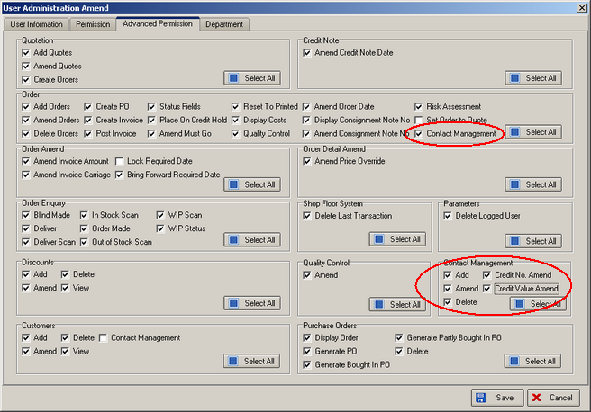

Once these permissions have been set, the user can add contact records against orders or customers. The following form will be displayed.

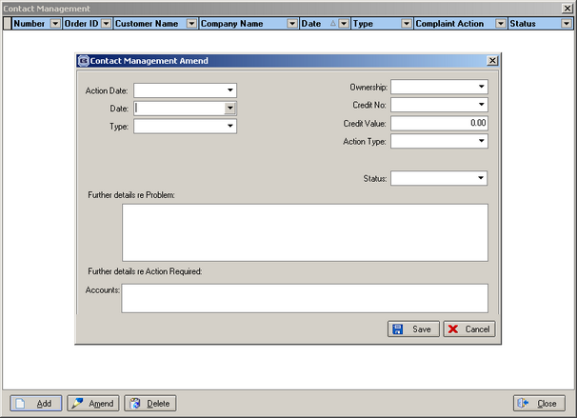

Contact records can now be added. Please make sure that you have entered records in Administration > System Tables > Complaint Type, Action Type and Complaint Status.

416. Order History

When a sales lead is converted to a quotation or an order, or when a quotation is converted to an order, we now copy the history from the sales lead and/or quotation to the order so the complete history of the sale can be seen.

When a bought in purchase order is generated for a sales order (either individually or via ‘Purchase Order Enquiry’) an order history record is also created.

422. Purchase Order Bought In – Standard

There is now an option to remove ‘Our order No’ and cost price from this report. Some customers want these to print, others don’t. There are two new parameters in Administration > Parameters > Reports called ‘Show Cost Price on PO’ and ‘Show Our Order No on PO’.

426. Batch In Transfer Report

A new report is available on the EDI Enquiry > Receiving Data form. It is called ‘Batch In Transfer Report’ and can be accessed via a button to the right of ‘Import Wizard’.

432. Financials > Create Invoices

The following Sage parameters are set:

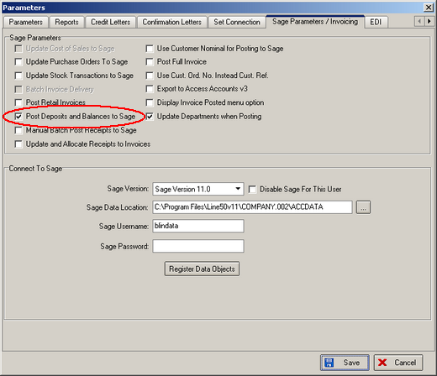

When you run ‘Create Invoices’, previously only orders with customer trade type = trade got turned into invoices. Orders with customer trade type = retail were ignored. We have changed this so both types are turned into invoices and have invoice numbers allocated to them.

