Blindata Release Note 3.1.7 

15 September 2006

Bug Fixes and Enhancements

1280. Splashscreen

A slight amendment has been made to the splashscreen. A jpg file should be used.

1284. Works Order – Label 1

We have further optimised this report.

1285. Invoice – Bespoke 10

We have made some minor layout changes to this report.

1286. Invoice – Sage Laser Print

We have made some minor layout changes to this report.

- ‘Deposit:’ should appear 8mm below ‘Total’. Only for trade type = retail.
- ‘Balance:’ should appear 8mm below ‘Deposit:’. Only for trade type = retail.

1287. Quotation – Bespoke 10

If you entered text in the Comment field in Component Detail Entry in the quotation entry program, it does not print out properly on the quotation. Fixed.

1288. Order Processing > Orders > Repair Entry

An error message appeared when trying to enter a repair. Fixed

1289. Reports > Financial Reports > Deposite For Incomplete Orders

A ‘divide by zero’ error occurred. Fixed.

1290. Administration > Users > Copy Existing User

The fields Amend Credit Note Date & Amend Price Override were not included when copying a user profile. Fixed.

1292. Delivery Docket – Despatch Manifest

The reprint now works properly. It only reprints orders where delivery date matches the one you have entered.

An order no longer prints on this report id it is on credit hold.

1293. Order Processing > Orders

A repair line now displays in the order it was entered.

1294. Works Order Landscape

- The first part of the postcode was missing.
- There are now lines to the right of the process types because people are going to initial (sign) next to the processes.
- The ‘Number of Vanes’ and ‘Number of Slats’ description was the wrong way round for verticals and Venetians.

All fixed.

1295. Order Processing > Orders > Risk Assessment

The time fields are now numeric entry, not a lookup to a time. These fields are required to record the length of time of an event, not the time at which it takes place.

1297. Quotation – Bespoke 10

- Moved these fields 7mm upwards.
- Moved the price field 20mm to the right.

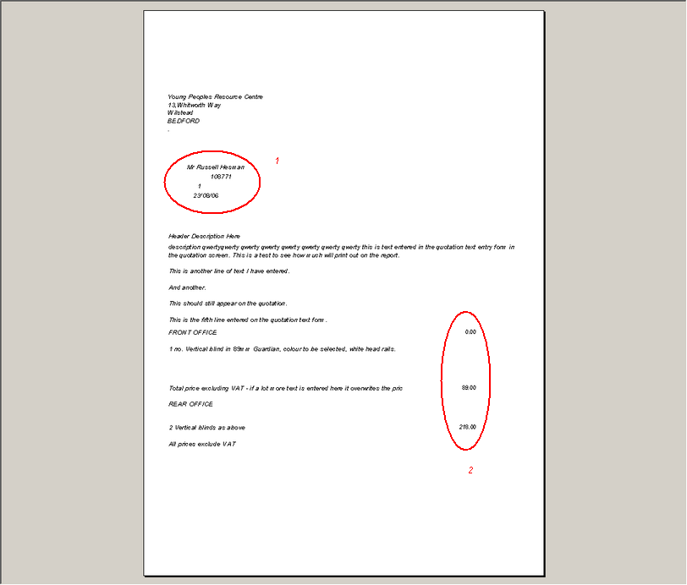

1298. Acknowledgement – Laser Print

If a detail line is a repair, it no longer prints width, drop and quantity.

1299. Order Processing > Orders

The ‘Email Order Ack’ button is now enabled if there is an email address against the order and the connection detail set to Outlook.

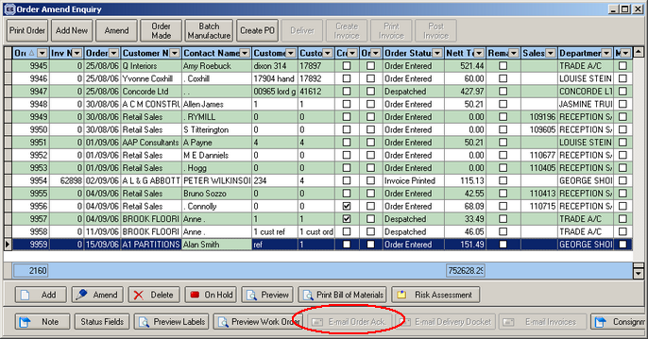

1301. Order Processing > Fitters Sheet / Sales Leads (Urgent)

When trying to convert a sales lead to an order and create a fitting appointment, the following error occured. Fixed.

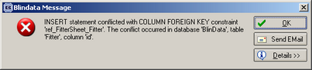

New Work and Customer Requests

348. EDI Delivery Address

Delivery addresses are now included in the EDI files that are transmitted. These are also imported into the system at the manufacturing site.

380. Delivery Docket - Despatch Manifest

A new delivery docket report has been created. This will only be run from Order Processing > Delivery Docket Batch Print.

It groups records by customer, with a new page starting for each customer. The report includes all orders that have a status of ‘Order Manufactured’, between the start and end order numbers entered in the form:

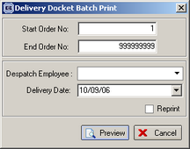

Within each customer, the records are grouped by order, and sorted by order. Within the orders, the records are sorted by blind id. Once the orders have been printed, the status changes to ‘Despatched’.

385. Sales Files > Customers

There is a new tab on the customer form so that blind types can be held against customers. These will be used to identify which blinds can be entered online, by customer. The tab is called ‘Blind Type Sync’. It has no effect on the desktop version of Blindata - only the online version.

389. Works Order – Landscape (New Report)

A new works order layout has been created. It is based on ‘Works order Bespoke’, which it is quite similar to.

391. Risk Assessment Form

A new form has been created. It is tied to the order and can be accessed from a button on the ‘Order Amend Enquiry’ screen.

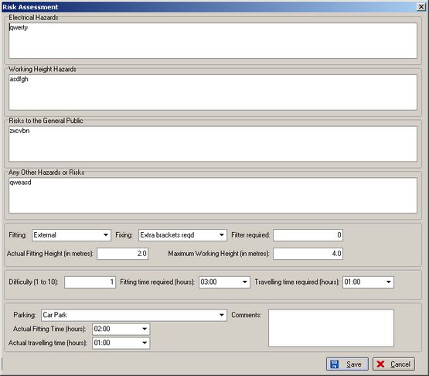

It has the following fields:

Electrical Hazards: free text

Working Height Hazards: free text

Risks to the General Public: free text

Any Other Hazards or Risks: free text

Fitting: a lookup to a new table in Administration > System Tables, called ‘Fitting’

Fixing: a lookup to a new table in Administration > System Tables, called ‘Fixing’

Fitter required: integer

Actual Fitting Height (in metres): allow for one decimal place.

Maximum Working Height (in metres): allow for one decimal place.

Difficulty (1 to 10): integer

Fitting time required (hours): allow for two decimal places

Travelling time required (hours): allow for two decimal places

Parking: a lookup to a new table in Administration > System Tables, called ‘Parking’

Actual Fitting Time (hours): allow for two decimal places

Actual travelling time (hours): allow for two decimal places

Comments: free text

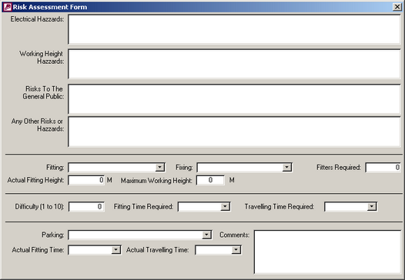

392. Order Processing > Orders > 2nd Telephone Number

It is now possible to hold a second telephone number against an order (eg for mobile number).

397. Sage Username and Passwords

We have amended the way in which Blindata connects to Sage when updating invoices, checking credit limits etc to stop the following message appearing.

398. Sales Lead Individual Normal

- We have included the sales lead mobile number on the report, just to the right of the Telephone Number.

- We have included a free text field (which is taken from a new field created in Company Details, called ‘Sales Lead Text’). This field replaces what is currently in the circled area.

- The total field now has a white background.

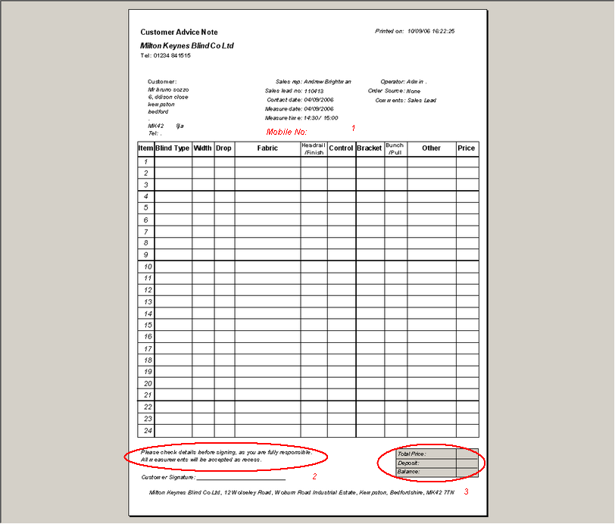

399. Delivery Docket – Laser Print

The following changes have been made:

- ‘VAT number’ has been moved left and to below company address.
- These fields have been moved up a couple of lines and ‘Rep:’ added below ‘Order Tel Number’.
- ‘Invoice Address’ has been placed in here, on the same horizontal lines as the delivery address.
- Imperial dimensions now appear with fractions, not decimal place ( i.e. 3/8 instead of .375).

