Blindata Release Note 3.1.6 

11 September 2006

Bug Fixes and Enhancements

1264. Acknowledgement – Laser Print

The nett amount is now showing on the detail line for orders with customer trade type = trade.

1265. Label Print 5 x 1 ½ CB

The following changes have been made:

- The ‘1 of total’ label numbering was wrong. The total is now only the number of blinds in the order, not the number of labels.
- The imperial and metric measurements were overwriting each other if the parameter to print both was switched on. Fixed.
- Special instructions were not printing out. Also they have been swapped round with Location so you can print out two lines.
- On the customer label, moved the address slightly closer together vertically.
- ‘1 of total’ no longer prints on the customer label.
- The printing order of the labels was wrong. All the production labels in an order now print, followed by the customer label, then the next order by production label and then customer label etc.

1268. Bespoke Works Order

The following changes have been made:

- Address line 4 was missing from both addresses. Fixed.
- The measurement print now adheres to the same parameter rules (Metric/Imp, recess/Blind Size)
- ‘Orde’ now says ‘Order.
- The ‘Measure To’ field now appears to the right of the fabric description.
- Special instructions now appear in the line below fabric description. If there are none, the line does not appear at all.

1269. Label Print - 200x24mm

‘Spec Inc:’ now says ’Spec Ins:’.

1270. Works Order - Landscape Metric

The following changes have been made:

- Address line 4 has replaced Country
- ‘Vane Lenthg’ now says ‘Vane Length’.
- Vane length does not appear for a venetian blind.

1271. Administration > Company Details

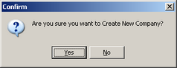

This message now says ‘Are you sure you want to create a new company?’

1274. Administration > Parameters > Reports

When you set up a new company, the reports now get set to the default printer.

1276. Financials > Invoice Batch Print > Invoice – Bespoke 1

A timeout error message occurred when running this report for a large number of orders eg 500. We have increased the timeout length.

1277. Invoice – Bespoke 10

The following changes have been made to this invoice:

- The width and drop are only displayed id blind identifier is not = miscellaneous.
- Cust. Order. No, despatch method and tel number (on order) now appear instead of delivery address
- Deposit Paid and Balance appear if trade type = retail.
- If trade type = trade, the Customer reference also appears in the bottom left (above cust. Order no.)

1278. Order Processing > Orders

If an order has a status of ‘Despatched’, ‘Invoice Created’ or ‘Invoice Printed’ the order entry program does not check if the credit limit has been exceeded.

1279. Financials > Post Invoices to Sage

The following bug was occurring. If only ‘Post Retail Invoices’ is set to true in Sage Parameters, it should be possible to post a retail invoice in the same way as a trade invoice is posted. This worked perfectly from the Order Amend Enquiry form, but the message below appeared if you tried to post an unbalanced retail invoice in ‘Post Invoices to Sage’. With the parameters set as they are, a retail invoice should get posted to Sage, regardless of the balance amount. Fixed.

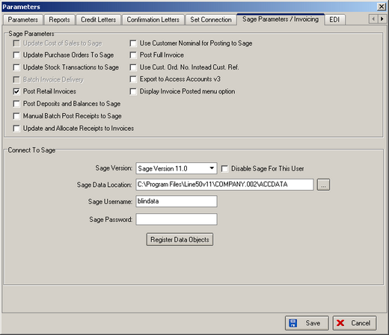

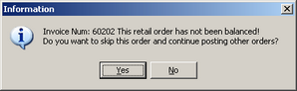

1281. Quotation – Bespoke 10

- The fields ‘Account Code’, ‘Cust Ref’ and ‘Cust ord No’ have been replaced by contact name (Title, First Name, Last Name concatenated), sales lead number, quote number.
- The space for the detail line has been extended down.

1282. Order Processing > Orders > Woodslat Calculator

It is now possible to calculate slat, bottom bar and valance widths for 35mm wood blinds, using the following style of code:

W7GO50 slat
W8GO50 bottom bar
W9GO50 valance

1283. Works Order – Label 1

If blind identifier = Wood Component, cord spacing now shows on the works order label.

New Work and Customer Requests

354. New Pleat Table Calculation

At the moment the system can find the number of pleats for a blind by looking in the blind type record and also looking in the stock item record. The latter takes precedence.

There is now a further option that is accessed depending on an option choice. This will work in exactly the same way as the headrail slat table functionality works.

The following functionality has been added:

- There is a new code description in the table ‘Option Names’ (in Administration > System Tables) called ‘Pleat Calc’.
- There is a new table ‘Pleat Calc Options’. This contains the option choice (stock item) and the pleat table.
- If an option is set to ‘Pleat Calc’ and that option is chosen, the program now looks in table ‘Pleat Calc Options’ to find the correct pleat table to use. This will then take precedence over the other two pleat tables.

358. Alternative Splashscreen

It is now possible to personalise a splashscreen on the Blindata menu form. This can be done by adding the following txt to the ini file in c: \program files\ball software\blindata\blindata.ini

[SplashScreen]
Image=D:\MyDir\IMG_7257.jpg

384. Order Processing > Orders

A new field called ‘Consignment note number’ has been created in order table, and is displayed on the order amend enquiry form and the archive enquiry form. There is a button on these forms to display the consignment note no.

There are two new options in advanced permissions - to be able to view and edit this button.

386. Receipt Bank Nominal Codes

It is now possible to post receipts to different bank accounts depending on whether it is cash, cheque or receipt. We are now to hold the bank account nominal code against the receipt type and allow more than one bank nominal code in the nominal code table.

To get this functionality to work, there are two things that must be done.

- Create bank nominal codes in Administration > System Tables > Nominal Codes. Make sure you flag the nominal code as a bank code and also identify the default bank nominal code. This will be used if there are no bank nominal codes set up against receipt types.
- Set up bank nominal codes against receipt types. This can be done in Administration > System Tables > Receipt Types.

387. Purchase Order – Bought In Blind Size (New Report)

There is a new purchase order which has the same layout as ‘Purchase Order – Bought In Standard’ but prints blind size instead of entered sizes.

388. Works Order – CB (New Report)
A new works order has been created. The page length is 11” (279.4mm). It is called ‘Works Order – CB’.
390. Invoice Terms and Conditions

There is a new table in Administration > System Tables, called ‘Invoice Terms and Conditions’. This contains description and text. The description is 20 characters long and the text 250 characters.
This can now be held against the customer record, so the terms and conditions can be printed on invoices, depending on the customer. To start with, it has been put on the bottom left of ‘Invoice – Bespoke 11’.

