Blindata Release Note 3.1.2 

11 August 2006

Bug Fixes and Enhancements

1226. Stock Setup > Purchase Order Enquiry > Bought In PO

When a purchase order (bought in) is fully delivered, it now change the status of the sales order to fully manufactured if there is only a fitting line outstanding on the sales order.

1228. Fitters Sheet / Sales Lead > Sales Lead History

If an appointment gets moved from one rep to another (or one fitter to another) we are now able to record this in the history as well.

1229. Order Processing > Quotes

The button to flag for a repair had disappeared from the quotation entry screen. It has been restored.

1230. Stock Setup > Stock Items > Stock Transaction

If a stock transaction is entered via Stock Setup > Stock Transaction Entry, it now appears on this form.

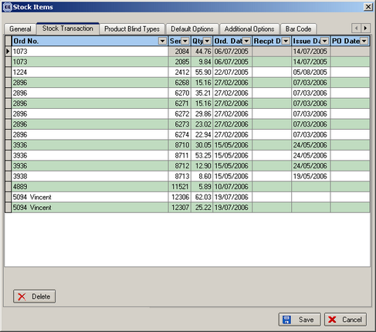

1231. Quotation – Bespoke 10

- Removed country and move postcode up a line
- Removed totals.

1232. Reports > System Reports > Customer Listing

‘Start Order Date’ and ‘End Order Date’ no longer appear when you choose this report.

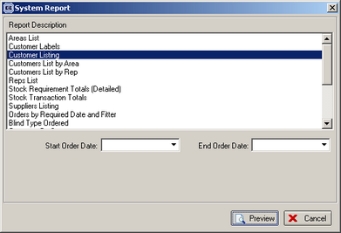

1233. Order Processing > Orders > Order Entry

The tab order was out of sequence in a retail order entry. Fixed.

1234. Invoice – Laser Print 11 Detail Lines

Option price and discount no longer print if ‘Hide Detail Line Totals’ is set to true in Order Entry > Totals.

1235. Acknowledgement – Laser Print

Option price and discount no longer print if ‘Hide Detail Line Totals’ is set to true in Order Entry > Totals.

1236. Delivery Docket – Laser Print

- If there are fitting instructions, they now appear below the options on each line.
- Order tel. number now appears on delivery docket.
- Moved totals up by 10mm as the last line was being chopped off on some printers.
- Removed country and moved postcode up a line
- Delivery date was missing. Fixed.

1237. Credit Letters

The surname was missing from all the credit letters. The name is a concatenation of title, first name and last name (surname).

1238. Invoice – Bespoke 5

- The width and drop are not required if the detail line has been entered as a component line.
- Moved ‘Page 1 of 1’ up to be level with the nett total line (up about 15mm).

1240. Acknowledgement – Laser Print (High Priority)

The delivery contact name and address are now in the left hand corner.

1241. Order Enquiry > Blind Made Scan (Bad Bug)

We now check when a blind is being scanned that the order status is not greater than ‘Order Printed’. Previously it was possible to scan a blind for an order that has a status of ‘Invoice Posted’, and the status will get set back to ‘Fully Manufactured’.

1242. Archive Enquiry

For credit notes, the form was showing the invoice no. It now shows the credit note no (credit id).

1243. Administration > Parameters > Reports

‘Invoice – Shaftesburys’ has been renamed ‘Invoice – Bespoke 12’. ‘Quotation – Shaftesburys’ has been renamed ‘Quotation – Bespoke 12’.

New Work and Customer Requests

262. New Calculator – Hypotenuse

A new calculator called ‘Hypotenuse’ has been added. This does the same thing as the ‘Width Variable’ calculator except it works for shaped blinds.

306. Advanced Permission

There is now an advanced permission option for Price override in the order entry program.

338. Box Code

The box code field has bee extended to 16 characters.

339. Works Order Label Blind Size

The fitter name now appears on the top two labels.

340. Purchase Order Bought In (Standard)

Location now prints on bought in purchase order print.

341. Works Order Label Blind Size

Box blind details ( Deduct Each End and Slat Deduction/Addition) now goes on ‘Works Order Label Blind Size’.

343. New Quotation and Invoice Print

There are new invoice and quotation layouts called ‘Invoice – Bespoke 12’.

347. Financials > Daily Sales Report

We can now choose this report by department as well as by invoice date.

351. Acknowledgement – Laser Print

Order contact name and telephone number now appear on this report.

352. Sales Lead Sheet – Normal

- We have put post code in where tel. number was, and moved tel. number down a line.
- Moved comments down two lines and put in operator on first line and order source on second line.

