Blindata Release Note 3.0.5 

26 June 2006

Bug Fixes and Enhancements

1103. Order Processing > Order Enquiry > Blind Made Scan

There is an occasional problem with this function at one site. If all the blinds on an order have been scanned as manufactured, the program is supposed to bring up the choice to flag the whole order as fully manufactured, like this:

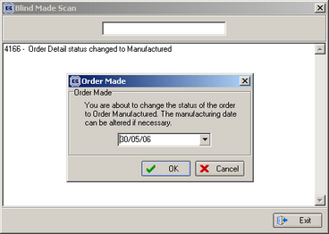

The problem is that sometimes the ‘Order Made’ box does not appear, even if all the detail lines on the order have been scanned as manufactured. We have checked the PC, the scanner and copied the data back to our office. We can never get the program to go wrong here. Can you check the logic at the point where the ‘Order Made’ window should appear. There must be something wrong there – maybe related to multiple users.

We have made the following changes:

1. Added verification for blocking of order details, and blocking of the order by other users.
2. Moved the scanning process to a separate transaction, it should make this operation more reliable.
3. Modified the procedure of comparing the total number of order details and the number of manufactured order details. Added a new verification which checks if the order is completed, even if the same detail is rescanned again.

1127. Sales Files > Customers

The Copy button was copying the wrong record. Fixed.

1143. On Sales Order

If you look at the stock in hand and the on sales order figures in the stock record, sometimes they do not tie in with the totals of all the stock transactions.

We have checked that the on sales order and stock in hand figures are being properly calculated.

The following should happen:

When a sales order is entered, the ‘on sales order’ figure should increase.

When blinds are manufactured (or set as WIP, depending on the parameter setting), the ‘on sales order’ figure and the ‘stock in hand’ figure should be reduced.

We also checked that the purchase ordering is also calculating the ‘on purchase order’ and ‘stock in hand’ figures.

When a purchase order is added or generated (and saved), the ‘on purchase order’ figure is increased. When the stock items are delivered, the ‘on purchase order’ figure should be reduced and the ‘stock in hand’ figure increased.

If the figures are incorrect, we need a routine that will correct them according to the transactions that have been entered. This has been added this as a development item.

1144. Variable Width and Drop Calculator

The quantity did not get picked up properly in the bill of materials if there are other records set up in ‘Values for Width Variable Calculator’. Fixed.

1146. Order Processing > Orders > Detail Entry

If you go to amend a detail line, the options did not appear in the same order as they do when you first enter the detail line. Fixed.

1149. Reports > Sales Analysis > Sales Analysis Invoice Audit Trail

This report was showing contact name instead of customer name. Also the total did not match the totals in Sales Analysis by Blind Type and the Daily Sales Report. Both fixed.

1151. Bill of Materials Calculation

If a quantity of 0.002 is entered in Blind Details > Blind Types > Stock Defaults, it displayed as 0.0020000000949949. When the bill of materials is calculated, it now gets calculated as 0.002, not 0.

1154. Sales Files > Customers

It was not possible to enter a product discount record against a customer. No records appear in the product lookup. Now working.

1155. Reports > Sales Analysis

If option ‘Invoice Date’ is selected, credit notes are now taken into account i.e. they are deducted from the totals.

1159. Financials > Daily Sales Report

The dates have been tidied up.

1160. Works Order Label Blind Size

If the following items are ticked for a pleated blind, the works order label has been tidied up. The brackets and cord spacing calculations were being printed in the same space.

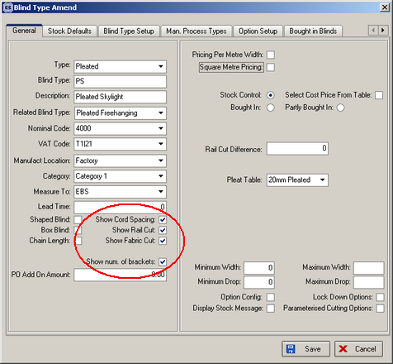

1161. Works Order Label Blind Size

If blind identifier = Headrail only, and headrail cut = true in the blind type record, then the headrail cut appears on the report.

1162. Order Processing > Orders > Component Detail Entry

If you entered a component, then changed the price, and then go in and out of the quantity field, the price was reset to the original amount.

Also, if you go to amend this item, and tab through quantity, the VAT rate changes from T1 to T0.

These have both been fixed. We have also introduced a ‘Price Overridden’ field.

1163. Stock Setup > Stock Items > Stock Price Tab

It is now possible to enter a price in here to 3 decimal places.

1164. Works Order Label Blind Size

We made an incorrect design decision some time ago. This particular report checked the blind type record to see if there is a works order control record and then printed out labels according to the number of records that were set up there. But we then changed this, so it would print at least one set of labels per blind type. This, we have decided, was a mistake. We have changed it back to check the works order control – in other words, if there are no records here, it will not print a label for that blind type.

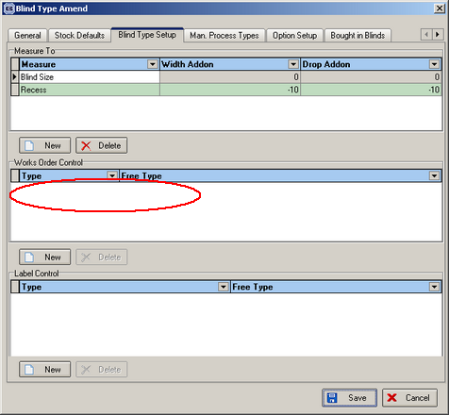

1165. Cord Spacing Calculation

The cord spacing calculation gave different answers, depending on whether the blind size or recess size was entered. Fixed.

1166. Order Manufactured Scan

When you selected order manufactured scan on the order enquiry screen, 'Unknown error changing status' appeared in the window after you scan an order. The order status still changed to Manufactured as normal. Fixed – the proper message now appears.

1167. Maximum Drop Check

When you entered a blind that is above the maximum width or drop, a warning appeared to alert the user. However, the user could still proceed to save the blind. If it is below the minimum width or drop, the blind cannot be saved. When entering a blind that violates the min/max width or the min drop, the program now prevents the user from saving the detail line.

1168. Quote Printed Status

When you print a quote on the quote screen, the status of the quote changed to 'Printed'. However, if you right click the quote and select history, the status change read 'Works Order Printed'. It now says ‘Quotation Printed’.

1169. Valance Calc

There was a refresh problem on the order entry form when using this functionality. If you changed an option which affected the size of the valance, the valance option did not update automatically. To force it to update, you had to change the fabric and change it back again. It should not be necessary to do this. Fixed.

1170. Customer Defaults

When a fabric is selected this overrode the customer default. The customer default should only be changed by the operator going into the option. In other words the customer default should get selected after the normal defaults are selected. Fixed.

1171. Order > Components VAT

If you clicked add 'component' for a customer with a 0% VAT rate, then add in carriage, the carriage entry automatically defaulted to 17.5% VAT. It didn't check what the customers VAT rate was. Fixed.

1172. Changing from metric to imperial

If you entered an order in metric, then realized that it should have been imperial (or vice versa), there was a bug. When you changed the measurement, the price did not recalculate. Fixed.

1173. Order Processing > Orders

The options were appearing in alphabetical order when they should be appearing in sequential order (as set up in Option Setup). Fixed.

1175. Order Processing > Orders

This message now say ‘This order is above £100.00 and requires authorization.’

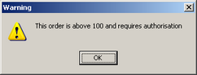

1176. Order Processing > Orders

This message now says ‘This order requires authorization.’

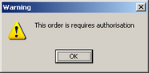

New Work and Customer Requests

280. Company Order Limit

If an order is for a large sum, it needs to be authorised by someone. The following changes have been made:

- Created a new field in Administration > Parameters called ‘Authorisation Amount’. This is a currency field. It defaults to zero.
- At the end of the order entry program, there is a check to see if the order total (including VAT) > Authorisation Amount. If so, a message appears saying 'This order is above £999.00 and requires authorisation'. The order should then be flagged as requiring authorisation. If the authorisation amount = 0, then it is not applied.
- A new menu option is available in the Order Processing menu that will allow an appropriate user to authorise the order. The fields on the screen are similar to those on the quality control form, except we don’t have log no.
- It is not possible to print a works order or a label for an order that requires authorisation. An order should not be able to progress past 'Order Entered' stage until it has been authorised.

318. Works Order Label Blind Size

If the parameterised cutting option in the blind type is true, we have adjusted the ‘works order label blind size’ report to display the cutting options. We have fitted the cutting option sizes in like this:
