Blindata Release Note 3.0.1 

26 May 2006

Bug Fixes and Enhancements

1088. Order Processing > Orders > Detail Line Entry

The ‘Measure To’ default is now working properly. If a blind is set to default to ‘Blind Size’, it now comes up as ‘Blind Size’ in order detail entry.

1091. Archiving Fully Paid Retail Sales

There was a problem in the system with retail orders. If the ‘Post Retail Invoices’ parameter was switched off, then orders for retail customers could never be archived. They would always remain in the order amend enquiry screen.

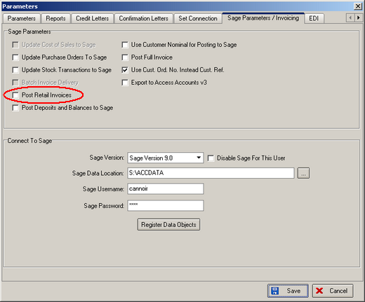

We have made the following change to solve this problem. If ‘Post Retail Invoices’ is false, the order has a status of Despatched and the balance on the order = 0, then the status of the order changes to archived (in effect, status = 6, invoice posted). This logic now takes effect either at the ‘Deliver’ stage or at the receipt entry stage.

This did leave one problem, however. The user still wants to be able to see the receipts posted against the order (which can now only be seen in the archive enquiry screen). Therefore there is now an option to view receipts, by right clicking on the relevant order.

1094. Order Processing > Orders

The check for the maximum drop is now working.

1095. Reports > Financial Reports > Outstanding Retail Debtors

This report is now grouping records correctly. Months are grouped together within departments.

New Work and Customer Requests

122. System Tables > Coordination Group

It is now possible to create a new table for coordination groups. The purpose of these coordination groups is to group fabrics together so the same default items can be applied to a number of fabrics.

These records can be set up in System Tables > Coordination Code.

A coordination group field will then need to be added to the fabrics table, but will not be a mandatory field. It will be used to group fabrics in such a way that, when an order detail line is entered, if a fabric has a coordination group stored against it, the following table is looked up to find the default option to use, and the calculator for the option is picked from here (instead of the fabric table).

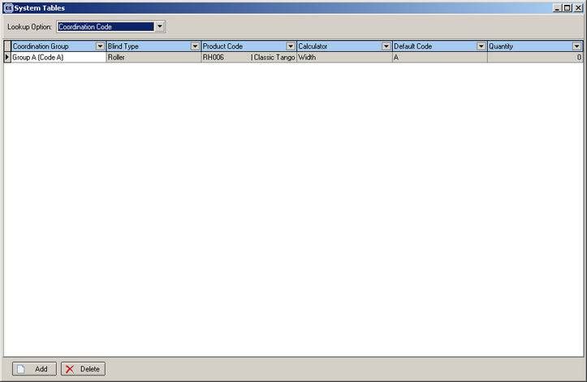

237. Order Processing > Orders > Detail Line Entry

If option config = true for a blind type, the rules now work the same for fabric as for options. Therefore it is now possible to set up a fabric in Blind Details > Blind Type Options > Link Options and determine the choices available in specific options.

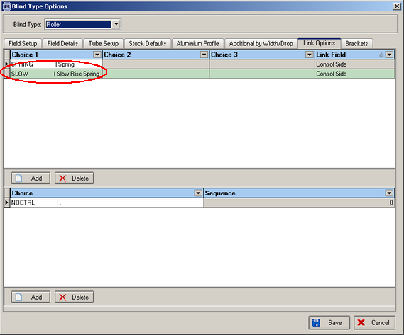

277. Financials > Retail Balances

Previously credit letters could only be run in batches. It is now possible to run them individually as well. This is done from the retail balances form.

There are two new buttons, ‘Letter Send Status’ and ‘Print Letter Status’.

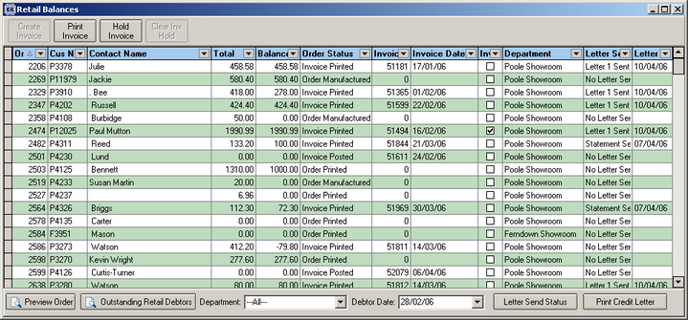

Letter Send Status

It should also be possible to change back the type of letter sent to the previous letter.

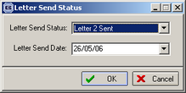

Print Letter Status

As soon as the letter has been printed (not just previewed), the status will change.

284. Cost Price Calculation

Previously cost prices for blinds were calculated in two different ways.

If a blind type was set to stock control = true, then the cost price was calculated by adding up the cost prices in the bill of materials.

If a blind type is set to bought in = true, then the cost price was taken from the cost price table that is set up in price table enquiry (and is related to the blind type in the bought in tab).

These two methods are still used, but a third method has been introduced.

A new field has been introduced in the blind type form called ‘Select Cost Price from Table’. It is only visible if stock control is switched on, and defaults to false. If it is set to true, then cost prices will be selected from the price table grid instead of the sum of the bill of materials.

