Blindata Release Note 2.9.4 

18 April 2006

Bug Fixes and Enhancements

1026. EDI Enquiry

It is now possible to import records under the following circumstances:

- There are no options on the import detail line.
- There are more options on the blind type detail line to be imported than on the blind type in the receiving system. Option records that do not have an inner option get put into special instructions.
- If the number of options on the sending side is less than the number of options required on the receiving side, then the missing options will be filled with default values.

1027. Order Processing > Order Entry

If the customer delivery days are set so that Saturday and Sunday are delivery days, then the system picked a Saturday or a Sunday as a required date, regardless of the fact that they are weekends. We have changed this so that a weekend day off takes priority over a weekend delivery day on setting in the customer record, and so the required date is calculated as the Monday instead of the Saturday or Sunday.

New Work and Customer Requests

197. Blind Details > Blind Types / Blind Type Options

These two forms have been merged (blind type options into blind types).

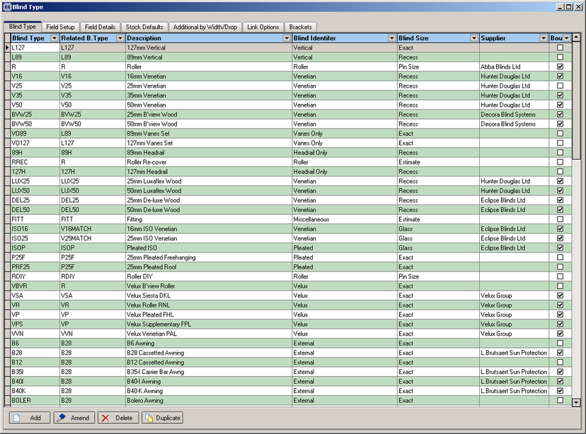

203. Stock Setup > Suppliers

We now display Supplier Code on left hand side of this screen.

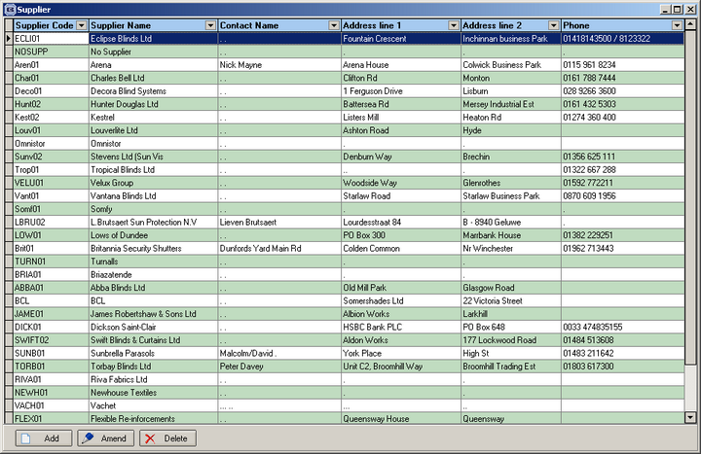

204. New Blind Identifier – Track

We have a new blind identifier called ‘Track’.

205. New Blind Identifier – Panel Blind

We have a new blind identifier called ‘Panel Blind’.

