Blindata Release Note 2.9.5 

21 April 2006

Bug Fixes and Enhancements

1001. Works Order A4 Individual

Should only show customer reference on works order individual, not customer order no.

1029. Administration > Import from Excel

When you import customers records that have no postal code, the validation for invoice and postcode address fields has been switched off.

1031. EDI Enquiry

The message now says ‘You have no new transactions.’

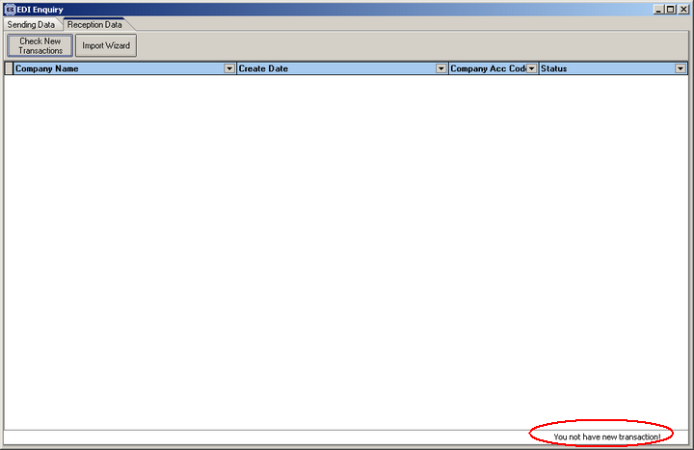

1032. EDI Enquiry Receive

The correct number of orders that have been imported is now displaying in the receive form.

1033. Order Processing > Orders

When adding an order, an error message appeared after selecting customer. Fixed.

1034. Order Processing > Orders

If an order was open with detail lines that haven’t been saved, it is ignored by the production documentation routine. However if an order is sitting open without any detail lines, the production documentation changed it to Works Order Printed. If there are no detail lines on an order, this no longer happens.

New Work and Customer Requests

215. Invoicing of EDI Orders

We have created a new invoice print for orders that have been transferred via EDI. This creates only one invoice for all the orders in a batch.

We have created a new parameter in Administration > Parameters called ‘EDI Batch Invoice’, which defaults to false. If it is set to false, the ‘Create Invoice’ routine works as it does at present.

If ‘EDI Batch Invoice’ is set to true, the ‘Create Invoice’ routine does the following:

- Sorts orders by EDI batch number
- Create invoices as normal for those with no batch number (ie assign invoice number and change status to ‘Invoice Created’.
- Groups remaining orders by batch number and assign an invoice number to the batch – this means 10 different orders with the same batch number will all have the same invoice number.

A new invoice layout has been created. This has the same layout as ‘Invoice Bespoke 6’, except for the following:

- Customer Order No. displays the EDI batch number.
- Customer reference and Order No. are not required.
- Details of invoices have been replaced by order header information – order date, order contact name, order id, customer order no, customer reference, nett amount.

231. Administration > System Tables > Option Calculations

P{reviously ,only Fabric Drop Calc was in system tables, now Fabric Width Calc has been added.

234. Order Processing > Orders

When a customer reference is entered in an order, there is now a function to check if the same customer reference has already been entered in an order for the same customer. If it has, a message now appears saying ‘An order has already been entered for this customer with this reference – is this ok?’. If the field is left blank, the function does not apply.

239. New Quotation Layout

There is a new quotation layout that itemises all options that have individual prices.

249. Controlling Quantity of Works Orders Labels (Works Order Label Blind Size)

If a component line is entered for a quantity of 10 items (eg brackets), the system previously printed out 10 sets of labels. For certain component, it is now possible to be able to print out only 1 works order label. There is a new field in the stock item record called ‘Only One WO Label’.

If this new field is set to true, the following changes take effect in the works order label print:

- Only one set of labels will print out, regardless of the quantity entered.
- If the quantity is 10, instead of displaying ‘10 M’, it will only show ‘1 M’.
- The quantity is printed on the large label.
- Instead of saying ‘1 of 10’, it will say ‘1 of 1’. If you had 10 components on one detail line and then a roller blind, it would say ‘1M, 1R’, and ‘1 of 2’.

250. Invoice Bespoke 5.

We are now able to itemise each option price on the invoice. Previously we showed a base price and then an option price, but now it prints out each individual option price. Options with zero prices are placed on the same line.

