Blindata Release Note 2.9.3 

18 April 2006

Bug Fixes and Enhancements

1021. Order processing > Orders > Detail Line Entry

The new fabric class discount is now being applied properly.

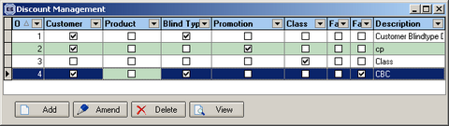

1022. Invoice Bespoke 3

The following changes have been made to this invoice (both regular and batch). For trade invoices:

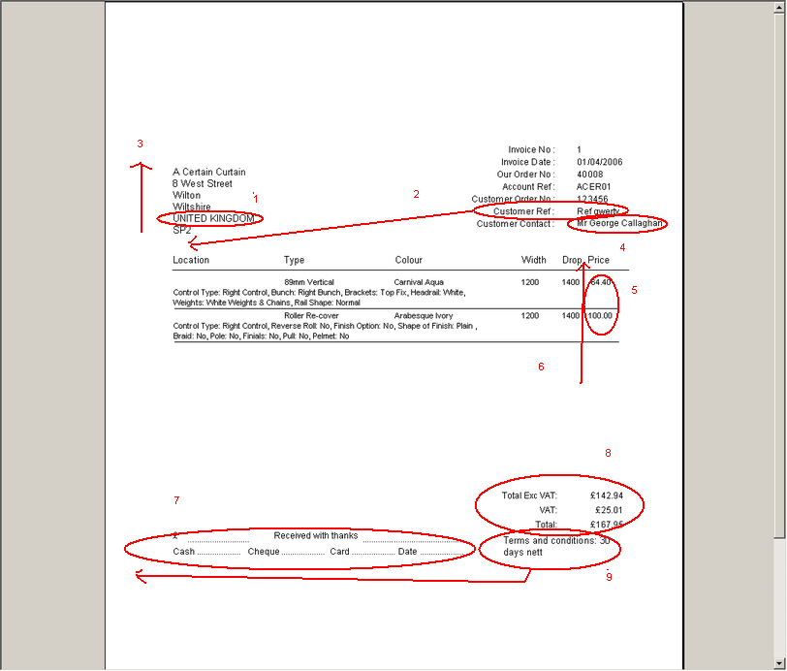

- ‘UNITED KINGDOM’ has been removed and the postcode moved up a line. This applies to retail invoices as well).
- Customer ref has moved to below address. There is a line between address and customer ref.
- The customer company name and address has moved up so it is in line with ‘Invoice No’.
- Customer contact has moved slightly to the left as it was running onto the preprinted artwork.
- These figures are now the nett price in the detail line, not the base price + option price.
- We have fitted quantity in here, but its heading is ‘No.’.
- All this text has been removed – only required for retail sales.
- The totals have been moved down 4 lines.
- The ‘terms and conditions’ text has been moved to the left, below guarantee text.
- The words ‘Sales invoice’ now appears in bold in the top right (just above Invoice No.).

Retail invoices:
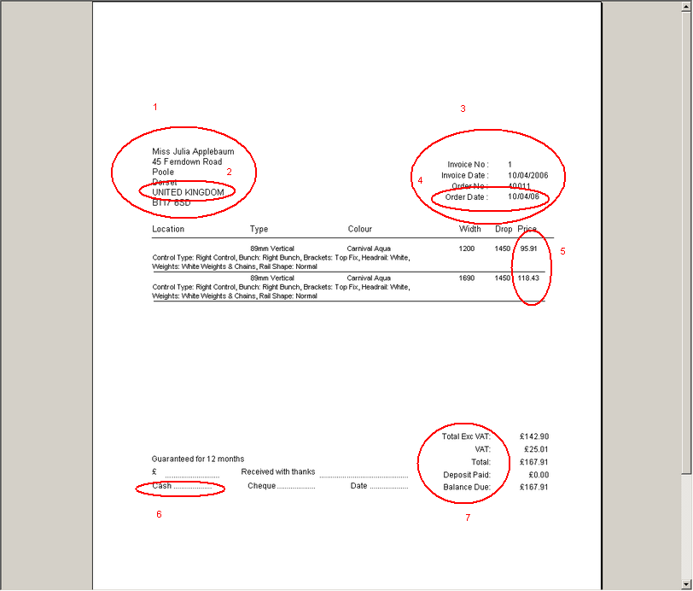

- Name and address have been moved up to the same place as trade invoice address is moved up to.
- Removed ‘UNITED KINGDOM’.
- Moved all fields up to where ‘Invoice No’ is on trade invoice.
- Removed ‘Order Date’.
- This now shows nett price + VAT (that is, retail price for detail line). Also shows £ sign.
- In the bottom the text appears like this:

£ ……….. Received with thanks…………………………………………. Total Exc VAT:
VAT:
Cash….... Date…………………………………………………………….. Total:
Deposit Paid:
Cheque ……………… [Guarantee field text ] Balance Due:

- The words ‘Sales invoice’ appears in bold in the top right (just above Invoice No.).

1023. Box Blinds Bill of Materials

When you enter an order for a box blind, the bill of materials did not pick up the records that are set up in Blind Details > Blind Types > Stock Defaults. The bill of materials for box blinds now picks up records from all the same places as a normal blind.

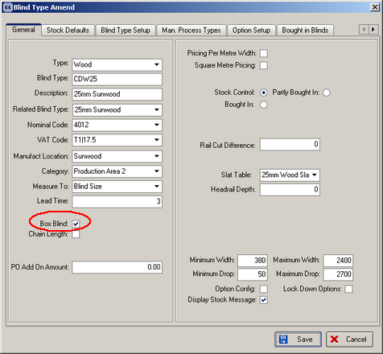

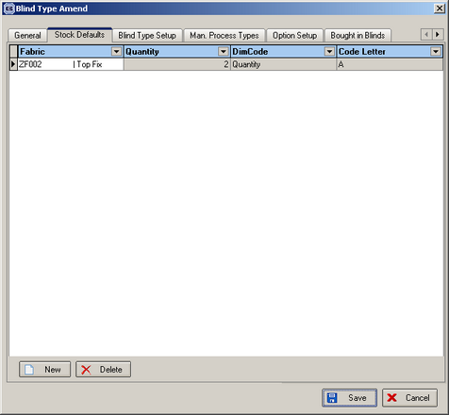

1024. Option Config

If Option Config = true and minimum width and/or minimum drop > 0, a message was appearing as soon as you entered the blind type to say that the blind is too small. The message now only appears after the width and drop have been entered (and if width or drop is less than the minimum amounts).

New Work and Customer Requests

230. Wood Slat Calculating

We have introduced a method of calculating what valance size to use with wood slat blinds. A valance is a strip of wood that fits across the top of a blind and is normally wider than the blind. In the Decora system, stock codes for valances are always in the format W6CG70, which is a 7’ wide valance for a Cactus Green blind.

The following table gives the widths that can be used for bottom bars, slats and valances. We need to have new fields in Administration > System Tables > Wood Slats for Valance(Plain) and Valance(Return).

Standard Length |  | Max. Blind Size
feet | mm | Btm. Bar | Slat |  | Valance(plain) | Valance(returns)
3 | 914.4 | 894.4 | 894.4 |  | 882.4 | 674.4
3.5 | 1,066.8 | 1,046.8 | 1,046.8 |  | 1,034.8 | 826.8
4 | 1,219.2 | 1,199.2 | 1,199.2 |  | 1,187.2 | 979.2
4.5 | 1,371.6 | 1,351.6 | 1,351.6 |  | 1,339.6 | 1,131.6
5 | 1,524.0 | 1,504.0 | 1,504.0 |  | 1,492.0 | 1,284.0
5.5 | 1,676.4 | 1,656.4 | 1,656.4 |  | 1,644.4 | 1,436.4
6 | 1,828.8 | 1,808.8 | 1,808.8 |  | 1,796.8 | 1,588.8
6.5 | 1,981.2 | 1,961.2 | 1,961.2 |  | 1,949.2 | 1,741.2
7 | 2,133.6 | 2,113.6 | 2,113.6 |  | 2,101.6 | 1,893.6
7.5 | 2,286.0 | 2,266.0 | 2,266.0 |  | 2,254.0 | 2,046.0
8 | 2,438.4 | 2,418.4 | 2,418.4 |  | 2,406.4 | 2,198.4
8.5 | 2,590.8 | 2,570.8 | 2,570.8 |  | 2,558.8 | 2,350.8
9 | 2,743.2 | 2,723.2 | 2,723.2 |  | 2,711.2 | 2,503.2
9.5 | 2,895.6 | 2,875.6 | 2,875.6 |  | 2,863.6 | 2,655.6
10 | 3,048.0 | 3,028.0 | 3,028.0 |  | 3,016.0 | 2,808.0
Standard Length |  | Standard lengths of wood material from warehouse
Max. Blind Size |  | Maximum blind size that can be produced from standard length for each component
Btm. Bar |  | Bottom Bar of blind
Slat |  | Slats for blind
Valance(plain) |  | Straight valance
Valance(returns) |  | Valance with returns to cover headrail endcaps.

When a wood blind is entered, the type of valance entered will determine the width of the valance. We already have a Valance option code in Administration > System Tables > Option Names, so we should be able to work out the size of the valance and therefore the correct valance stock code to use.

Additional Notes

This is the way it now works.

1. We need to set up a new option name called ‘Valance Type’ (with code = Valance Calc) and set up two new stock items, ‘Plain’ and ‘Return’. Both of these will have link option = Valance Type.
2. If we look at the table above we can see that if valance type = Plain, we need to add 12mm to the width to get the valance width. If valance type = Return, we need to add 208mm. This means we are able to hold this data in the Option Calculations table and we don’t need to add extra fields to the Wood Sizes table.

Example: an order is entered for a 25mm Balmoral Wood blind, width = 1400, drop = 1600. The colour is Cactus Green. It will currently work out the slat, bottom bar and valance as follows:

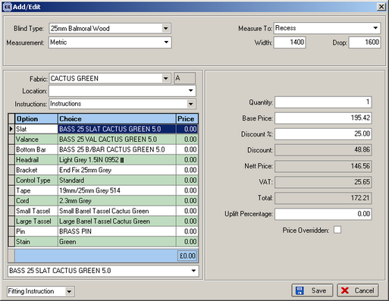

If we have a new option called ‘Valance Type’, we will be able to calculate the width of the valance. In the example above, a plain valance would have width = 1412, a return valance would have width = 1608. If we look at the wood slat table, a width of 1608 means we would have to use a code 55. This means the valance required is W5CG55, not W5CG50.

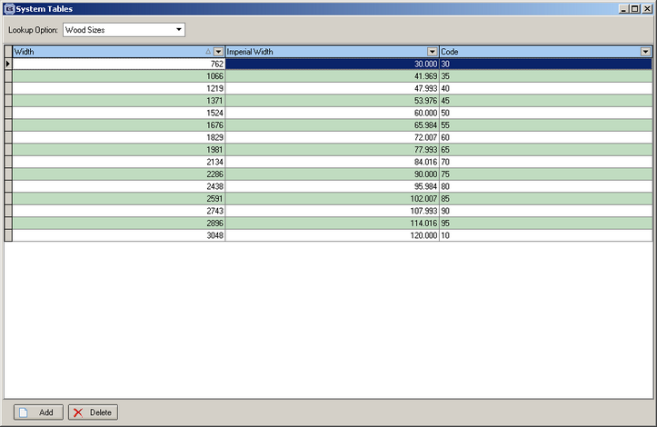

244. Reports > System Reports > Fitters Report by Department

We have another choice in this report, customer trade type. The user is able to choose ‘All’, ‘Retail’ or ‘Trade’.

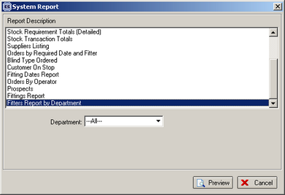

246. Works Order Label Blind Size

Tube Cut and fabric cut now appear on Roller Blind Works Order label. These are set as parameters in the blind type record in the same way as ‘Cord Spacing’ is for Venetian blinds.

Rail Cut and Fabric Cut are now on Pleated Works Order. These are also set as parameters in the same way as ‘Cord Spacing’ is for Venetian blinds.

The number of brackets now displays on this report for all blind types. This is also a parameter. The number of brackets is selected from Blind Details > Blind type Options > Brackets.

