Blindata Release Note 2.9.2 

7 April 2006

Bug Fixes and Enhancements

985. Order Processing > Orders > Order Detail Entry

If you enter a detail line that has records set in Blind Details > Blind Type Options > Link Option, the link option records now get picked up as a default.

996. Order Processing > Orders > Detail Line Entry > Square Metre Pricing

Square metre pricing is now calculating price in order entry. If square metre pricing = true in the blind type record (see below), the price is calculated as follows (in metric)

Width: 1500, Drop: 1200, Square Metre Base price = 16.00.

Base price in detail line = (1500/1000) * (1200/1000) * 16.00 = 28.80.

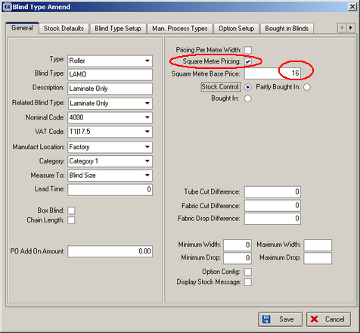

1016. Order Processing > Orders > Batch Manufacture

We omitted one important item here. The condition is now as follows:

‘You are about to change all orders that have been printed and have a required date <= today to status = Order Manufactured. Do you want to continue?’

1019. Create Invoices

When you created invoices using Financials > Create Invoices, it adds carriage to orders that pass the criteria. However since 2.8.7 was installed, it was not possible to see the carriage lines when they go into the order amend screen. The carriage printed out ok on the invoice. Fixed.

1020. Order Processing > Orders > Detail Line Entry

When option config = true for a blind type, options in the detail line entry program were not displaying properly. Fixed.

New Work and Customer Requests

214. New Invoice Layout – Invoice Bespoke 8

A new invoice layout is available for both regular and batched print. It displays multiple invoices.

216. Fabric Class Discount

There is a new field in the discount structure so we can have discounts by fabric class and any combination. Fabric class refers to this field in the fabrics table:
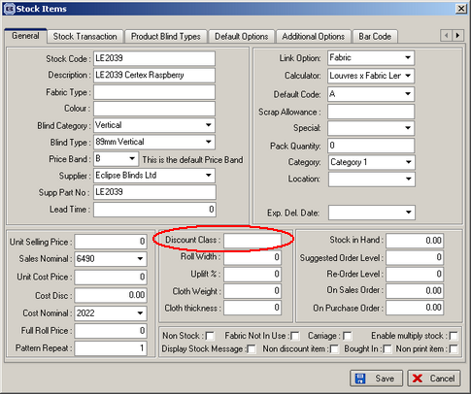

There is a new column called ‘Fabric Class’ in this form:

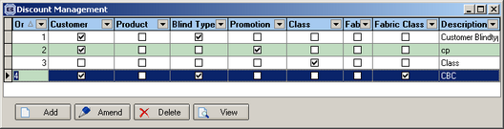

217. Sales Files > Customers > Product Discount

There is a new table to hold product discount for customers. This is required because some customers are given specific discounts on stock items, but these are amounts, not percentage discount. It is possible to view this table via a form on a new tab in the Customers form.

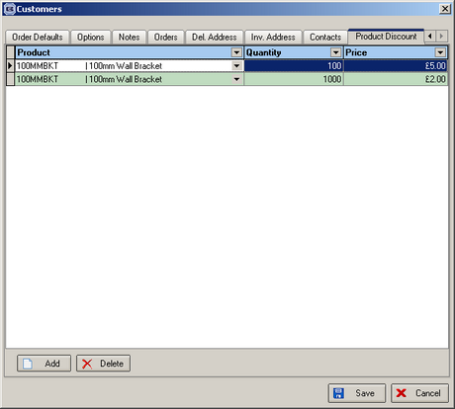

When a component detail line is entered in order entry, the program now checks in this new table to see if there is an applicable price for that product for that customer. The quantity is also checked because the price may alter depending on the quantity being sold.

218. Velux Price Table Import

It is now possible to import velux prices into the velux price table. This is done in Administration > Import from Excel > Velux Price Table. The spreadsheet contains blind type code, velux code, fabric group, price code description, price (eg VR, 102, A, Trade, 45.00).

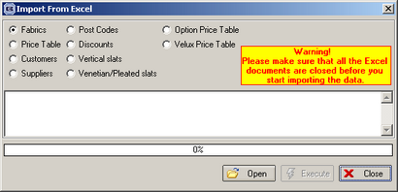

233. New Invoice Layout

There is another new invoice layout called ‘Invoice – Bespoke 7’.

245. Reports > Outstanding Orders Reports

If the following field is ticked, the detail lines for those orders where ‘Exclude from retail Balances’ = true do not appear on the outstanding orders reports.

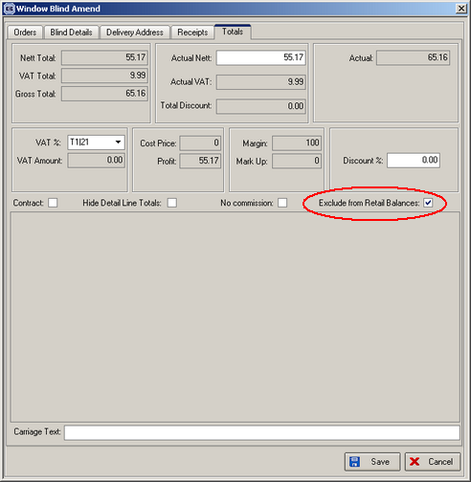

248. New Order Acknowledgement Layout

This is identical to the layout for ‘Invoice Bespoke 6’, except that prices are not shown. It is called ‘Order Acknowledgement 6’.

